an Working Group | IEEE DYSPAN-SC 1900.5
Title | Meeting minutes 0268 for the P1900.5 Meetings of August 5, 2022
DCN | 5-22-0019-01-mins
Date Submitted | 10/3/2022
Source(s) | Carlos Caicedo (Syracuse University)  email: ccaicedo@syr.edu
Abstract | Minutes for the IEEE 1900.5 meetings held on August 5, 2022
Notice | This document has been prepared to assist the IEEE DYSPAN-SC. It is offered as a basis for discussion and is not binding on the contributing individual(s) or organization(s). The material in this document is subject to change in form and content after further study. The contributor(s) reserve(s) the right to add, amend or withdraw material contained herein.
Release | The contributor grants a free, irrevocable license to the IEEE to incorporate material contained in this contribution, and any modifications thereof, in the creation of an IEEE Standards publication; to copyright in the IEEE’s name any IEEE Standards publication even though it may include portions of this contribution; and at the IEEE’s sole discretion to permit others to reproduce in whole or in part the resulting IEEE Standards publication. The contributor also acknowledges and accepts that IEEE DYSPAN SC may make this contribution public.
Patent Policy | The contributor is familiar with IEEE patent policy, as outlined in Section 6.3 of the IEEE-SA Standards Board Operations Manual <http://standards.ieee.org/guides/opman/sect6.html#6.3> and in Understanding Patent Issues During IEEE Standards Development <http://standards.ieee.org/board/pat/guide.html>.
>.

1. Administrivia

1.a Roll Call

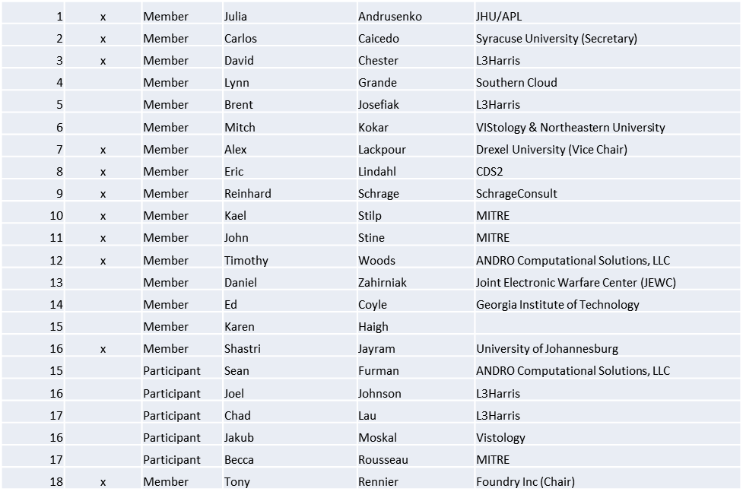

Quorum achieved

1.b. Approval of Agenda
Approval of Agenda from 5-22-0016-00-agen

- Mover: Reinhard
Second: Tim
Vote: UC

1.c. Copyright slides
Copyright policy slides were presented. No comments came forward.

1.d. Patent slides / Notes on status
Patent related slides were presented, no issues came forward

1.e. Approval of recent minutes
Approval of 7/1/22 WG minutes postponed to next WG meeting

2. Status of 1900.5 Revision
- Last met 2 weeks ago
- Discussed how we could proceed with an MBSE approach
  - CAMEO
  - Enterprise Architect
  - Experience and Cost
  - Investigating using IEEE WG funds to purchase licenses
    - Lynn indicates we have $1466 WG funds available
  - XMI is the export standard we want to look at
- Discussed the availability of O-RAN MBSE models to support possible heterogeneous spectrum sharing

3. Status of 1900.5.1
- Had an ad-hoc with some technical difficulties
- Planning a Doodle Pool for those who missed or would like to repeat
- Next ad-hoc planned on 9/30/22 1300 EDT
- Continuing with compiler development – expect a demonstrable program at next F2F meeting

4. Status of 1900.5.2 Revision
- So far addressed 128 of 165 comments on the CRG
- Still targeting end-of-calendar year

5. Review of other DySPAN-SC activities
- Discussed Memo of Agreement with WINNFORUM

6. 1900.5 marketing opportunities
- MILCOM 2022 has a panel on dynamic spectrum access
- Spectrum Innovation Summit
  - NSC event 2 day

7. 1900.5 meeting planning and review
- P1900.5 Revision Ad-hoc 8/12/22 1300 ET
- P1900.5.2 Revision CRG 8/19/22 1300 ET
- P1900.5 Revision Ad-hoc 8/26/22 1300 ET
- P1900.5 WG Mtg 9/2/22 1430 ET
- P1900.5.2 Revision CRG 9/2/22 1300 ET
- P1900.5.1 Ad-hoc 9/30/22 1300 ET

8. AoB
- Looking for Architecture description

Meeting adjourned at 4:25 P.M. EST

