an Working Group | IEEE DYSPAN-SC 1900.5
Title | Meeting minutes 0267 for the P1900.5 Meetings of July 1, 2022
DCN | 5-22-0018-00-mins
Date Submitted | 8/31/2022
Source(s) | Carlos Caicedo (Syracuse University)  email: ccaicedo@syr.edu
Abstract | Minutes for the IEEE 1900.5 meetings held on July 1, 2022
Notice | This document has been prepared to assist the IEEE DYSPAN-SC. It is offered as a basis for discussion and is not binding on the contributing individual(s) or organization(s). The material in this document is subject to change in form and content after further study. The contributor(s) reserve(s) the right to add, amend or withdraw material contained herein.
Release | The contributor grants a free, irrevocable license to the IEEE to incorporate material contained in this contribution, and any modifications thereof, in the creation of an IEEE Standards publication; to copyright in the IEEE’s name any IEEE Standards publication even though it may include portions of this contribution; and at the IEEE’s sole discretion to permit others to reproduce in whole or in part the resulting IEEE Standards publication. The contributor also acknowledges and accepts that IEEE DYSPAN SC may make this contribution public.
Patent Policy | The contributor is familiar with IEEE patent policy, as outlined in Section 6.3 of the IEEE-SA Standards Board Operations Manual <http://standards.ieee.org/guides/opman/sect6.html#6.3> and in Understanding Patent Issues During IEEE Standards Development <http://standards.ieee.org/board/pat/guide.html>.
>.

1. Administrivia

1.a Roll Call

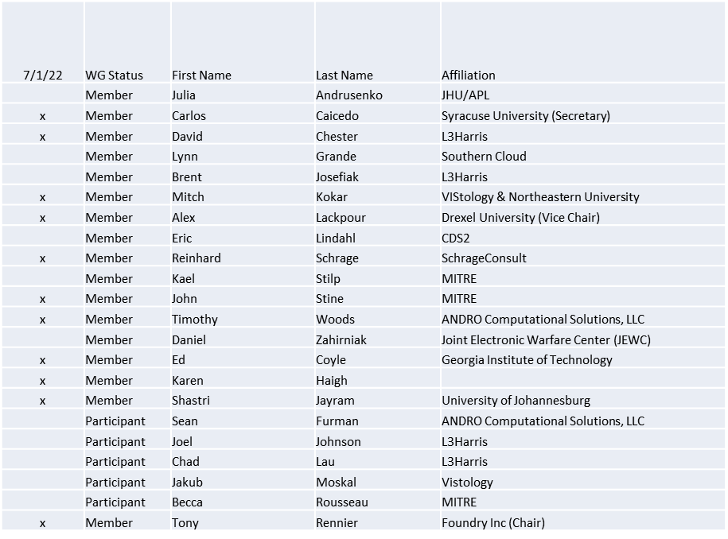

Quorum achieved

1.b. Approval of Agenda
Approval of Agenda from 5-22-0015-00-agen

- Mover: Reinhard
Second: Ed
Vote: UC

1.c. Copyright slides
Copyright policy slides were presented. No comments came forward.

1.d. Patent slides / Notes on status
Patent related slides were presented, no issues came forward

1.e. Approval of recent minutes
Motion to approve 6/3/22 WG minutes contained in Doc #: 5-22-00014-00-mins

Mover: Reinhard
Second: Karen
Vote: UC

2. Status of 1900.5 Revision
- 2 areas of discussion for the revision
  - Cognitive Radio Networks
    - Working on standard definition
    - Looking at an update to 1900.1 definition
  - Dynamic Policy Management
    - Expansion of PMP functions

3. Status of 1900.5.1
- Presented ad-hoc for the application to the augmented policy language
- Looked at an exemplar John contributed
- Planning new ad-hoc on 7/29 at 1300 EDT

4. Status of 1900.5.2 Revision
- Addressed 105 of 157 comments on the CRG
- Still targeting end-of-calendar year

5. Review of other DySPAN-SC activities
- DySPAN-SC Leadership
  - Oliver Holland (Chair) stepping down temporarily
  - Stephen Berger (Vice Chair) taking on Acting Chair role

6. 1900.5 marketing opportunities
- MILCOM 2022 has a panel on dynamic spectrum access
- Spectrum Innovation Summit
  - NSC event 2 day

7. 1900.5 meeting planning and review
- P1900.5.2 Revision CRG 7/1/22 1300 ET
- P1900.5 Revision Ad-hoc 7/8/22 1300 ET
- P1900.5.2 Revision CRG 7/15/22 1300 ET
- P1900.5 Revision Ad-hoc 7/22/22 1300 ET (Tony PTO)
- P1900.5.1 Ad-hoc 7/29/22 1300 ET
- P1900.5.2 Revision CRG 8/5/22 1300 ET
- P1900.5 WG Mtg 8/5/22 1430 ET

8. AoB
- Looking for Architecture description

Meeting adjourned at 9:30 A.M. EST

