an Working Group | IEEE DYSPAN-SC 1900.5
Title | Meeting minutes 0266 for the P1900.5 Meetings of June 3, 2022
DCN | 5-22-0014-00-mins
Date Submitted | 6/28/2022
Source(s) | Carlos Caicedo (Syracuse University)  email: ccaicedo@syr.edu
Abstract | Minutes for the IEEE 1900.5 meetings held on June 3, 2022
Notice | This document has been prepared to assist the IEEE DYSPAN-SC. It is offered as a basis for discussion and is not binding on the contributing individual(s) or organization(s). The material in this document is subject to change in form and content after further study. The contributor(s) reserve(s) the right to add, amend or withdraw material contained herein.
Release | The contributor grants a free, irrevocable license to the IEEE to incorporate material contained in this contribution, and any modifications thereof, in the creation of an IEEE Standards publication; to copyright in the IEEE’s name any IEEE Standards publication even though it may include portions of this contribution; and at the IEEE’s sole discretion to permit others to reproduce in whole or in part the resulting IEEE Standards publication. The contributor also acknowledges and accepts that IEEE DYSPAN SC may make this contribution public.
Patent Policy | The contributor is familiar with IEEE patent policy, as outlined in Section 6.3 of the IEEE-SA Standards Board Operations Manual <http://standards.ieee.org/guides/opman/sect6.html#6.3> and in Understanding Patent Issues During IEEE Standards Development <http://standards.ieee.org/board/pat/guide.html>.
>.

1. Administrivia

1.a Roll Call

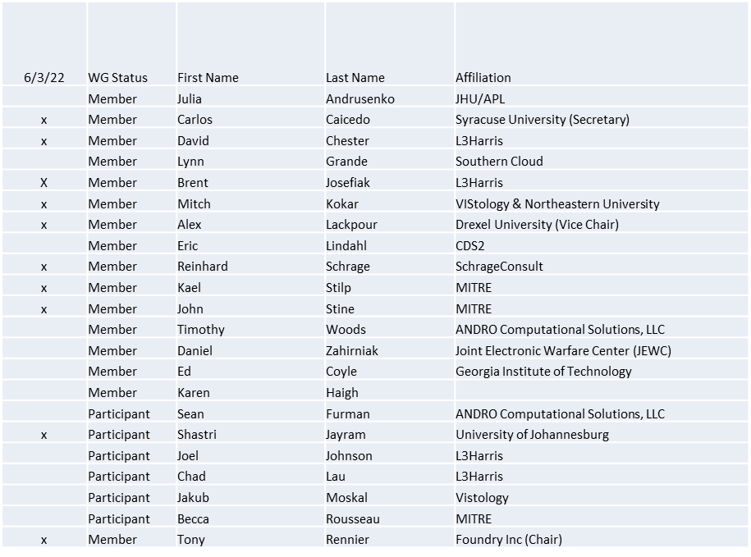

Quorum achieved

1.b. Approval of Agenda
Approval of Agenda from 5-22-0012-00-agen

- Mover: John
Second: Carlos
Vote: UC

1.c. Copyright slides
Copyright policy slides were presented. No comments came forward.

1.d. Patent slides / Notes on status
Patent related slides were presented, no issues came forward

1.e. Approval of recent minutes
Motion to approve 5/6/22 WG minutes contained in Doc #: 5-22-00013-00-mins

Mover: Reinhard
Second: Brent
Vote: UC

2. Status of 1900.5 Revision
- Contribution from Dave on a standard definition of Cognitive system
- Tim working on heterogeneous sharing diagrams

3. Status of 1900.5.1
- Ad-hoc for June 3
- Looked at the latest draft for 1900.5.2
- Briefing algorithms vs code for how to implement compatibility
- Next Ad-hoc will review code that implements the algorithms

4. Status of 1900.5.2 Revision
- CRG has addressed 95 of the 135 comments (hard ones remain)
- Still planning for end-of-calendar year

5. Review of other DySPAN-SC activities
- DySPAN-SC Leadership
  - Oliver Holland (Chair) stepping down temporarily
  - Stephen Berger (Vice Chair) taking on Acting Chair role

6. 1900.5 marketing opportunities
Nothing to report

7. 1900.5 meeting planning and review
- P1900.5 WG Mtg 7/1/221 0800 ET

9. AoB
- from Carlos Caicedo to Everyone:
https://www.fcc.gov/document/fcc-launches-proceeding-promoting-receiver-performance-0
- Question for WINNFORUM awareness

Meeting adjourned at 3:45 P.M. EST

