an Working Group | IEEE DYSPAN-SC 1900.5
Title | Meeting minutes 0265 for the P1900.5 Meetings of May 6, 2022
DCN | 5-22-0013-00-mins
Date Submitted | 5/30/2022
Source(s) | Carlos Caicedo (Syracuse University)  email: ccaicedo@syr.edu
Abstract | Minutes for the IEEE 1900.5 meeting held on May 6, 2022
Notice | This document has been prepared to assist the IEEE DYSPAN-SC. It is offered as a basis for discussion and is not binding on the contributing individual(s) or organization(s). The material in this document is subject to change in form and content after further study. The contributor(s) reserve(s) the right to add, amend or withdraw material contained herein.
Release | The contributor grants a free, irrevocable license to the IEEE to incorporate material contained in this contribution, and any modifications thereof, in the creation of an IEEE Standards publication; to copyright in the IEEE’s name any IEEE Standards publication even though it may include portions of this contribution; and at the IEEE’s sole discretion to permit others to reproduce in whole or in part the resulting IEEE Standards publication. The contributor also acknowledges and accepts that IEEE DYSPAN SC may make this contribution public.
Patent Policy | The contributor is familiar with IEEE patent policy, as outlined in Section 6.3 of the IEEE-SA Standards Board Operations Manual <http://standards.ieee.org/guides/opman/sect6.html#6.3> and in Understanding Patent Issues During IEEE Standards Development <http://standards.ieee.org/board/pat/guide.html>.
>.

1. Administrivia

1.a Roll Call

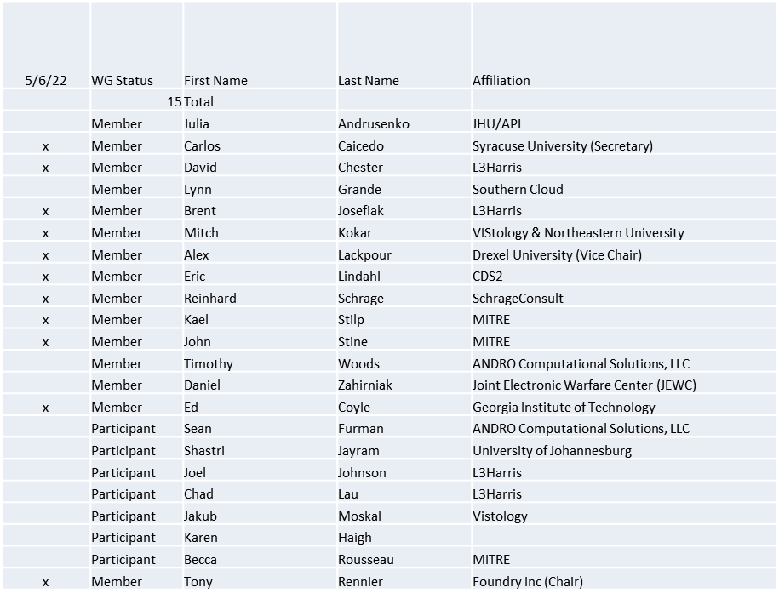

Quorum achieved

1.b. Approval of Agenda
Approval of Agenda from 5-22-0011-00-agen

- Mover: Ed
Second: Reinhard
Vote: UC

1.c. Copyright slides
Copyright policy slides were presented. No comments came forward.

1.d. Patent slides / Notes on status
Patent related slides were presented, no issues came forward

1.e. Approval of recent minutes
Motion to approve 4/1/22 WG minutes contained in Doc #: 5-22-0010-00-mins

Mover: John
Second: Reinhard
Vote: UC

2. Discussion on the definition Cognitive Radio
Discussion starts with an analysis of a definition for cognitive system provided by Julia:
A cognitive system, or rational agent, can iteratively assess the situation, plan and decide its actions, and learn from its experience. Its objective is to achieve the best outcome or, in the presence of uncertainty, the best excepted outcome. Ultimately, a cognitive system is one that operates on a multi-objective Pareto frontier that can be temporally and spatially varying and uses various AI and traditionally based algorithms to keep the system on or near the Pareto front.

Definitions from WINNFORUM for Adaptive radio, Cognitive Radio and Intelligent Radio are provided for contrast.

To continue discussion, a sub-group to elaborate an initial definition for cognitive radio will be led by Dave Chester and bring their agreed upon definition to one of the next 1900.5 WG meetings for consideration.

3. Status of 1900.5 Revision
- Continuing to work toward a conceptual agreement
- Need to start writing
- Need to have a topic (written) for each meeting
  - Perhaps have a Google Doc
- Eric to begin writing in some forum

4. Status of 1900.5.1
- Held an ad-hoc
- Discuss how the new policy language bring together 3 key components
  - Ontology Reasoning, Rule Reasoning, and Computational
- Working on John Stine scenario
- Planning another ad-hoc to discuss scenario
  - After next WG meeting

5. Status of 1900.5.2 Revision
- CRG is going (Need to add time to the CRG meetings)

6. Review of other DySPAN-SC activities
- DySPAN-SC Leadership
  - Oliver Holland (Chair) stepping down temporarily
  - Stephen Berger (Vice Chair) taking on Acting Chair role
- Going forward
  - Stephen believes this a good opportunity to have a group wide discussion to evaluate where the DySPAN committee is in its work, what purposes it is pursuing and how effectively it is achieving its goals.
    - When this effort began there was a desire from the DoD to create a form in which spectrum conflicts between government and commercial interests could be sorted out. We are far away from achieving that vision. So, the question is where are we today and what is our purpose?

7. 1900.5 marketing opportunities
- ISART info pending

8. 1900.5 meeting planning and review
- P1900.5 Revision Ad-hoc 5/13/22 1300 ET
- P1900.5.2 Revision CRG 5/13/22 1345 ET
- P1900.5 Revision Ad-hoc 5/27/22 1300 ET
- P1900.5.2 Revision CRG 5/27/22 1345 ET
- P1900.5 WG Mtg 6/3/221 1430 ET

9. AoB
- N/A

