an Working Group | IEEE DYSPAN-SC 1900.5
Title | Meeting minutes 0264 for the P1900.5 Meetings of April 1, 2022
DCN | 5-22-0010-00-mins
Date Submitted | 5/3/2022
Source(s) | Carlos Caicedo (Syracuse University)  email: ccaicedo@syr.edu
Abstract | Minutes for the IEEE 1900.5 meetings held on April 1, 2022
Notice | This document has been prepared to assist the IEEE DYSPAN-SC. It is offered as a basis for discussion and is not binding on the contributing individual(s) or organization(s). The material in this document is subject to change in form and content after further study. The contributor(s) reserve(s) the right to add, amend or withdraw material contained herein.
Release | The contributor grants a free, irrevocable license to the IEEE to incorporate material contained in this contribution, and any modifications thereof, in the creation of an IEEE Standards publication; to copyright in the IEEE’s name any IEEE Standards publication even though it may include portions of this contribution; and at the IEEE’s sole discretion to permit others to reproduce in whole or in part the resulting IEEE Standards publication. The contributor also acknowledges and accepts that IEEE DYSPAN SC may make this contribution public.
Patent Policy | The contributor is familiar with IEEE patent policy, as outlined in Section 6.3 of the IEEE-SA Standards Board Operations Manual <http://standards.ieee.org/guides/opman/sect6.html#6.3> and in Understanding Patent Issues During IEEE Standards Development <http://standards.ieee.org/board/pat/guide.html>.
>.

1. Administrivia

1.a Roll Call

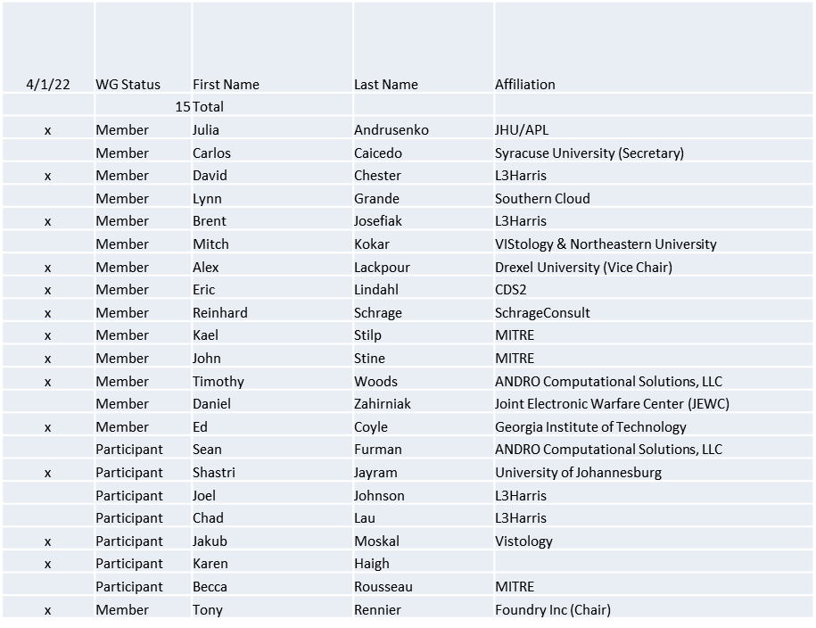

Quorum achieved

1.b. Approval of Agenda
Approval of Agenda from 5-22-0009-00

- Mover: Dave
Second: Tim
Vote: UC

1.c. Copyright slides
Copyright policy slides were presented. No comments came forward.

1.d. Patent slides / Notes on status
Patent related slides were presented, no issues came forward

1.e. Approval of recent minutes
Motion to approve 2/4/22 WG minutes contained in Doc #: 5-22-0007-00-mins

Mover: Reinhard
Second: Tim
Vote: UC

Motion to approve 3/4/22 WG minutes contained in Doc #: 5-22-0008-00-mins

Mover: John
Second: Reinhard
Vote: UC

2. Status of 1900.5 Revision
- Continuing to work toward a conceptual agreement
- Action Item
  - 1 pager to intro (Alex Eric)
  - Use Case review and scenario development

3. Status of 1900.5.1
- Doodle Poll on next Ad-hoc (4/29/22 1500 EDT) 90 minutes
- Working on presentation

4. Status of 1900.5.2 Revision
- CRG is going (50% of the comments 25% of the work complete)

5. Review of other DySPAN-SC activities
- DySPAN-SC Leadership
  - Oliver Holland (Chair) stepping down temporarily
  - Stephen Berger (Vice Chair) taking on Acting Chair role
- Going forward
  - Stephen believes this a good opportunity to have a group wide discussion to evaluate where the DySPAN committee is in its work, what purposes it is pursuing and how effectively it is achieving its goals.
    - When this effort began there was a desire from the DoD to create a form in which spectrum conflicts between government and commercial interests could be sorted out. We are far away from achieving that vision. So, the question is where are we today and what is our purpose?

6. 1900.5 marketing opportunities
- EMBM OTA MVCR1
- Integration EWPMT
- Operationalizing SCMs for use EMBM

7. 1900.5 meeting planning and review
- P1900.5.2 Revision CRG 4/8/22 1345 ET
- P1900.5 Revision Ad-hoc 4/15/22 1300 ET
- P1900.5.2 Revision CRG 4/22/22 1345 ET
- P1900.5 Revision Ad-hoc 4/29/22 1300 ET
- P1900.5 WG Mtg 5/6/221 0800 ET

9. AoB
- N/A

