an Working Group | IEEE DYSPAN-SC 1900.5
Title | Meeting minutes 0263 for the P1900.5 Meetings of March 4, 2022
DCN | 5-22-0008-00-mins
Date Submitted | 3/30/2022
Source(s) | Carlos Caicedo (Syracuse University)  email: ccaicedo@syr.edu
Abstract | Minutes for the IEEE 1900.5 meetings held on March 4, 2022
Notice | This document has been prepared to assist the IEEE DYSPAN-SC. It is offered as a basis for discussion and is not binding on the contributing individual(s) or organization(s). The material in this document is subject to change in form and content after further study. The contributor(s) reserve(s) the right to add, amend or withdraw material contained herein.
Release | The contributor grants a free, irrevocable license to the IEEE to incorporate material contained in this contribution, and any modifications thereof, in the creation of an IEEE Standards publication; to copyright in the IEEE’s name any IEEE Standards publication even though it may include portions of this contribution; and at the IEEE’s sole discretion to permit others to reproduce in whole or in part the resulting IEEE Standards publication. The contributor also acknowledges and accepts that IEEE DYSPAN SC may make this contribution public.
Patent Policy | The contributor is familiar with IEEE patent policy, as outlined in Section 6.3 of the IEEE-SA Standards Board Operations Manual <http://standards.ieee.org/guides/opman/sect6.html#6.3> and in Understanding Patent Issues During IEEE Standards Development <http://standards.ieee.org/board/pat/guide.html>.
>.

1. Administrivia

1.a Roll Call

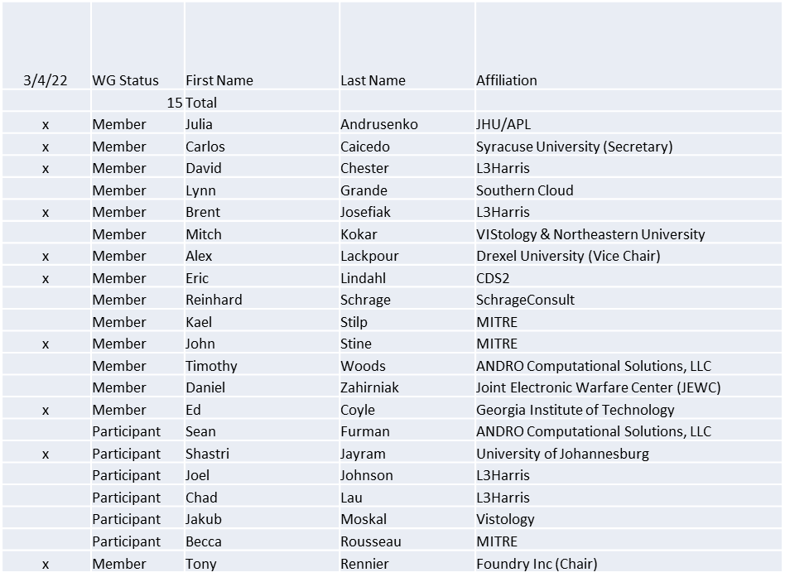

Quorum achieved

1.b. Approval of Agenda
Approval of Agenda from 5-22-0006-00

- Mover: Ed
Second: Carlos
Vote: UC

1.c. Copyright slides
Copyright policy slides were presented. No comments came forward.

1.d. Patent slides / Notes on status
Patent related slides were presented, no issues came forward

1.e. Approval of recent minutes
Motion to approve 1/7/22 WG minutes contained in Doc #: 5-22-0004-00-mins

Mover: Eric
Second: Carlos and Dave
Vote: UC

Motion to approve 2/4/22 WG minutes contained in Doc #: 5-22-0007-00-mins
Postponed to next meeting

2. Status of 1900.5 Revision
- Working to identify the objectives/principles for the revision
  - Broad agreement
  - Some details TBD
  - Email exchange to come to conclusion on what will be in the revision

3. Status of 1900.5.1
- Ad-hoc February 11
  - Presented an approach for a more accessible policy language
  - Reinhard seeking feedback
  - Suggestion for a concrete example of DSA Policy using the approach
  - John will create a sample scenario and send to Reinhard

4. Status of 1900.5.2 Revision
- Knocking out comments in the CRG.
- CRG meeting today (3/4) and new meeting scheduled every two weeks.

5. Review of other DySPAN-SC activities
- Next leadership meeting
  - TBD

6. 1900.5 marketing opportunities
- ISART paper abstracts sent
  - Tony and Alex
  - Carlos and John
  - Response expected to begin by 3/14/22
- 1900.5.2
  - Doing an experiment using models to do a risk assessment
  - Goes beyond current regulatory only approach

7. 1900.5 meeting planning and review
- P1900.5.2 Revision CRG 3/4/22 0930 ET
- P1900.5 Revision Ad-hoc 3/4/22 1300 ET
- P1900.5 Revision Ad-hoc 3/18/22 1300 ET
- P1900.5 WG Mtg 4/1/221 1430 ET
- Spring Plenary Choose between week of:
  - 3/21?
  - 3/28?
  - 4/4?

9. AoB
- N/A

Meeting adjourned at 9:35 A.M. EST

