an Working Group | IEEE DYSPAN-SC 1900.5
Title | Meeting minutes 0262 for the P1900.5 Meetings of February 4, 2022
DCN | 5-22-0007-00-mins
Date Submitted | 3/3/2022
Source(s) | Carlos Caicedo (Syracuse University)  email: ccaicedo@syr.edu
Abstract | Minutes for the IEEE 1900.5 meetings held on February 4, 2022
Notice | This document has been prepared to assist the IEEE DYSPAN-SC. It is offered as a basis for discussion and is not binding on the contributing individual(s) or organization(s). The material in this document is subject to change in form and content after further study. The contributor(s) reserve(s) the right to add, amend or withdraw material contained herein.
Release | The contributor grants a free, irrevocable license to the IEEE to incorporate material contained in this contribution, and any modifications thereof, in the creation of an IEEE Standards publication; to copyright in the IEEE’s name any IEEE Standards publication even though it may include portions of this contribution; and at the IEEE’s sole discretion to permit others to reproduce in whole or in part the resulting IEEE Standards publication. The contributor also acknowledges and accepts that IEEE DYSPAN SC may make this contribution public.
Patent Policy | The contributor is familiar with IEEE patent policy, as outlined in Section 6.3 of the IEEE-SA Standards Board Operations Manual <http://standards.ieee.org/guides/opman/sect6.html#6.3> and in Understanding Patent Issues During IEEE Standards Development <http://standards.ieee.org/board/pat/guide.html>.
>.

1. Administrivia

1.a Roll Call

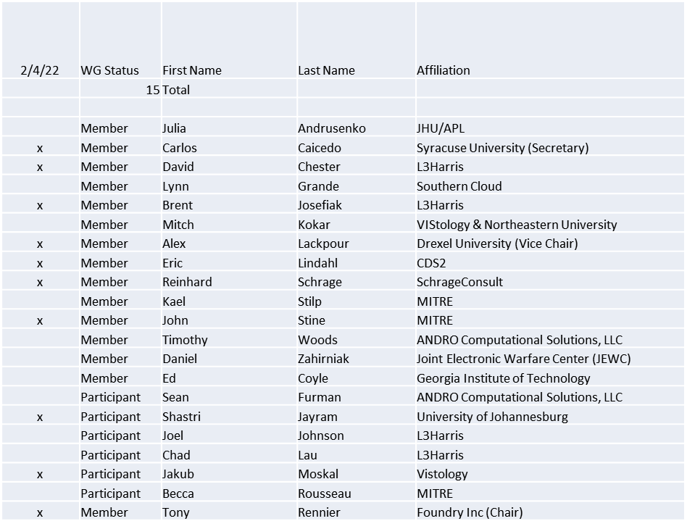

Quorum achieved

1.b. Approval of Agenda
Approval of Agenda from 5-22-0003-00

- Mover: Reinhard
Second: Dave
Vote: UC

1.c. Copyright slides
Copyright policy slides were presented. No comments came forward.

1.d. Patent slides / Notes on status
Patent related slides were presented, no issues came forward

1.e. Approval of recent minutes
Motion to approve 12/9/21 WG minutes contained in Doc #: 5-22-00022-00-mins

Mover: John
Second: Carlos
Vote: UC

Motion to approve 1/7/22 WG minutes contained in Doc #: 5-22-0004-00-mins
Postponed to next meeting

2. Status of 1900.5 Revision
- Discussed decision points on the Revision
- Confirmed decisions on what is in and not in the new standard
- Explored the need for interfaces with other (non spectrum) management systems
- Discussed the introduction of dynamism to the policy management
- Looking to obtain a Word version of the 1900.5-2011
- Collecting a list of external standards that will be referenced (e.g. VITA-49)

3. Status of 1900.5.1
  - Ad-hoc scheduled for next Friday
  - Demonstrating a feasible front end – focus on semantics preserving

4. Status of 1900.5.2 Revision
- Approval Rate Achieved
- 114 Total Comments
- John only Disapprove
- Comment Sheet sent to CRG
- Jenn’s reminders
  - Accept should be word for word the suggested change and the disposition detail should be blank
  - Revised- you accept in principle the suggested change but don't change this could be a bigger change or something to the difference of "the dog has a blue collar" vs "the dogs collar is blue" - that is considered revised
  - Reject- you need to have a disposition detail explaining why
- CRG agreed to meet every other Friday starting 2/11 Time TBD

5. Review of other DySPAN-SC activities
- January meeting cancelled
- Next leadership meeting
  - February 28th, 2022, 5pm UTC (12pm EST)
    - Leadership meeting is schedule to recur at 12pm ET throughout the year.

6. 1900.5 marketing opportunities
- ISART First week of June – call for input
- We should submit an abstract by 2/21/22
- Carlos working with COSMOS testbed on SCMs

7. 1900.5 meeting planning and review
- P1900.5.1 Ad-hoc 2/11/22 1315 ET
- P1900.5.2 Revision CRG 2/11/22 14:15 ET
- P1900.5 Revision Ad-hoc 2/18/22 1300 ET
- P1900.5 Revision Ad-hoc 3/4/22 1300 ET
- P1900.5 Revision Ad-hoc 3/18/22 1300 ET
- P1900.5 WG Mtg 3/4/221 0800 ET
- Spring Plenary Choose between week of:
  - 3/21?
  - 3/28?
  - 4/4?

9. AoB
- N/A

Meeting adjourned at 4:05 P.M. EST

