an Working Group | IEEE DYSPAN-SC 1900.5
Title | Meeting minutes 0261 for the P1900.5 Meetings of January 7, 2022
DCN | 5-22-0004-00-mins
Date Submitted | 2/2/2022
Source(s) | Carlos Caicedo (Syracuse University)  email: ccaicedo@syr.edu
Abstract | Minutes for the IEEE 1900.5 meetings held on January 7, 2022
Notice | This document has been prepared to assist the IEEE DYSPAN-SC. It is offered as a basis for discussion and is not binding on the contributing individual(s) or organization(s). The material in this document is subject to change in form and content after further study. The contributor(s) reserve(s) the right to add, amend or withdraw material contained herein.
Release | The contributor grants a free, irrevocable license to the IEEE to incorporate material contained in this contribution, and any modifications thereof, in the creation of an IEEE Standards publication; to copyright in the IEEE’s name any IEEE Standards publication even though it may include portions of this contribution; and at the IEEE’s sole discretion to permit others to reproduce in whole or in part the resulting IEEE Standards publication. The contributor also acknowledges and accepts that IEEE DYSPAN SC may make this contribution public.
Patent Policy | The contributor is familiar with IEEE patent policy, as outlined in Section 6.3 of the IEEE-SA Standards Board Operations Manual <http://standards.ieee.org/guides/opman/sect6.html#6.3> and in Understanding Patent Issues During IEEE Standards Development <http://standards.ieee.org/board/pat/guide.html>.
>.

1. Administrivia

1.a Roll Call

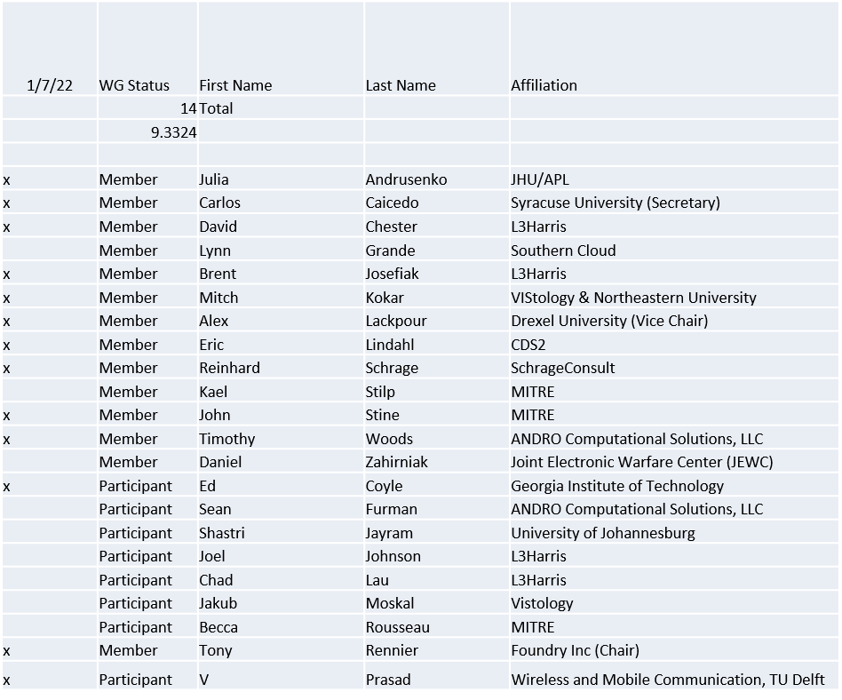

Quorum achieved

1.b. Approval of Agenda
Approval of Agenda from 5-22-0022-00

- Mover: Reinhard
Second: Ed
Vote: UC

1.c. Copyright slides
Copyright policy slides were presented. No comments came forward.

1.d. Patent slides / Notes on status
Patent related slides were presented, no issues came forward

1.e. Approval of recent minutes
Motion to approve 12/9/21 WG minutes contained in Doc #: 5-22-00022-00-mins

Postponed to next meeting

2. Status of 1900.5 Revision
- Continue to talk about User Stories
  - Uncovering issues of what should be included in the standard
  - Still working toward a unanimous or nearly unanimous agreement
  - Making progress
  - Held a general vs specific discussion on data formats and APIs in the standard
- Planning to discuss where we are now at today’s meeting
- Considering a Minimum Viable Product concept

3. Status of 1900.5.1
- Ready to show enhanced policy language based on 1900.5.1-2020
- Scheduling an ad-hoc 2/11/22 1:15pm

4. Status of 1900.5.2 Revision
- SA Ballot
  - Began 12/13/21
  - Ends 1/27/22
  - 12 approvals to Date
  - No comments received so far

5. Approval of 1900.5.2R Comment Resolution Group
A motion to approve the following membership in the 1900.5.2R Comment Resolution Group was presented.
Members: John, Kael, Carlos, Eric, Tony

Mover: John
Second: Carlos
Vote: UC

6. Review of other DySPAN-SC activities
- 2022-2023 Officer Elections completed, all officers re-elected
  - Chair – Oliver Holland
  - Vice Chair – Stephen Berger
  - Secretary – Alex Lackpour
  - Treasurer – Lynn Grande
- Potential New Projects
  - SC2 CIL Language Project is still being developed by Bob Baxley in the NSF POWDER SDR testbed. Recommend that we contact Bob in a few months once he has finished his project on leveraging the CIL in that project.
  - National Spectrum Consortium (NSC) -> NTR
- Plenary Meeting
  - Location: online virtual meeting if pandemic continues to impose expected restrictions
  - Option: End of March, first week of April 2022.
- Next leadership meeting
  - January 24th, 2022, 5pm UTC (12pm EST)
    - Leadership meeting is schedule to recur at 12pm ET throughout the year.

- 1900.1 WG report – Francesco reported
  - Next meeting on Thursday Dec 9th at 10am EST (3pm UTC)
- 1900.2 WG report – Stephen reported
  - No WG meetings planned this week.
- 1900.6 WG report – Oliver reported
  - Currently four voting members
  - P1900.6b
    - Four sessions this week
    - Goal is to complete the comments resolution and initiate the recirculation
  - 1900.6R
    - Plan to discuss mapping of use cases
- 1900.8 WG – Alex reported
  - Meeting on Tuesday at 11am EST – discussing an annotated outline for the standard with the newly appointed Technical Editor.

7. 1900.5 marketing opportunities

- NTR

8. 1900.5 meeting planning and review
- P1900.5 Revision Ad-hoc 1/7/22 1300 ET
- P1900.5 Revision Ad-hoc 1/21/22 1300 ET
- P1900.5 Revision Ad-hoc 2/5/22 1300 ET
- P1900.5 WG Mtg 2/5/221 1430 ET
- P1900.5.1 Ad-hoc 2/11/22 1315 ET
- Spring Plenary Choose between week of:
  - 3/21, 3/28 or 4/4?

9. AoB
- N/A

Meeting adjourned at 9:45 A.M. EST

