an Working Group | IEEE DYSPAN-SC 1900.5
Title | Meeting minutes 0260 for the P1900.5 Meetings of December 9, 2021
DCN | 5-22-0002-00-mins
Date Submitted | 1/5/2022
Source(s) | Carlos Caicedo (Syracuse University)  email: ccaicedo@syr.edu
Abstract | Minutes for the IEEE 1900.5 meetings held on December 9, 2021
Notice | This document has been prepared to assist the IEEE DYSPAN-SC. It is offered as a basis for discussion and is not binding on the contributing individual(s) or organization(s). The material in this document is subject to change in form and content after further study. The contributor(s) reserve(s) the right to add, amend or withdraw material contained herein.
Release | The contributor grants a free, irrevocable license to the IEEE to incorporate material contained in this contribution, and any modifications thereof, in the creation of an IEEE Standards publication; to copyright in the IEEE’s name any IEEE Standards publication even though it may include portions of this contribution; and at the IEEE’s sole discretion to permit others to reproduce in whole or in part the resulting IEEE Standards publication. The contributor also acknowledges and accepts that IEEE DYSPAN SC may make this contribution public.
Patent Policy | The contributor is familiar with IEEE patent policy, as outlined in Section 6.3 of the IEEE-SA Standards Board Operations Manual <http://standards.ieee.org/guides/opman/sect6.html#6.3> and in Understanding Patent Issues During IEEE Standards Development <http://standards.ieee.org/board/pat/guide.html>.
>.

1. Administrivia

1.a Roll Call

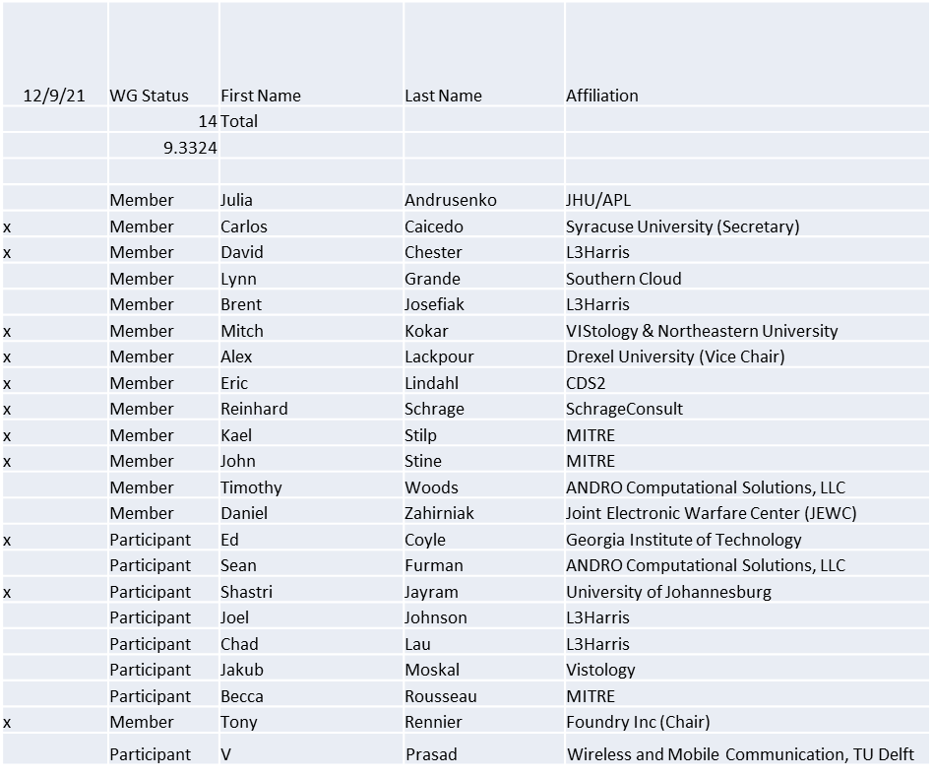

Quorum achieved

1.b. Approval of Agenda
Approval of Agenda from 5-21-0021-00

- Mover: Alex
Second: John
Vote: UC

1.c. Copyright slides
Copyright policy slides were presented. No comments came forward.

1.d. Patent slides / Notes on status
Patent related slides were presented, no issues came forward

1.e. Approval of recent minutes
Motion to approve 10/1/21 WG minutes contained in Doc #: 5-21-00023-00-mins

- Mover: Dave
Second: John
Vote: UC

Motion to approve 11/5/21 WG minutes contained in Doc #: 5-21-00024-00-mins

- Mover: John
Second: Dave
Vote: UC

2. Status of 1900.5 Revision
- Started on question of boundaries of the standard, details of interfaces and others
- Interfaces need definitions e.g. floating point format – supporting interoperability
- Write time decisions
- Discuss approaches to policy verification - human readable XML ??
- Add AI agent to list of stakeholders??

3. Status of 1900.5.1
- Had ad-hoc before today’s WG meeting
- Suggestion to take one or more business cases and show the assembler level solution
  - Should we look at Agile User story format?
- Begin consideration for a 1900.5.1 Amendment
- Still looking at grammar issues

4. Status of 1900.5.2 Revision
- Awaiting DySPAN-SC approval

5. Review of other DySPAN-SC activities
- N/A

6. 1900.5 marketing inputs

- Offer to share 1900.5.2 with DECT Forum

7. 1900.5 meeting planning and review
- DySPAN-SC Plenary 12/6/21 – 12/10/21
- P1900.5 Revision Ad-hoc 12/24/21 1300 ET
- P1900.5 WG Mtg 1/7/221 0800 ET
- Spring Plenary Choose between week of:
- 3/21, 3/28 or 4/4?

8. AoB
- N/A

Meeting adjourned at 2:25 P.M. EST

