an Working Group | IEEE DYSPAN-SC 1900.5
Title | Meeting minutes 0259 for the P1900.5 Meetings of November 5, 2021
DCN | 5-21-0024-00-mins
Date Submitted | 12/6/2021
Source(s) | Carlos Caicedo (Syracuse University)  email: ccaicedo@syr.edu
Abstract | Minutes for the IEEE 1900.5 meetings held on November 5, 2021
Notice | This document has been prepared to assist the IEEE DYSPAN-SC. It is offered as a basis for discussion and is not binding on the contributing individual(s) or organization(s). The material in this document is subject to change in form and content after further study. The contributor(s) reserve(s) the right to add, amend or withdraw material contained herein.
Release | The contributor grants a free, irrevocable license to the IEEE to incorporate material contained in this contribution, and any modifications thereof, in the creation of an IEEE Standards publication; to copyright in the IEEE’s name any IEEE Standards publication even though it may include portions of this contribution; and at the IEEE’s sole discretion to permit others to reproduce in whole or in part the resulting IEEE Standards publication. The contributor also acknowledges and accepts that IEEE DYSPAN SC may make this contribution public.
Patent Policy | The contributor is familiar with IEEE patent policy, as outlined in Section 6.3 of the IEEE-SA Standards Board Operations Manual <http://standards.ieee.org/guides/opman/sect6.html#6.3> and in Understanding Patent Issues During IEEE Standards Development <http://standards.ieee.org/board/pat/guide.html>.
>.

1. Administrivia

1.a Roll Call

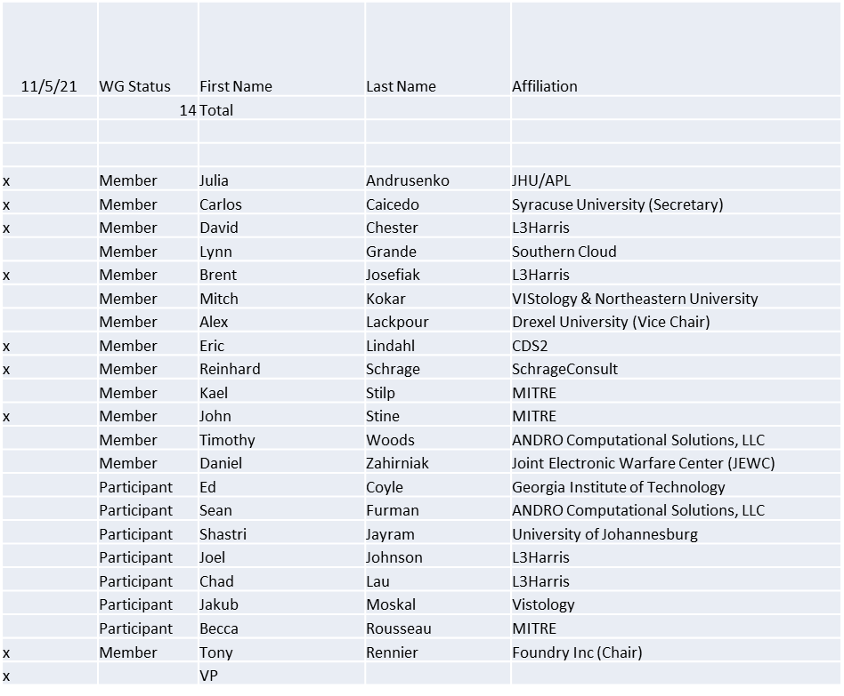

Quorum achieved

1.b. Approval of Agenda
Approval of Agenda from 5-21-0017-00

- Mover: Dave
Second: John
Vote: UC

1.c. Copyright slides
Copyright policy slides were presented. No comments came forward.

1.d. Patent slides / Notes on status
Patent related slides were presented, no issues came forward

1.e. Approval of recent minutes
Motion to approve 9/3/21 WG minutes contained in Doc #: 5-21-00016-00-mins

- Mover: Dave
Second: Carlos
Vote: UC

2. Status of 1900.5 Revision
- Users stories continued
- Considering whether a PAR mod is needed to support the open concept
- Consider Oliver’s POV

3. Status of 1900.5.1
- Preparing for Plenary
- Making progress
- Serving as a panelist for meetings addressing ML and AI ethics looking at how policy (like P1900.5.1) can be facilitating a dynamic range of permission granting and revoking “Consent Fatigue”

4. Status of 1900.5.2 Revision
- SA Ballot Invitation closed
- Awaiting new draft addressing MEC comments
- SA Ballot to begin shortly
- New draft available on Monday
- Aiming for 45 days to complete revision
- Will form Comment Resolution Group in the December WG

5. Review of other DySPAN-SC activities
- DySPAN-SC December Plenary will be virtual
  - 12/6/21 -> 12/10/21
- P1900.5 plenary scheduled
- DySPAN-SC Leadership Meeting
  - DySPAN-SC Elections for 2022 – 2023
    - Tony is planning to send the call for nomination email.
  - New Projects – No updates
    - DARPA SC2 CIL standardization
    - National Spectrum Consortium (NSC) standards
    - NTIA Incumbent Informing Capability (IIC)
  - Discussion on IEEE web/email tools
    - DySPAN-SC website
      - Oliver requested the following changes:
        - Change capitalization on DySPAN-SC banner text.
        - Add opening and closing December plenary meeting info.
        - Add link to agenda slides from previous Plenary meeting
        - Change PNP menu bar item to P&Ps and link directly to file on box.com.
      - Discussion about DySPAN-SC Logo
        - Oliver will remind Lynn to recommend a freelance graphic designer to design a DySPAN-SC logo for the website.

6. 1900.5 marketing inputs

- N/A

7. 1900.5 meeting planning and review
- 1900.5 Revision Ad- hoc 11/12/21 1300-1400 ET
- DySPAN-SC Plenary 12/6/21 – 12/10/21
  - 1900.5.1 on the 9th
  - 1900.5.2R on the 8th
    - Likely to be moved to the 7th to accommodate Carlos and others

8. AoB
- N/A

Meeting adjourned at 9:45 A.M. EST

