an Working Group | IEEE DYSPAN-SC 1900.5
Title | Meeting minutes 0258 for the P1900.5 Meetings of October 1, 2021
DCN | 5-21-0023-00-mins
Date Submitted | 12/6/2021
Source(s) | Carlos Caicedo (Syracuse University)  email: ccaicedo@syr.edu
Abstract | Minutes for the IEEE 1900.5 meetings held on October 1, 2021
Notice | This document has been prepared to assist the IEEE DYSPAN-SC. It is offered as a basis for discussion and is not binding on the contributing individual(s) or organization(s). The material in this document is subject to change in form and content after further study. The contributor(s) reserve(s) the right to add, amend or withdraw material contained herein.
Release | The contributor grants a free, irrevocable license to the IEEE to incorporate material contained in this contribution, and any modifications thereof, in the creation of an IEEE Standards publication; to copyright in the IEEE’s name any IEEE Standards publication even though it may include portions of this contribution; and at the IEEE’s sole discretion to permit others to reproduce in whole or in part the resulting IEEE Standards publication. The contributor also acknowledges and accepts that IEEE DYSPAN SC may make this contribution public.
Patent Policy | The contributor is familiar with IEEE patent policy, as outlined in Section 6.3 of the IEEE-SA Standards Board Operations Manual <http://standards.ieee.org/guides/opman/sect6.html#6.3> and in Understanding Patent Issues During IEEE Standards Development <http://standards.ieee.org/board/pat/guide.html>.
>.

1. Administrivia

1.a Roll Call

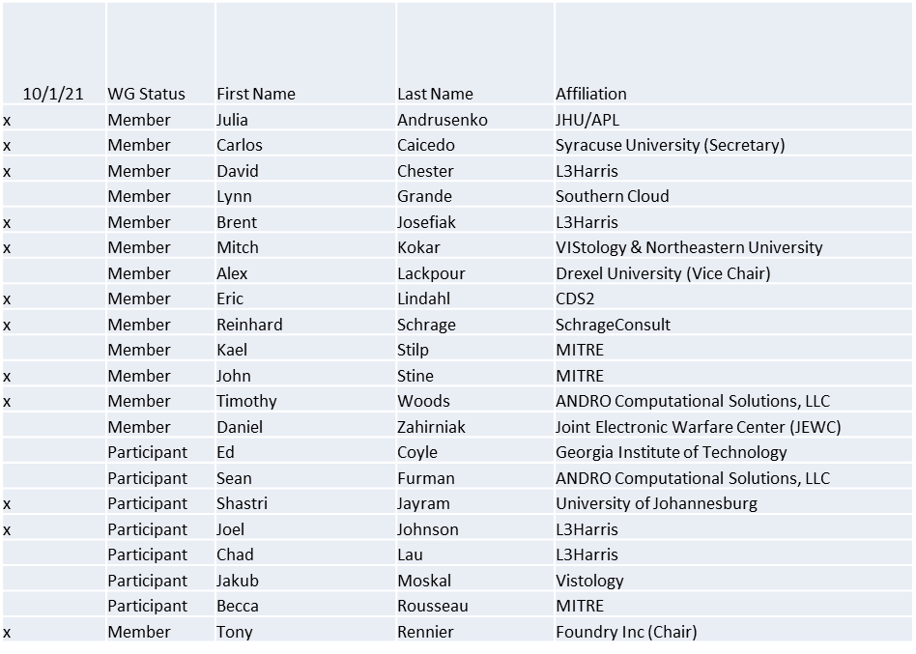

Quorum achieved

1.b. Approval of Agenda
Approval of Agenda from 5-21-0015-00

- Mover: Dave
Second: Reinhard
Vote: UC

1.c. Copyright slides
Copyright policy slides were presented. No comments came forward.

1.d. Patent slides / Notes on status
Patent related slides were presented, no issues came forward

1.e. Approval of recent minutes
Approval of 9/3/21 WG minutes contained in Doc #: 5-21-00016-00-mins deferred to next meeting.

2. Status of 1900.5 Revision
- 9/3/21
  - 8/6/21 Meeting
    - Discussed Black Box I/F
    - QoS inputs? Or Spectrum Access Inputs? -> Consensus for Both
    - Concern that leaving QoS out would be an issue
  - Next Ad-hoc Meeting 9/3/21

- 10/1/21
  - Tim suggestion to start users stories is being put to practice
  - Agreed to additional meetings in the 2 of weeks
  - iMeet was down
  - Considering a schedule for activities

3. Status of 1900.5.1
- Working on a useable and presentable version
- Scheduling an ad-hoc during Dec plenary – target 12/8/21

4. Status of 1900.5.2 Revision
- PAR actions approved by NESCOM 9/23/21
- Reinitiating SA Ballot
  - Looking to recover first ballot members

5. Review of other DySPAN-SC activities
- DySPAN-SC December Plenary will be virtual
  - 12/6/21 -> 12/10/21
- P1900.5 plenary scheduling TBD

6. 1900.5 marketing inputs

- N/A

7. 1900.5 meeting planning and review
- 1900.5 Revision Ad- hoc 10/1/21 1300-1430 ET
- 1900.5 WG 11/5/21 0800-1000 ET
- DySPAN-SC Plenary 12/6/21 – 12/10/21
  - 1900.5.1 on the 8th
  - 1900.5.2 review feedback
  - 1900.5R 1 or more

8. AoB
- DySPAN 2021 paper deadline missed this time

Meeting adjourned at 4 p.m. EDT

