an Working Group | IEEE DYSPAN-SC 1900.5
Title | Meeting minutes 0257 for the P1900.5 Meetings of September 3, 2021
DCN | 5-21-0016-00-mins
Date Submitted | 9/29/2021
Source(s) | Carlos Caicedo (Syracuse University)  email: ccaicedo@syr.edu
Abstract | Minutes for the IEEE 1900.5 meetings held on September 3, 2021
Notice | This document has been prepared to assist the IEEE DYSPAN-SC. It is offered as a basis for discussion and is not binding on the contributing individual(s) or organization(s). The material in this document is subject to change in form and content after further study. The contributor(s) reserve(s) the right to add, amend or withdraw material contained herein.
Release | The contributor grants a free, irrevocable license to the IEEE to incorporate material contained in this contribution, and any modifications thereof, in the creation of an IEEE Standards publication; to copyright in the IEEE’s name any IEEE Standards publication even though it may include portions of this contribution; and at the IEEE’s sole discretion to permit others to reproduce in whole or in part the resulting IEEE Standards publication. The contributor also acknowledges and accepts that IEEE DYSPAN SC may make this contribution public.
Patent Policy | The contributor is familiar with IEEE patent policy, as outlined in Section 6.3 of the IEEE-SA Standards Board Operations Manual <http://standards.ieee.org/guides/opman/sect6.html#6.3> and in Understanding Patent Issues During IEEE Standards Development <http://standards.ieee.org/board/pat/guide.html>.
>.

1. Administrivia

1.a Roll Call

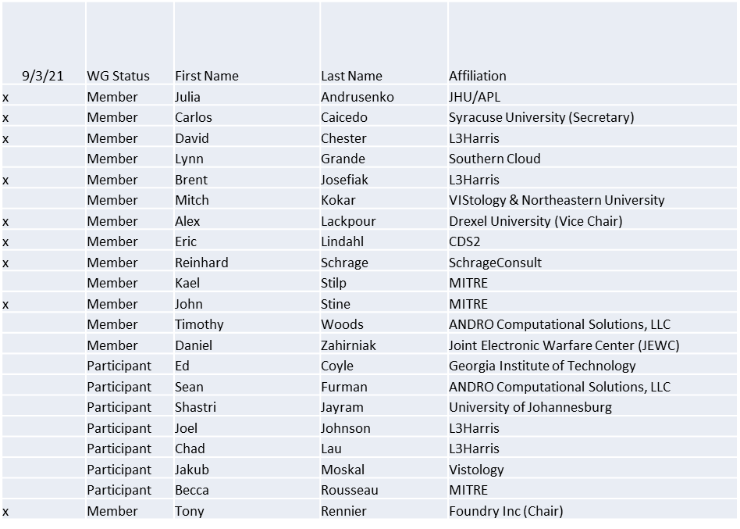

Quorum achieved

1.b. Approval of Agenda
Approval of Agenda from 5-21-0013-00

- Mover: John
Second: Reinhard
Vote: UC

1.c. Copyright slides
Copyright policy slides were presented. No comments came forward.

1.d. Patent slides / Notes on status
Patent related slides were presented, no issues came forward

1.e. Approval of recent minutes
Motion to approve 3/31/21 & 4/2/21 WG minutes contained in Doc #: 5-21-0008-00-mins
Mover: Eric
Second: Reinhard
Vote: UC

Motion to approve 5/7/21 WG minutes contained in Doc #: 5-21-0009-00-mins
Mover: Carlos
Second: Dave
Vote: UC

Motion to approve 7/16/21 WG minutes contained in Doc #: 5-21-0013-00-mins
Mover: Dave
Second: Reinhard
Vote: UC

2. Status on 1900.5a
- 7/16/21
  - PAR to be reviewed for scope in the future
  - Strawman outline from 1900.5-2011
  - Continue to populate the iMeet Wiki
  - Ad-hoc on 7/14/21
    - More details on Black-box description
    - Support for Dynamic Policy Management in addition Dynamic Spectrum Access (from P1900.5-2011)
    - Details around QoS being discussed embedded or external of the black-box
      - Dave Initiating an email discussion to explore the concept
- 9/3/21
  - 8/6/21 Meeting
    - Discussed Black Box I/F
    - QoS inputs? Or Spectrum Access Inputs? -> Consensus for Both
    - Concern that leaving QoS out would be an issue
  - Next Ad-hoc Meeting 9/3/21

3. Status of 1900.5.1
- Looking at remaining issues
- New paradigm OBDA (Ontology-Based Data Access)
  - Merges SQL DB and rule-based
- Goal – demonstration by EOCY (last DySPAN-SC meeting this year)
- Current prototype showing signs of over business (98% CPU occupancy)

4. Status on 1900.5.2a

- Waiting for PAR transition
- Responded to question from NESCOM voter on how Rx consume spectrum
- Need to ping Oliver on DySPAN-SC approval

5. Review of other DySPAN-SC activities

- December Plenary will be virtual
- Still scheduling the plenary
- Doodle Pool on Plenary voted

6. 1900.5 marketing inputs
- EMBM Acquisition (2)
  - One already awarded
  - Second is an OTA for JEMSOC
  - Internal MITRE CAPSTONE project raised awareness of 1900.5.2 in DoD
- Looking at ways to connect Spectrum Dependency Maps to SCMs
  - MITRE ARCENT Project

7. 1900.5 meeting planning and review
- 1900.5 Revision Ad- hoc 9/3/21 1300-1430 ET
- 1900.5 Revision Ad- hoc 10/1/21 1300-1430 ET
- 1900.5 WG 10/1/21 1430-1630 ET

8. AoB
- Julia has coauthored a book and mentioned P1900.5 in the bio
  - Dr. Karen Haigh Cognitive-EW
- Considering a DySPAN 2021 conference paper
  - Deadline in one month – can we agree and write down what we are planning
  - Capitalize on opportunities do more concretely say what we are doing and collect feedback

