an Working Group | IEEE DYSPAN-SC 1900.5
Title | Meeting minutes 0255 for the P1900.5 Meetings of May 7, 2021
DCN | 5-21-0009-00-mins
Date Submitted | 6/2/2021
Source(s) | Carlos Caicedo (Syracuse University)  email: ccaicedo@syr.edu
Abstract | Minutes for the IEEE 1900.5 meeting held on May 7, 2021
Notice | This document has been prepared to assist the IEEE DYSPAN-SC. It is offered as a basis for discussion and is not binding on the contributing individual(s) or organization(s). The material in this document is subject to change in form and content after further study. The contributor(s) reserve(s) the right to add, amend or withdraw material contained herein.
Release | The contributor grants a free, irrevocable license to the IEEE to incorporate material contained in this contribution, and any modifications thereof, in the creation of an IEEE Standards publication; to copyright in the IEEE’s name any IEEE Standards publication even though it may include portions of this contribution; and at the IEEE’s sole discretion to permit others to reproduce in whole or in part the resulting IEEE Standards publication. The contributor also acknowledges and accepts that IEEE DYSPAN SC may make this contribution public.
Patent Policy | The contributor is familiar with IEEE patent policy, as outlined in Section 6.3 of the IEEE-SA Standards Board Operations Manual <http://standards.ieee.org/guides/opman/sect6.html#6.3> and in Understanding Patent Issues During IEEE Standards Development <http://standards.ieee.org/board/pat/guide.html>.
>.

1. Administrivia

1.a Roll Call

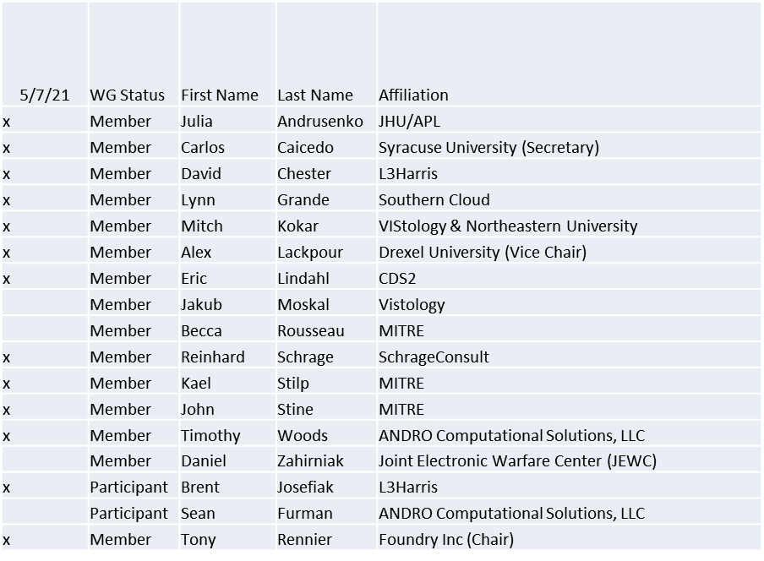
Quorum achieved

1.b. Approval of Agenda
Approval of Agenda from 5-21-0007-00

- Mover: Dave
Second: Lynn
Vote: UC

1.c. Copyright slides
Copyright policy slides were presented. No comments came forward.

1.d. Patent slides / Notes on status
Patent related slides were presented, no issues came forward

1.e. Approval of recent minutes
- Motion to approve 3/31/21 & 4/2/21 WG minutes contained in Doc #: 5-21-0008-00-mins
Postponed to next meeting

2. Status on 1900.5a
- Last ad-hoc very productive
- Focusing on PMP and giving it some detail
- Considering the meaning of a hierarchical policy sets
- Adopting a good strategy… finally
- Related presentation on Future creators given by Tim

3. Status of 1900.5.1
- Provided overview of variants
  - Still high level
- Working with 1900.5.2a draft schema
  - Creating a 1900.5.1 Ontology
  - .1 Rules will be used on .2a to develop a down to earth (and lengthy) example
- Working toward a new ad-hoc to review progress

4. Status on 1900.5.2a
- Moving to Sponsor ballot – electronic ballot passed

5. Review of other DySPAN-SC activities
- 1900.8 PAR
  - Alex will schedule an initial meeting via Doodle and send out the meeting notice. Once the P&Ps has been approved after the first meeting – Jennifer can, optionally, issue a call for participation.
- Discussion on IEEE web/email tools
  - Oliver has volunteered to update the email distribution list for DySPAN-SC.
  - Alex has volunteered to update the DySPAN-SC Wordpress website.
  - Jennifer will check and report which WGs have Wordpress website already and who is the admin.
- 1900.6 WG (Oliver reports)
  - Continued the comment resolution during the Spring Plenary session.
  - Updated the draft and will soon conduct a WG ballot on the draft.
- 1900.8 WG (Alex reports)
  - Working on scheduling the first official meeting.
- Summer Plenary planning
  - Alex action: Meeting scheduled according to UTC–2 time zone during the week of July 12th.

6. 1900.5 marketing inputs
- NSC NTR
- NTIA discussion on IIC
  - Augment ESC
  - Focus on test ranges
    - Sensor-based sharing not practical
    - More of a reservation system
- Eric meeting with NEIM on spectrum management

7. 1900.5 meeting planning and review
- 1900.5a Ad- hoc 5/14/21 1300-1500 ET
- 1900.5 WG 6/4/21 1430-1630 ET

8. AoB
None

