an Working Group | IEEE DYSPAN-SC 1900.5
Title | Meeting minutes 0254 for the P1900.5 Meetings of March 30-April 1, 2021
DCN | 5-21-0008-00-mins
Date Submitted | 5/6/2021
Source(s) | Carlos Caicedo (Syracuse University)  email: ccaicedo@syr.edu
Abstract | Minutes for the IEEE 1900.5 meetings held on March 30 and April 1, 2021
Notice | This document has been prepared to assist the IEEE DYSPAN-SC. It is offered as a basis for discussion and is not binding on the contributing individual(s) or organization(s). The material in this document is subject to change in form and content after further study. The contributor(s) reserve(s) the right to add, amend or withdraw material contained herein.
Release | The contributor grants a free, irrevocable license to the IEEE to incorporate material contained in this contribution, and any modifications thereof, in the creation of an IEEE Standards publication; to copyright in the IEEE’s name any IEEE Standards publication even though it may include portions of this contribution; and at the IEEE’s sole discretion to permit others to reproduce in whole or in part the resulting IEEE Standards publication. The contributor also acknowledges and accepts that IEEE DYSPAN SC may make this contribution public.
Patent Policy | The contributor is familiar with IEEE patent policy, as outlined in Section 6.3 of the IEEE-SA Standards Board Operations Manual <http://standards.ieee.org/guides/opman/sect6.html#6.3> and in Understanding Patent Issues During IEEE Standards Development <http://standards.ieee.org/board/pat/guide.html>.
>.

1. Administrivia

1.a Roll Call

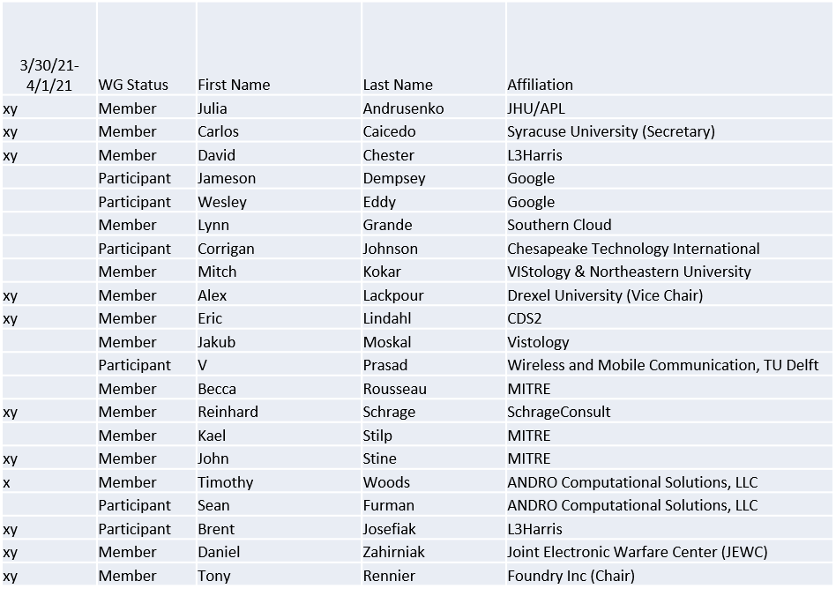
x = attendance on 3/30 Quorum achieved
y = attendance on 4/1 Quorum achieved

1.b. Approval of Agenda
Approval of Agenda from 5-21-0005-00

- Mover: Alex
Second: Carlos
Vote: UC

1.c. Copyright slides
Copyright policy slides were presented. No comments came forward.

1.d. Patent slides / Notes on status
Patent related slides were presented, no issues came forward

1.e. Approval of recent minutes
Motion to approve minutes of the March 5 / 2021 WG meeting minutes contained in Doc #: 5-21-0006-00-mins
- Mover: Alex
Second: Reinhard
Vote: UC

2. Approval of Motion for Chair to Ballot 1900.5.2a Draft
- Approval for WG Chair to ballot with editorial changes as necessary the document 5-19-0032-15 for acceptance as the 1900.5.2a WG Draft. Ballot shall be no less than minimum required calendar days.
- Mover: John
- Second: Reinhard
- Vote:
    - 8 Approve
    - 0 Disapprove
    - 0 Abstain

3. Status on 1900.5a
- 3/30/21
  - Ad-hoc at 2pm on 3/30/21
  - Revisiting P1900.5-2011 pros and cons
  - Working on requirements and black box description
- 4/1/21
  - Discuss properties of policy management and delivery
    - Including lifecycle of a policy
    - Hierarchical nature
    - Generation of mission policy, likely machine generated
  - Eric planning a reference implementation
    - Planning toward informational items for the standard
    - Addressing
      - Digital signature
      - Policy decomposability

4. Status of 1900.5.1
- Published 2/26/21
- Ad-hoc 4/8/21 at 1100 ET
- Focusing now on the practical aspects of a policy language

5. Status on 1900.5.2a
- 3/30/21
  - Posted latest version 2 weeks ago
  - Dave Chester reviewed - discussed hybrid (FH and DS) systems
  - Others are still reviewing
  - Will make an agenda item for 4/1/21 to promote the draft to WG ballot
  - Canceling the ad-hoc on 3/31/21
- 4/1/21
  - Motion to promote draft to WG ballot passed

6. Review of other DySPAN-SC activities
- Chair update:
  - New Projects
    - 1900.1 PAR
      - Francesco resolved a couple of minor comments from NesCom.
    - 1900.8 PAR
      - Alex resolved a couple of minor comments from NesCom. Now approved!
    - DARPA SC2 Language standardization
      - Possible standardization effort?
    - National Spectrum Consortium
      - No updates
    - Recommend that we have an ad hoc meeting on potential impact of DySPAN-SC on IMT2020 and other 5G standards
- Discussion on IEEE web/email tools
  - Discussion about DySPAN-SC email distribution list
    - Jennifer recommends removing emails from the SC list, as well as the WG list, if a person has not attended a meeting for one year or otherwise not responded to communication.
  - Alex to develop a basic WordPress website for DySPAN-SC prior to Spring Plenary meeting.

- WG Status Reports
  - 1900.1 WG (Francesco reports)
    - Waiting for PAR approval in late March.
  - 1900.2 WG (Stephen reports)
    - Working on draft revision – plan to share with the WG soon
  - 1900.6 WG (Oliver reports)
    - 1900.6b
      - Continuing to finalize comment resolutions.
  - 1900.8 WG (Alex reports)
    - Planning to hold an informal meeting during the Spring plenary session.
- Next Leadership meeting:
Next leadership meeting: April 26th, 2021 @ 4PM UTC (Noon EDT)

7. 1900.5 marketing inputs
- 3/30/21
  - NITA and WINNFORUM meeting mentioned by 1900.5.2
- 4/1/21
  - NSC obliquely referencing P1900.5 standard efforts
  - Alex attending NSC WG meetings on standardization
  - 3 WGs related to standards
    - Military Civilian sharing
    - Military Military
    - 5G sharing
    - Regulatory issues and topics

8. 1900.5 meeting planning and review

- 4/8/21 1100 P1900.5.1 Ad-hoc
- 4/16/21 1300 P1900.5a Ad-hoc
- 5/7/21 0800 P1900.5 WG
- 5/14/21 1300 P1900.5a Ad-hoc

9. AoB
None

