an Working Group | IEEE DYSPAN-SC 1900.5
Title | Meeting minutes 0253 for the P1900.5 Meetings of March 5, 2021
DCN | 5-21-0006-00-mins
Date Submitted | 3/29/2021
Source(s) | Carlos Caicedo (Syracuse University)  email: ccaicedo@syr.edu
Abstract | Minutes for the IEEE 1900.5 meeting held on March 5, 2021
Notice | This document has been prepared to assist the IEEE DYSPAN-SC. It is offered as a basis for discussion and is not binding on the contributing individual(s) or organization(s). The material in this document is subject to change in form and content after further study. The contributor(s) reserve(s) the right to add, amend or withdraw material contained herein.
Release | The contributor grants a free, irrevocable license to the IEEE to incorporate material contained in this contribution, and any modifications thereof, in the creation of an IEEE Standards publication; to copyright in the IEEE’s name any IEEE Standards publication even though it may include portions of this contribution; and at the IEEE’s sole discretion to permit others to reproduce in whole or in part the resulting IEEE Standards publication. The contributor also acknowledges and accepts that IEEE DYSPAN SC may make this contribution public.
Patent Policy | The contributor is familiar with IEEE patent policy, as outlined in Section 6.3 of the IEEE-SA Standards Board Operations Manual <http://standards.ieee.org/guides/opman/sect6.html#6.3> and in Understanding Patent Issues During IEEE Standards Development <http://standards.ieee.org/board/pat/guide.html>.
>.

1. Administrivia

1.a Roll Call

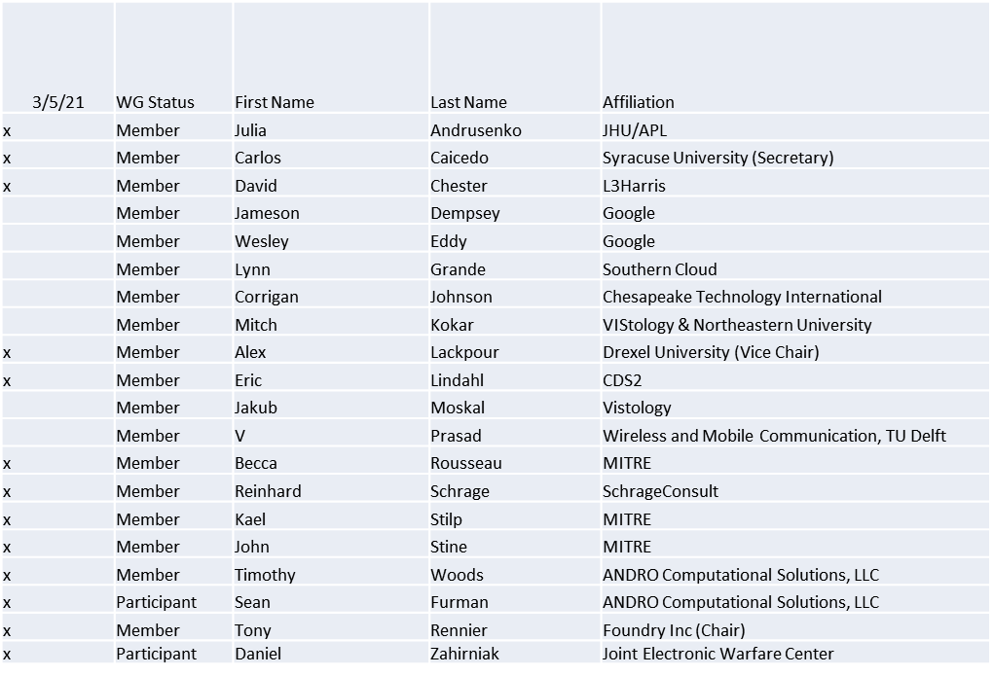

Quorum achieved

1.b. Approval of Agenda
Approval of Agenda from 5-21-0004-00

- Mover: Reinhard
Second: Carlos
Vote: UC

1.c. Copyright slides
Copyright policy slides were presented. No comments came forward.

1.d. Patent slides / Notes on status
Patent related slides were presented, no issues came forward

1.e. Approval of recent minutes
Motion to approve minutes of the February 2 / 2021 WG meeting minutes contained in Doc #: 5-21-0003-00-mins
- Mover: Reinhard
Second: John
Vote: UC

2. Status on 1900.5a
- March 5 ad-hoc:
  - Contribution from Mitch, the MLM Use case from SDRF 11 year ago, London bombing
  - Next meeting 3/19
    - Planning a discussion on requirements for the standard
    - Taking on a complex task with the goal of making a not too complex standard
    - Considering multiple architectures? Including the idea of a Meta architecture

3. Status of 1900.5.1
- Final document published P1900.5.1-2020
- Planning a Hands-on at the Plenary 3/31/21

4. Status on 1900.5.2a
- John posted latest revision on 3/4/2021
- Awaiting comments - 3/22/21 deadline
- Planning 3/31/21 ad-hoc to support comment resolution

5. Review of other DySPAN-SC activities
- Monthly Meeting Postponed until 3/8/21
- Machine Learning PAR will be P1900.8
  - First meeting in the upcoming plenary

6. 1900.5 marketing inputs
- Carlos working with a few other Universities on a Spectrum Innovation Initiative proposal
- Created a Demo on using SCMs to control SDRs

7. 1900.5 meeting planning and review

- P1900.5
  - 1900.5a Ad- hoc 3/19/21 1300-1500 ET
  - 1900.5 WG Plenary Opening Session 3/30/21 0900-1030 ET
  - 1900.5.1 Ad-hoc 3/31/21 1200-1330 ET*
  - 1900.5a Ad-hoc 3/30/21 1400-1530 ET
  - 1900.5.2a Ad-hoc 3/31/21 1400 ET
  - 1900.5 WG Plenary Closing Session 4/1/21 0900-1030 ET
8. AoB
None

Meeting adjourns at 9:55 a.m. EST

