an Working Group | IEEE DYSPAN-SC 1900.5
Title | Meeting minutes 0252 for the P1900.5 Meetings of February 12, 2021
DCN | 5-21-0003-00-mins
Date Submitted | 3/3/2021
Source(s) | Carlos Caicedo (Syracuse University)  email: ccaicedo@syr.edu
Abstract | Minutes for the IEEE 1900.5 meeting held on February 12, 2021
Notice | This document has been prepared to assist the IEEE DYSPAN-SC. It is offered as a basis for discussion and is not binding on the contributing individual(s) or organization(s). The material in this document is subject to change in form and content after further study. The contributor(s) reserve(s) the right to add, amend or withdraw material contained herein.
Release | The contributor grants a free, irrevocable license to the IEEE to incorporate material contained in this contribution, and any modifications thereof, in the creation of an IEEE Standards publication; to copyright in the IEEE’s name any IEEE Standards publication even though it may include portions of this contribution; and at the IEEE’s sole discretion to permit others to reproduce in whole or in part the resulting IEEE Standards publication. The contributor also acknowledges and accepts that IEEE DYSPAN SC may make this contribution public.
Patent Policy | The contributor is familiar with IEEE patent policy, as outlined in Section 6.3 of the IEEE-SA Standards Board Operations Manual <http://standards.ieee.org/guides/opman/sect6.html#6.3> and in Understanding Patent Issues During IEEE Standards Development <http://standards.ieee.org/board/pat/guide.html>.
>.

1. Administrivia

1.a Roll Call
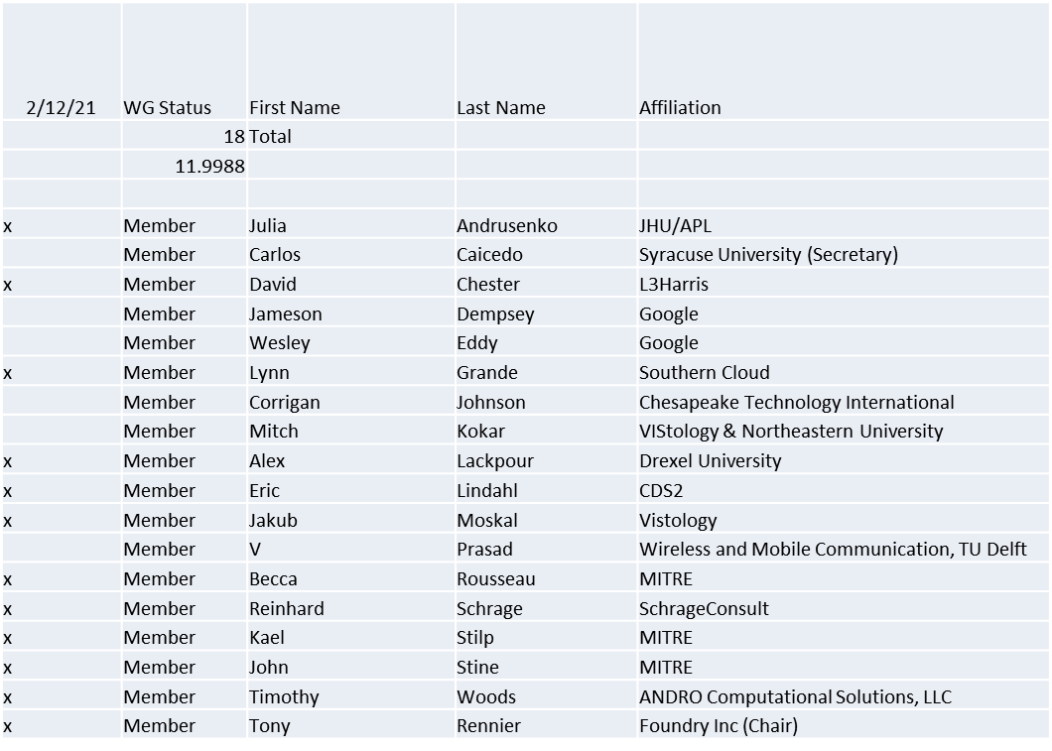
Quorum achieved

1.b. Approval of Agenda
Approval of Agenda from 5-21-0002-00

- Mover: Reinhard
Second: John
Vote: UC

1.c. Copyright slides
Copyright policy slides were presented. No comments came forward.

1.d. Patent slides / Notes on status
Patent related slides were presented, no issues came forward

1.e. Approval of recent minutes
Motion to approve minutes of the December 15-17 / 2020 WG meeting minutes contained in Doc #: 5-21-0001-00-mins
- Mover: John
Second: Lynn
Vote: UC

2. Status on 1900.5a
- Continue to have ad-hocs – Andy from ANDRO last week
- ANDRO (Tim and Sean) today – XACML (Mitch) next week
- Will begin recording ad-hocs

3. Status of 1900.5.1
- Issues with reference implementation discovered
- Working toward an ad-hoc on the UI
- IEEE publications/editorials reviewed the approved draft 1900.5.1
  - All issues agreed
  - Will distribute final document to WG

4. Status on 1900.5.2a
- Ad-hoc yesterday
- Final changes will be posted this weekend
- Many presentations well received in US DoD

5. Review of other DySPAN-SC activities
- AudCom revised P&Ps for 2021
  - If P&Ps are submitted before March 1st, can use either 2017 or 2020 baseline P&Ps
  - Any P&Ps submitted after March 1st will use the 2021 baseline P&Ps
  - Current DySPAN-SC P&Ps will expire in 2022
  - Stephen and Lynn recommended that we wait until to update
  - Oliver agrees and will notify Jennifer that DySPAN-SC will wait until 2022 to update our P&Ps
- New Projects
  - 1900.1 PAR
    - Francesco already submitted the PAR via IEEE MyProject’s web form
  - Machine Learned Spectrum Awareness (MLSA) PAR
    - Alex action: Need to submit MLSA PAR via MyProjects web form by Feb 12th
      - This will allow it to be voted on in March meeting by NesCom

- DySPAN-SC Chair update (cont):
  - Discussion about possible impact of DySPAN-SC on IMT2020
    - Stephen has been working on presentation to FCC on this topic
    - IEEE’s Future Network’s International Network Generations Roadmap (INGR) does not currently address DSA/spectrum sharing or the semantic web.
      - https://futurenetworks.ieee.org/roadmap
    - IMT2020
      - Addresses 5G commercial technologies
      - 3GPP is the dominant standard organization for 5G
        - DSA/Sharing could enable 5G high data rates using low and mid-band frequencies through dynamic carrier aggregation and horizontal (peer) and vertical (incumbent) sharing techniques.
        - MULTEFIRE is an example of 3GPP proposing to share with unlicensed bands that contain Wi-Fi
    - The DECT forum has developed a 5G unlicensed standard. There is also a separate standard for 5G SATCOM.
      - Its possible that DySPAN-SC may have a larger impact in the non-3GPP technologies and supporting standards.
      - ETSI - Webinars on interplay between unlicensed and licensed bands and standards
    - Recommend that we have an ad hoc meeting on potential impact of DySPAN-SC on IMT2020 and other 5G standards
  - Discussion on IEEE web/email tools
    - IEEE Mentor is becoming less functional over time, aside from the document repository
    - Jennifer has requested a new WordPress website for DySPAN-SC
    - Oliver recommends that we continue using Mentor for document control because it has better management features than iMeet. There is a concern about non-reputability and non-indelibility with iMeet.

- WG Status Reports
  - 1900.1 WG (Francesco reports)
    - PAR has been submitted via MyProjects for next NesCom meeting in March
    - Plan to hold next WG meeting after NesCom approves the PAR
  - 1900.2 WG (Stephen reports)
    - No updates
  - 1900.6 WG (Oliver reports)
    - 1900.6b - Continuing to finalize comment resolutions – five comments remain
- Discussion on new projects
  - DARPA SC2 Language standardization
    - No updates
  - National Spectrum Consortium
    - No updates
- Next Leadership meeting:
  - Skipping March 22nd leadership meeting because Spring Plenary is following week
  - Next leadership meeting: April 26th, 2021

6. 1900.5 marketing inputs
- N/A

7. 1900.5 meeting planning and review

- P1900.5
  - 1900.5a Ad- hoc 2/12/21 10:00-11:30 EST
  - 1900.5a Ad- hoc 2/19/21 13:30-15:00 EST
  - 1900.5 WG 3/5/21 8:00-9:30 EST
- DySPAN Plenary
  - Meeting scheduled according to UTC–2 time zone
    - Therefore: 9am UTC-2 is 7am EST
  - Oliver’s recommended opening/closing meetings:
    - Opening plenary: 1PM UTC-2 on Tuesday, March 30th
    - Closing plenary: 1PM UTC-2 on Thursday, April 1st

