an Working Group | IEEE DYSPAN-SC 1900.5
Title | Meeting minutes 0251 for the P1900.5 Meetings of December 15-17, 2020
DCN | 5-21-0001-00-mins
Date Submitted | 2/2/2021
Source(s) | Carlos Caicedo (Syracuse University)  email: ccaicedo@syr.edu
Abstract | Minutes for the IEEE 1900.5 meetings held on December 15-17, 2020
Notice | This document has been prepared to assist the IEEE DYSPAN-SC. It is offered as a basis for discussion and is not binding on the contributing individual(s) or organization(s). The material in this document is subject to change in form and content after further study. The contributor(s) reserve(s) the right to add, amend or withdraw material contained herein.
Release | The contributor grants a free, irrevocable license to the IEEE to incorporate material contained in this contribution, and any modifications thereof, in the creation of an IEEE Standards publication; to copyright in the IEEE’s name any IEEE Standards publication even though it may include portions of this contribution; and at the IEEE’s sole discretion to permit others to reproduce in whole or in part the resulting IEEE Standards publication. The contributor also acknowledges and accepts that IEEE DYSPAN SC may make this contribution public.
Patent Policy | The contributor is familiar with IEEE patent policy, as outlined in Section 6.3 of the IEEE-SA Standards Board Operations Manual <http://standards.ieee.org/guides/opman/sect6.html#6.3> and in Understanding Patent Issues During IEEE Standards Development <http://standards.ieee.org/board/pat/guide.html>.
>.

1. Administrivia

1.a Roll Call
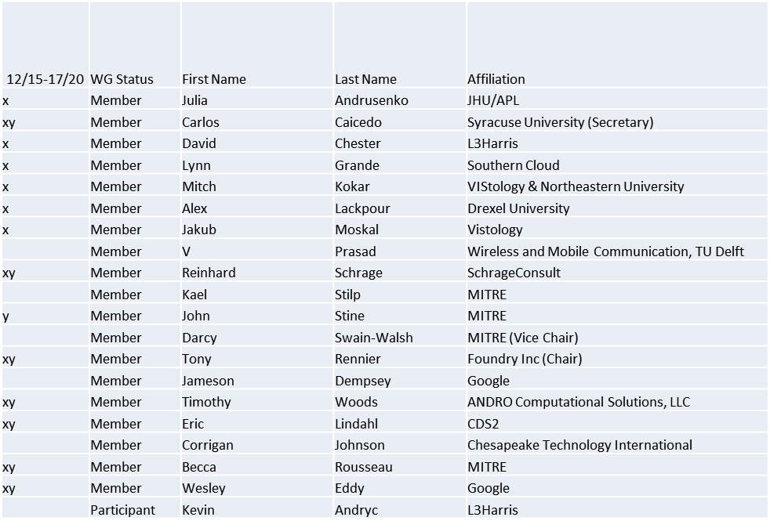
x = attendance on 12/15
y = attendance on 12/17
Quorum achieved on 12/15
No Quorum achieved on 12/17

1.b. Approval of Agenda
Approval of Agenda from 5-20-0034-00

- Mover: Dave
Second: Carlos
Vote: UC

1.c. Copyright slides
Copyright policy slides were presented. No comments came forward.

1.d. Patent slides / Notes on status
Patent related slides were presented, no issues came forward

1.e. Approval of recent minutes
Motion to approve 10/2/20 WG meeting minutes contained in Doc #: 5-20-0035-00-mins
- Mover: Reinhard
Second: Dave
Vote: UC

Motion to approve 11/6/20 WG meeting minutes contained in Doc #: 5-20-0036-00-mins
- Mover: Dave
Second: Reinhard
Vote: UC

1.f. iMeet discussion
- All WG members have been invited and accepted
- Alex brought up some questions on how e-mail notices are sent by iMeet.

1.g. Election Chair report
The P1900.5 Working Group officers for the calendar years 2021 and 2022 term are as follows:
- Chair – Tony Rennier
- Vice Chair – Alex Lackpour
- Secretary -- Carlos Caicedo

2. Status on 1900.5a
- Ad-hoc scheduled at 2 p.m. on 12/15/20
- Looking at Use Cases
  - Addressing the hierarchical scheme Tim and Wes reported on
- Returning to the question of document structure in January
- From past ad-hoc
  - Will author capabilities statements
  - Continue to discuss Alex’s list of hard questions

3. Status of 1900.5.1
- Draft Standard Policy Language for Dynamic Spectrum Access Systems was approved on 12/2/20 by RevCom
- Working on a more comfortable interface for policy language in the future
- Current reference implementation sometimes crashes computer (Reinhard)
- Will discuss next steps in ad-hoc
  - Will schedule ad-hoc to review reference implementation

4. Status on 1900.5.2a
- Kael is continuing on the schema
- Becca working on verification rules
  - Addressing options modeling
- Few more changes to vote on the latest draft Feb

5. Review of other DySPAN-SC activities
- Notes from the 11/30/20 Leadership meeting
  - 1900.1 WG (Francesco reports)
    - Next SG meeting is scheduled for early December.
    - Goal is to create a draft PAR by end of 2020 and submit it in early January.
  - 1900.2 WG (Stephen reports)
    - No response yet to request for comments on 1900.2 revision.
    - Stephen recommends a minimal revision and update to the standard.
    - Attendees to the first 1900.2 meeting in 2019 are automatically members of the WG. Other members can be added as requested.
  - 1900.6 WG (Oliver reports)
    - 1900.6b
      - Continuing to finalize comment resolutions – five comments remain
      - Hope to complete resolution before mid-December meeting
    - 1900.6
      - NesCom is likely to approve the PAR extension this week.

- Discussion on new projects
  - DARPA SC2 Language standardization
    - No updates
  - DySPAN Study Group on Machine Learning for DSA Radio Networks
    - Discussion of draft PAR on Machine Learned Spectrum Awareness
      - Oliver recommended that “member” be added to the list of participants.
      - Oliver recommended extending the duration to take the full four years granted for IEEE standards development. No penalty if the WG finishes earlier and avoids asking for an extension until the four year expires.
  - National Spectrum Consortium
    - No updates

- Next Leadership meeting:
  - January 25th at 14:00 UTC. Oliver will finalize via email.

6. 1900.5 marketing inputs
- Possible discussions in the NSC meeting this week

7. 1900.5 meeting planning and review
- WG meetings
  - 2/5/21 2pm EDT
  - 3/5/21 8am EDT
- 1900.5a Ad-hoc
  - 1/22/21 1pm EDT
  - 2/19/21 1pm EDT

Meeting adjourns at 10:30 a.m. EST

