an Working Group | IEEE DYSPAN-SC 1900.5
Title | Meeting minutes 0250 for the P1900.5 Meetings of – November 6, 2020
DCN | 5-20-0036-00-mins
Date Submitted | 12/13/2020
Source(s) | Carlos Caicedo (Syracuse University)  email: ccaicedo@syr.edu
Abstract | Minutes for the IEEE 1900.5 meetings held on November 6, 2020
Notice | This document has been prepared to assist the IEEE DYSPAN-SC. It is offered as a basis for discussion and is not binding on the contributing individual(s) or organization(s). The material in this document is subject to change in form and content after further study. The contributor(s) reserve(s) the right to add, amend or withdraw material contained herein.
Release | The contributor grants a free, irrevocable license to the IEEE to incorporate material contained in this contribution, and any modifications thereof, in the creation of an IEEE Standards publication; to copyright in the IEEE’s name any IEEE Standards publication even though it may include portions of this contribution; and at the IEEE’s sole discretion to permit others to reproduce in whole or in part the resulting IEEE Standards publication. The contributor also acknowledges and accepts that IEEE DYSPAN SC may make this contribution public.
Patent Policy | The contributor is familiar with IEEE patent policy, as outlined in Section 6.3 of the IEEE-SA Standards Board Operations Manual <http://standards.ieee.org/guides/opman/sect6.html#6.3> and in Understanding Patent Issues During IEEE Standards Development <http://standards.ieee.org/board/pat/guide.html>.
>.

1. Administrivia

1.a Roll Call

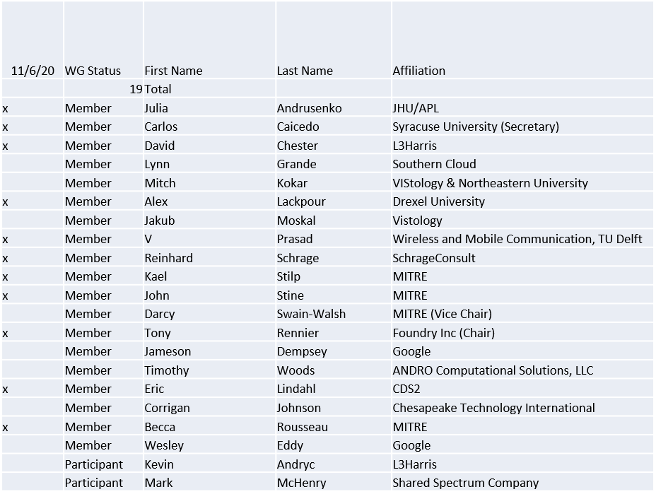

Quorum was achieved

1.b. Approval of Agenda

Approval of Agenda from 5-20-0033-00

- Mover: John
Second: Dave
Vote: UC

1.c. Copyright slides
Copyright policy slides were presented. No comments came forward.

1.d. Patent slides / Notes on status
Patent related slides were presented, no issues came forward

1.e. Approval of recent minutes
Motion to approve 9/4/20 WG meeting minutes contained in Doc #: 5-20-0031-00-mins
- Mover: Dave
Second: Carlos
Vote: UC

- Approval of 10/2/20 WG minutes was postponed to next session

1.f. iMeet discussion
- All WG members have been invited and accepted
- Discussion on how to leverage for WG items took place. Verification that iMeet can support document versioning will be conducted by Tony and Alex.

1.g. Election Chair report
  - Nominations closing 11/6/2020
  - Will send notices to nominees
  - Dave did not nominate anyone
  - Vice Chair and Secretary two nominations shared
  - Two weeks for nominees to respond (Deadline: 11/20/20)

2. Status on 1900.5a
- Ad-hoc schedule for Nov? Suggestion to move to the 11/20/20 10am EDT
- Contribution Spectrum Highways reviewed in the last ad-hoc 10/30/20

3. Status of 1900.5.1
- Project IEEE P1900.5.1 Standard Policy Language for Dynamic Spectrum Access Systems has been assigned to a RevCom agenda 02 Dec 2020 - vote is 1-0 (yes-no) – 12 members
- Request for PAR extension to be considered at the 2 Dec 2020 NesCom meeting – vote is 6-0 (yes-no) – 13 members
- Reference implementation of 1900.5.1
  - Has integrated JAVA and C++ into solution
  - New OWL API release integrated
  - 10/2/20 great progress ad-hoc desired Dec plenary
- Coming soon (year end) a more accessible interface
- Reviewing a paper from Oxford CL that aligns well with the approach taken in 1900.5.1 on rules vs ontology reasoning

4. Status on 1900.5.2a
- Awaiting update XML schema
- Tentative end of year to start ballot process

5. Review of other DySPAN-SC activities
- Updates from 10/26/20 meeting
  - 1900.6 WG (Oliver reports)
    - Continuing to address collected comments on 1900.6b draft.
    - Plan to resolve remaining comments by next meeting.

- Discussion on new projects
  - DARPA SC2 Language standardization
    - No new information has been published about the NTIA’s Incumbent Informing capability. This capability could ultimately benefit from standardizing messages used for incumbent protection in the DARPA SC2 CIRN Interaction Language (CIL).
  - DySPAN Study Group on Machine Learning for DSA Radio Networks
    - Continuing to discuss RF emission classification use cases and how to standardize the creation of appropriate ML model training data that generalizes to operational scenarios.
    - Oct 26th meeting included contributions from NIST (Raied Caromi) on his radar waveform simulation and detector and imec (Belgian consortium) on their ML techniques for radio protocol classification.
    - Next meeting is Nov 9th at 10am EST
  - National Spectrum Consortium
    - Discussion about the upcoming NSC internal meeting about creating working groups to standardize spectrum sharing technology on Nov 2nd
    - Tim Woods and Mitch Kokar might be current members of the NSC. Tony will ask if they need any support representing DySPAN-SC standards with the new NSC standardization WGs.

- Next Leadership meeting:
  - November 23rd at 14:00 UTC

6. 1900.5 marketing inputs

- SCMs proposed for DSA in a NSF Spectrum Innovation Initiative Program

7. 1900.5 meeting planning and review

- Cancel/remove WG meeting planned for 12/4/2020 and just meet during the December plenary session

- DySPAN Plenary
  - December 2020 Plenary session
    - Location: Larnaca/Nicosia, Cyprus (Likely to be moved online due to the pandemic)
    - Dates: Dec 15th - 17th – 1900.5.1 Ad-hoc
  - Late-March/early-April 2021 Plenary session
    - Larnaca/Nicosia, Cyprus, if the December meeting is held online

Meeting adjourns at 8:55 a.m. EST

