an Working Group | IEEE DYSPAN-SC 1900.5
Title | Meeting minutes 0249 for the P1900.5 Meetings of – October 2, 2020
DCN | 5-20-0035-00-mins
Date Submitted | 12/12/2020
Source(s) | Carlos Caicedo (Syracuse University)  email: ccaicedo@syr.edu
Abstract | Minutes for the IEEE 1900.5 meetings held on October 2, 2020
Notice | This document has been prepared to assist the IEEE DYSPAN-SC. It is offered as a basis for discussion and is not binding on the contributing individual(s) or organization(s). The material in this document is subject to change in form and content after further study. The contributor(s) reserve(s) the right to add, amend or withdraw material contained herein.
Release | The contributor grants a free, irrevocable license to the IEEE to incorporate material contained in this contribution, and any modifications thereof, in the creation of an IEEE Standards publication; to copyright in the IEEE’s name any IEEE Standards publication even though it may include portions of this contribution; and at the IEEE’s sole discretion to permit others to reproduce in whole or in part the resulting IEEE Standards publication. The contributor also acknowledges and accepts that IEEE DYSPAN SC may make this contribution public.
Patent Policy | The contributor is familiar with IEEE patent policy, as outlined in Section 6.3 of the IEEE-SA Standards Board Operations Manual <http://standards.ieee.org/guides/opman/sect6.html#6.3> and in Understanding Patent Issues During IEEE Standards Development <http://standards.ieee.org/board/pat/guide.html>.
>.

1. Administrivia

1.a Roll Call

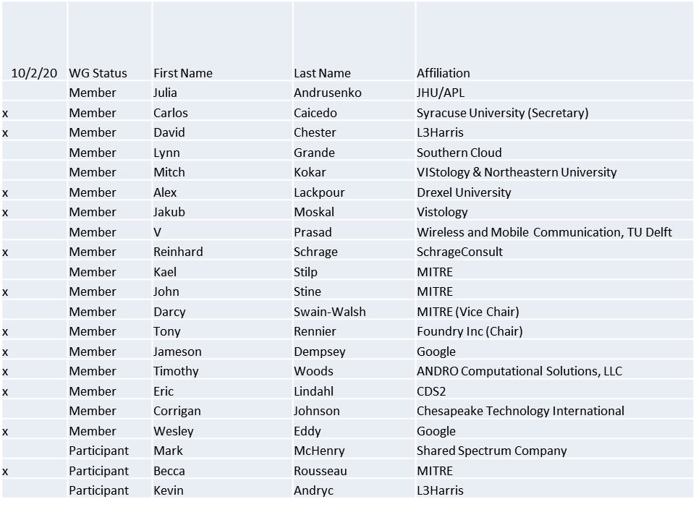

Quorum was achieved

1.b. Approval of Agenda

Approval of Agenda from 5-20-0030-00

- Mover: Reinhard
Second: Carlos
Vote: UC

1.c. Copyright slides
Copyright policy slides were presented. No comments came forward.

1.d. Patent slides / Notes on status
Patent related slides were presented, no issues came forward

1.e. Approval of recent minutes
Motion to approve 9/4/20 WG meeting minutes contained in Doc #: 5-20-0031-00-mins
- Postponed to give more time for review

2. Status on 1900.5a
- Held meeting 10/2/20 1pm EDT
- Exploring the hierarchical nature of system, network, and device policies
- Meeting planned with 1900.4 Chair 10/6/20 08:30 EDT

3. Status of 1900.5.1
- Schedule
  - Sponsor Recirc - 8/20 √
  - Project IEEE P1900.5.1 Standard Policy Language for Dynamic Spectrum Access Systems has been assigned to a RevCom agenda 02 Dec 2020
- Suggestion from DySPAN to put in for a PAR extension
  - Checking with IEEE…
- Reference implementation of 1900.5.1
  - Has integrated JAVA and C++ into solution
  - New OWL API release integrated
  - 10/2/20 great progress ad-hoc desired Dec plenary
- Coming soon (year end) a more accessible interface

Recirculation comment related to content in page 28 of draft was resolved

4. Status on 1900.5.2a
- Schema expected Nov 6 meeting Ad-hoc
- Looking at RADAR exemplar

5. Review of other DySPAN-SC activities
- Updates from 9/28/20 meeting
  - 1900.1 WG (Francesco reports)
    - Meeting on Sept 29th to discuss feasibility of refining cognitive and machine learning terms in the context of DSA radio networking in a 1900.1 revision.
    - We will discuss Dave Chester’s (1900.5) contribution on cognitive radio networks and its impact to the 1900.1 PAR.
  - 1900.2 WG (Stephen reports)
    - A minimal revision is possible – focus would be on revising its references.
    - 1900.2 is actively being used and it is serving its purpose – there is no known request for a revision.
  - 1900.6 WG (Oliver reports)
    - Addressing comments - final ten comments remain
    - Plan to recirculate draft by mid-December Plenary meeting

- Discussion on new projects
  - DARPA SC2 Language standardization
    - NTIA recently announced their plan to study the feasibility of an Incumbent Informing capability for Federal systems. This capability is intended to complement, or replace, spectrum sensing and monitoring capabilities for secondary DSA radio networks.
  - DySPAN Study Group on Machine Learning for DSA Radio Networks
    - Currently evaluating a variety of use cases for applying ML to DSA radio networks.
    - Planning to discuss the value of RF Scene Analysis at the next meeting on Oct 12th
    - Invited participation from L3Harris, Lockheed Martin, and Microsoft.
  - National Spectrum Consortium
    - No updates
- Next Leadership meeting:
  - Oct 26th at 14:00 UTC

6. 1900.5 marketing inputs

- A recent RFI from DoD on Defense Spectrum Sharing was released a few days ago:
  - https://beta.sam.gov/opp/4851a65e2b2d4d73865a0e9865b0c28a/view?keywords=spectrum&sort=-modifiedDate&index=&is_active=true&page=1
  - Should 1900.5 respond? I think this is a nice opportunity to promote SCMs, especially when addressing questions 3.C and 3.L and maybe 3.E and 3.I
  - Or maybe MITRE and others are already set to respond and include SCMs in their responses?
- Spectrum Highways document from MITRE is publicly released
  - Spectrum highways are fully defined using the IEEE Standard 1900.5.2a. The architecture is different than most of what has been described in 1900.5a but it provides an approach that will deliver on all of what you want to accomplish in that new standard. It would be a great piece of work to point to in a response to the DoD RFI and could be a future 1900.5 standard.

7. 1900.5 meeting planning and review

- 11/6/20 1900.5 WG 8:00 -10:00 EDT
- DySPAN Plenary
  - December 2020 Plenary session
  - Location: Larnaca/Nicosia, Cyprus (Likely to be moved online due to the pandemic)
  - Dates: Dec 15th - 17th – 1900.5.1 Ad-hoc
- Late-March/early-April 2021 Plenary session
  - Larnaca/Nicosia, Cyprus, if the December meeting is held online

