an Working Group | IEEE DYSPAN-SC 1900.5
Title | Meeting minutes 0248 for the P1900.5 Meetings of – September 4, 2020
DCN | 5-20-0031-00-mins
Date Submitted | 10/1/2020
Source(s) | Carlos Caicedo (Syracuse University)  email: ccaicedo@syr.edu
Abstract | Minutes for the IEEE 1900.5 meetings held on September 4, 2020
Notice | This document has been prepared to assist the IEEE DYSPAN-SC. It is offered as a basis for discussion and is not binding on the contributing individual(s) or organization(s). The material in this document is subject to change in form and content after further study. The contributor(s) reserve(s) the right to add, amend or withdraw material contained herein.
Release | The contributor grants a free, irrevocable license to the IEEE to incorporate material contained in this contribution, and any modifications thereof, in the creation of an IEEE Standards publication; to copyright in the IEEE’s name any IEEE Standards publication even though it may include portions of this contribution; and at the IEEE’s sole discretion to permit others to reproduce in whole or in part the resulting IEEE Standards publication. The contributor also acknowledges and accepts that IEEE DYSPAN SC may make this contribution public.
Patent Policy | The contributor is familiar with IEEE patent policy, as outlined in Section 6.3 of the IEEE-SA Standards Board Operations Manual <http://standards.ieee.org/guides/opman/sect6.html#6.3> and in Understanding Patent Issues During IEEE Standards Development <http://standards.ieee.org/board/pat/guide.html>.
>.

1. Administrivia

1.a Roll Call

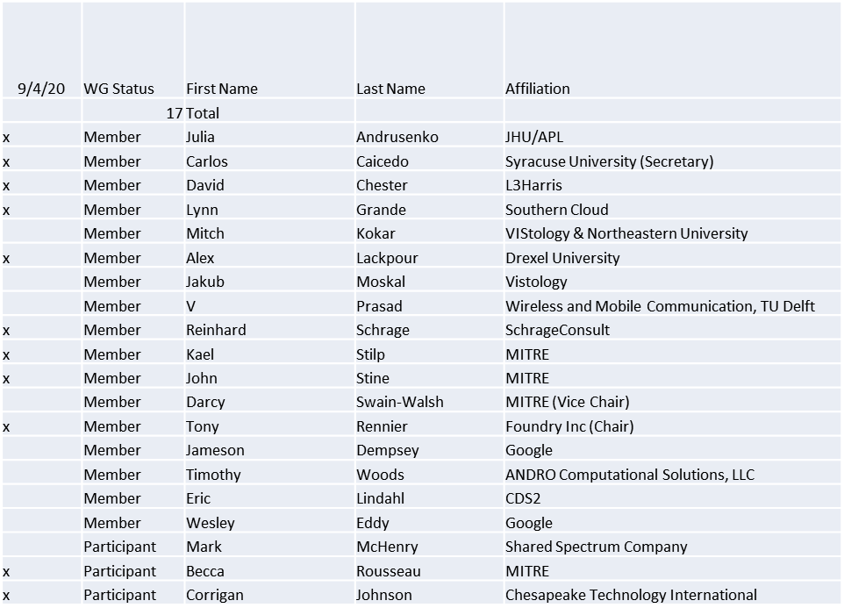

Quorum was achieved

1.b. Approval of Agenda

Approval of Agenda from 5-20-0029-00

- Mover: Reinhard
Second: Lynn
Vote: UC

1.c. Copyright slides
Copyright policy slides were presented. No comments came forward.

1.d. Patent slides / Notes on status
Patent related slides were presented, no issues came forward

1.e. Approval of recent minutes
Motion to approve 7/21-23/2020 WG meeting minutes contained in Doc #: 5-20-0028-00-mins
- Mover: Reinhard
Second: Carlos
Vote: UC

2. Status on 1900.5a
- Looking at overlap with 1900.4
  - Investigate moving .4 into .5
- Very productive ad-hocs
  - Several contributions (Loon and Andro)
  - Explore hierarchical policy structure (radio/node, network levels, regulatory)
  - Use Cases under study - CBRS, Tactical, Loon global mobile network
- Need to clear up meeting schedule

3. Status of 1900.5.1
- CRG submitted sponsor ballot response to WG
- WG approved sponsor ballot response by email ballot
  - Voting occurred 7/29/20 until 8/13/20
  - 17 members, 14 approve, 3 no response
  - 14/17 = 82.35% > 66% required
- Sponsor ballot recirculation began 8/28/20
- Schedule
  - Sponsor Recirc - 8/20 √
  - Sponsor Recirc 2 - 9/20 – if needed
  - Submit to REVCOM – NLT 13 Oct 2020

4. Status on 1900.5.2a
- Ad-hoc after meeting to discuss additional changes

5. Review of other DySPAN-SC activities
- Updates from 8/24/20 meeting
  - 1900.1 WG (Alex reports)
    - Alex forwarded a 1900.5a contribution from Dave Chester on theory of operation of cognitive and Intelligent radio networks to 1900.1 participants for consideration of inclusion.
    - Meeting planned for 9/10/20 1200 EDT
  - 1900.2 WG (Sent apologies)
    - Tony reports that it is possible that NIST will have a contribution when the WG resumes activity.
  - Restarting 1900.4 WG
    - Oliver will finalize the adaptation of 1900.4 WG as an individual-based WG vs. entity-based
    - Current chair/members wants to transition to new participants.
  - 1900.6 WG (Oliver reports)
    - 1900.6b: Continued resolution of comments

- Machine Learning standardization Study Group
  - Met three times, next meeting is scheduled for Sept 14th, 14:00 UTC
  - Selected a SG Secretary: Immanuel Freedman
  - Created iMeet workspace and reflector mailing list
  - Status:
    - Identified a high value use case for incumbent radar detection required for the CBRS band’s Environmental Sensing Capability (ESC).
      - Jesse Caulfield is motivated in standardizing the use of ML for this use case to reduce his company’s operating costs through commodification of ML technology.
    - Reviewing ITU’s recently completed focus group of applying ML to IMT2020 networks and beyond.
      - ITU developed a reference architecture for automating the creation and management of ML pipelines within 5G networks based on operator’s “ML intent”.
      - Next, get participation from other stake holders for applying ML to the CBRS band use case (specifically NIST and other ESC developers)
      - We also want to explore the viability of adding a second use case that includes a Reinforcement Learning agent for making control decisions within the cognitive controller of a DSA radio network.
  - Recommendation – review the IEEE’s 5 Criteria for feasibility

6. 1900.5 marketing inputs

- N/A

7. 1900.5 meeting planning and review

- 10/2/20 1900.5 WG 14:30 -16:00 EDT

