an Working Group | IEEE DYSPAN-SC 1900.5
Title | Meeting minutes 0247 for the P1900.5 Meetings of – July 21-23, 2020
DCN | 5-20-0028-00-mins
Date Submitted | 9/2/2020
Source(s) | Carlos Caicedo (Syracuse University)  email: ccaicedo@syr.edu
Abstract | Minutes for the IEEE 1900.5 meetings held on July 21-23, 2020
Notice | This document has been prepared to assist the IEEE DYSPAN-SC. It is offered as a basis for discussion and is not binding on the contributing individual(s) or organization(s). The material in this document is subject to change in form and content after further study. The contributor(s) reserve(s) the right to add, amend or withdraw material contained herein.
Release | The contributor grants a free, irrevocable license to the IEEE to incorporate material contained in this contribution, and any modifications thereof, in the creation of an IEEE Standards publication; to copyright in the IEEE’s name any IEEE Standards publication even though it may include portions of this contribution; and at the IEEE’s sole discretion to permit others to reproduce in whole or in part the resulting IEEE Standards publication. The contributor also acknowledges and accepts that IEEE DYSPAN SC may make this contribution public.
Patent Policy | The contributor is familiar with IEEE patent policy, as outlined in Section 6.3 of the IEEE-SA Standards Board Operations Manual <http://standards.ieee.org/guides/opman/sect6.html#6.3> and in Understanding Patent Issues During IEEE Standards Development <http://standards.ieee.org/board/pat/guide.html>.
>.

1. Administrivia

1.a Roll Call

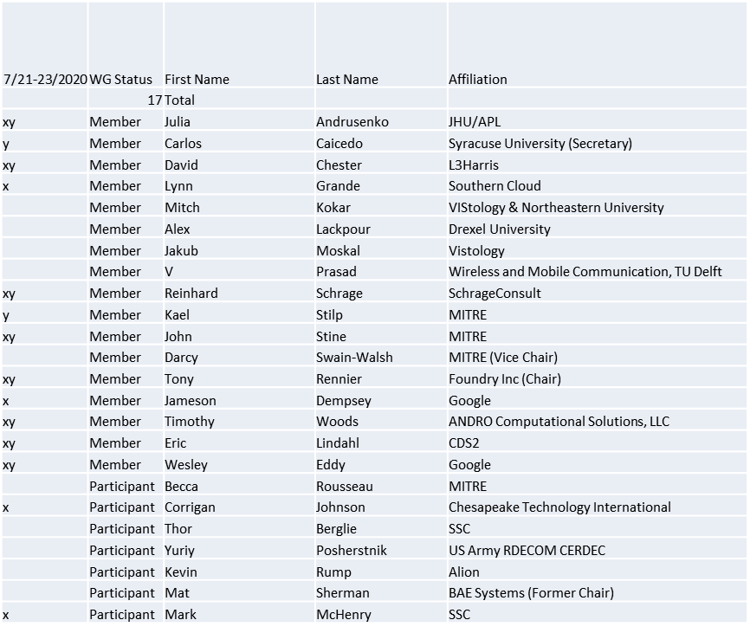

x=attendance on July 21
y=attendance on July 23

Quorum achieved July 21 and July 23

1.b. Approval of Agenda

Approval of Agenda from 5-20-0022-00

- Mover: Lynn
Second: Dave
Vote: UC

1.c. Copyright slides
Copyright policy slides were presented. No comments came forward.

1.d. Patent slides / Notes on status
Patent related slides were presented, no issues came forward

1.e. Approval of recent minutes
Motion to approve May 1 WG meeting minutes contained in Doc #: 5-20-0023-00-mins
- Mover: Dave
Second: Lynn
Vote: UC

2. Status on 1900.5.1
- 1900.5.1 Comment Resolution Group
  - Met 4/3
    - Reviewed comments
  - Final draft with CRS nearly complete
    - D3 document formatting/template problems getting resolved
    - Tweaks to the CRS required
    - WG needs to vote soon so we can start our 10-day recirculation

- Reinhard working on a reference implementation of 1900.5.1
  - Shooting for an April F2F demonstration - postponed
  - Looking at Java but doesn’t support operator overload, C++ a better option
  - Has integrated JAVA and C++ into solution
  - New OWL API release integrated
- Coming soon (year end) a more accessible policy language
  - Working on defining preprocessor to enable easier policy creation
  - Using John’s contributions as use cases

3. Status of 1900.5.2a
- Still few more details getting worked smallish
  - Polarization
  - Power turnability
  - Harmonics
  - Antenna Pointing
  - Planar approximations

4. Status on 1900.5a
- Continuing to address scope around the move to Cognitive Wireless Networks
- Need to allow innovation as high priority

5. Review of other DySPAN-SC activities
- 1900.1 Study Group initial meeting well attended
  - 25 interested 16 attended up from 4
- Machine Learning

6. 1900.5 marketing inputs

- N/A

7. 1900.5 meeting planning and review
- WG meetings
  - 9/4/20 8am EDT

- 1900.5a Ad-hoc
  - 8/7/20 1pm EDT
  - 9/4/20 1pm EDT

- Plenary Dec 15-17 On-line Only – Tentative good

