an Working Group | IEEE DYSPAN-SC 1900.5
Title | Meeting minutes 0246 for the P1900.5 Meetings of – June 5, 2020
DCN | 5-20-0023-00-mins
Date Submitted | 7/17/2020
Source(s) | Carlos Caicedo (Syracuse University)  email: ccaicedo@syr.edu
Abstract | Minutes for the IEEE 1900.5 meetings held on June 5, 2020
Notice | This document has been prepared to assist the IEEE DYSPAN-SC. It is offered as a basis for discussion and is not binding on the contributing individual(s) or organization(s). The material in this document is subject to change in form and content after further study. The contributor(s) reserve(s) the right to add, amend or withdraw material contained herein.
Release | The contributor grants a free, irrevocable license to the IEEE to incorporate material contained in this contribution, and any modifications thereof, in the creation of an IEEE Standards publication; to copyright in the IEEE’s name any IEEE Standards publication even though it may include portions of this contribution; and at the IEEE’s sole discretion to permit others to reproduce in whole or in part the resulting IEEE Standards publication. The contributor also acknowledges and accepts that IEEE DYSPAN SC may make this contribution public.
Patent Policy | The contributor is familiar with IEEE patent policy, as outlined in Section 6.3 of the IEEE-SA Standards Board Operations Manual <http://standards.ieee.org/guides/opman/sect6.html#6.3> and in Understanding Patent Issues During IEEE Standards Development <http://standards.ieee.org/board/pat/guide.html>.
>.

1. Administrivia

1.a Roll Call

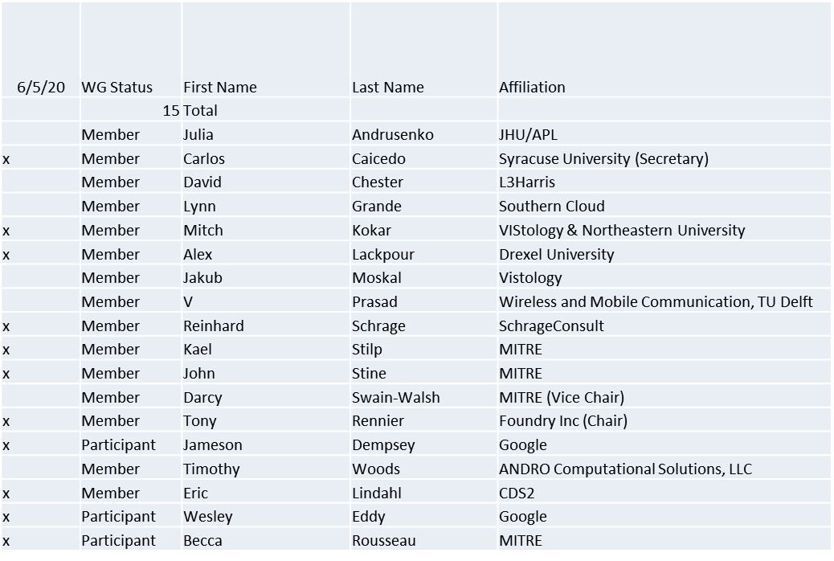

Quorum achieved

1.b. Approval of Agenda

Approval of Agenda from 5-20-0020-00

- Mover: Alex
Second: Reinhard
Vote: UC

1.c. Copyright slides
Copyright policy slides were presented. No comments came forward.

1.d. Patent slides / Notes on status
Patent related slides were presented, no issues came forward

1.e. Approval of recent minutes
Motion to approve May 1 WG meeting minutes contained in Doc #: 5-20-0019-00-mins
- Mover: Alex
Second: Carlos
Vote: UC

Motion to approve April 7-8 WG meeting minutes contained in Doc #: 5-20-0016-00-mins
- Mover: Reinhard
Second: Carlos
Vote: UC

2. Status on 1900.5a

- Held Ad-hoc 5/15/20, minutes posted on mentor
  - Actions:
    - Dave Chester is planning on delivering a draft use case in time for mid-June ad hoc meeting
    - Use case development
      - Alex started listing the elements that define a use case required for 1900.5a (see end of these notes)
      - Loon’s use case of High Altitude Platforms for cellular networks
      - CBRS band use cases. i.e., vertical and horizontal sharing scenarios.
  - Held discussion on how to address external and internal system interfaces in the 1900.5a standard
  - Held group discussion about adopting a hierarchical architecture for Policy-based spectrum management (PBSM) of DSA radio networks
- Dave Chester posted “Hierarchical Cognitive Network Characteristics and Potential Supporting Technologies from the Tactical Perspective” on Mentor

3. Status on 1900.5.1

- 1900.5.1 Comment Resolution Group
  - Met 4/3
    - Reviewed comments
  - Proposal for WG on Comment Resolution to be presented today
  - New introduction is incorporated
  - New Annex D and G in process
    - 5% left to do (6/19/20)
    - A few other items
- Reinhard working on a reference implementation of 1900.5.1
  - Shooting for an April F2F demonstration - postponed
  - Looking at Java but doesn’t support operator overload, C++ a better option
  - Has integrated JAVA and C++ into solution
  - New OWL API release integrated
- Coming soon (year end) a more accessible policy language

4. Status of 1900.5.2a
- Posted a new contribution
- New final draft planned for July

5. Review of other DySPAN-SC activities

No updates. Items of the 4/7/20 meeting were captured in the previous minutes.

6. 1900.5 marketing inputs

- N/A

7. 1900.5 meeting planning and review

- 7/3/20 1900.5 WG 08:00 -10:00 EDT
  - Will reschedule for 7/10/20 1430-1630 – check with DySPAN

8. 1900.5.1 Comment Resolution Report/Review

Comment resolution complete. Will be formatted according to IEEE requirements.

9. AoB
N/A

Meeting ends at 9:25 a.m. EDT

