an Working Group | IEEE DYSPAN-SC 1900.5
Title | Meeting minutes 0245 for the P1900.5 Meetings of – May 1, 2020
DCN | 5-20-0019-00-mins
Date Submitted | 6/3/2020
Source(s) | Carlos Caicedo (Syracuse University)  email: ccaicedo@syr.edu
Abstract | Minutes for the IEEE 1900.5 meetings held on May 1, 2020
Notice | This document has been prepared to assist the IEEE DYSPAN-SC. It is offered as a basis for discussion and is not binding on the contributing individual(s) or organization(s). The material in this document is subject to change in form and content after further study. The contributor(s) reserve(s) the right to add, amend or withdraw material contained herein.
Release | The contributor grants a free, irrevocable license to the IEEE to incorporate material contained in this contribution, and any modifications thereof, in the creation of an IEEE Standards publication; to copyright in the IEEE’s name any IEEE Standards publication even though it may include portions of this contribution; and at the IEEE’s sole discretion to permit others to reproduce in whole or in part the resulting IEEE Standards publication. The contributor also acknowledges and accepts that IEEE DYSPAN SC may make this contribution public.
Patent Policy | The contributor is familiar with IEEE patent policy, as outlined in Section 6.3 of the IEEE-SA Standards Board Operations Manual <http://standards.ieee.org/guides/opman/sect6.html#6.3> and in Understanding Patent Issues During IEEE Standards Development <http://standards.ieee.org/board/pat/guide.html>.
>.

1. Administrivia

1.a Roll Call

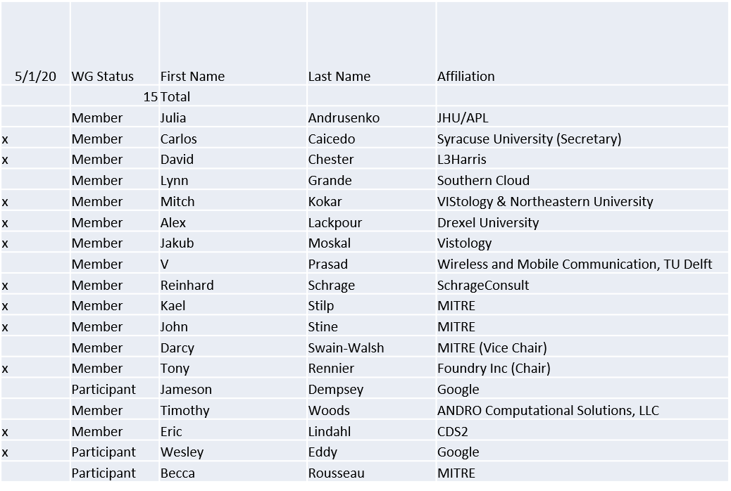

Quorum achieved

1.b. Approval of Agenda

Approval of Agenda from 5-20-0015-00

- Mover: Dave
Second: Carlos
Vote: UC

1.c. Copyright slides
Copyright policy slides were presented. No comments came forward.

1.d. Patent slides / Notes on status
Patent related slides were presented, no issues came forward

1.e. Approval of recent minutes
Motion to approve April 7-8 WG minutes contained in Doc #: 5-20-0016-00-mins
- Mover:
Second:
Vote: Postponed for next meeting

2. Status on 1900.5.1

- 1900.5.1 Comment Resolution Group
  - Proposal for WG on Comment Resolution likely to be presented in June meeting

- Schedule (Tentative)
  - Sponsor Recirculation ballot - 6/20 (Target date)
  - Submit to REVCOM - 8/20
- Reinhard working on a reference implementation of 1900.5.1
  - Shooting for an April F2F demonstration - postponed
  - Looking at Java but doesn’t support operator overload, C++ a better option

3. Status of 1900.5.2a
- Lots of internal discussion
  - Confidence value with location index
  - Configuration models for directionality
  - Carlos continuing detailed review
  - Planning June draft proposal

4. Status on Architecture / 1900.5 revision
  - Next ad-hoc on 5/15
  - Entering a new discussion on architecture
    - Where do we put the interface specifications?
      - Internal and External
    - Collecting Use Cases (Dave and Wesley)

5. Review of other DySPAN-SC activities

- Updates from 4/27/20 meeting
  - 1900.1 WG (Francesco reports)
    - Approved Study Group – next step is issuing the Call for Participation (CFP)
  - 1900.6 WG (Oliver reports)
    - Two online sessions during the March virtual-F2F meetings
    - Currently voting on extending the sponsor balloting
    - Continuing comment resolution on 1900.6b
    - 1900.6 draft PAR has been developed – scheduled to be approved in July
  - DARPA SC2 Language standardization
    - Action Oliver: will send an email to John Chapin to propose alternative approach to starting standardization now.
    - Oliver asks Jennifer if “direct adoption” is a possible option
    - Jennifer: IEEE does not have an existing agreement with DARPA on adopting existing technology as a standard – therefore need to discuss it further
  - Machine Learning standardization Study Group
    - Alex is currently drafting an email to Jennifer Santulli on the call for participation (CFP)
    - Planned first meeting time: Monday, July 13th
    - Still considering using the IEEE’s Wordpress option for creating a SG website
    - Is there another virtual collaboration space that can be used in addition to IEEE mentor?
  - National Spectrum Consortium
    - Tony met with Apurva Mody (NSC Small Business Rep on Exec Committee) and Mat Sherman and discussed 1900 standards work
    - NSC is preparing a survey and sent it to NSC membership on DSA standards engagement regarding formation of an NSC DSA standards WG. (DSA – Architecture, DSA – Radio Rules, DSA – Network Policies, DSA – Spectrum Sensing Interface)
    - Possible publication through a standards body (IEEE-SA, WINNFORUM, 3GPP) possible in future
  - 1900.5a interfaces (Cross WG collaboration)
    - Last ad hoc was canceled, reschedule for May 15th at 1pm ET
    - Pivotal question: including external interfaces in 1900.5a revision
  - Restarting 1900.4 WG
    - Oliver will finalize the adaptation of 1900.4 WG as an individual-based WG vs. entity-based

6. 1900.5 marketing inputs

- N/A

7. 1900.5 meeting planning and review

- 6/5/20 1900.5 WG 14:00 -16:30 EDT

8. AoB
N/A

Meeting ends at 9:25 a.m. EDT

