an Working Group | IEEE DYSPAN-SC 1900.5
Title | Meeting minutes 0244 for the P1900.5 Meetings of – April 7-8, 2020
DCN | 5-20-0016-00-mins
Date Submitted | 4/30/2020
Source(s) | Carlos Caicedo (Syracuse University)  email: ccaicedo@syr.edu
Abstract | Minutes for the IEEE 1900.5 meetings held on April 7-8, 2020
Notice | This document has been prepared to assist the IEEE DYSPAN-SC. It is offered as a basis for discussion and is not binding on the contributing individual(s) or organization(s). The material in this document is subject to change in form and content after further study. The contributor(s) reserve(s) the right to add, amend or withdraw material contained herein.
Release | The contributor grants a free, irrevocable license to the IEEE to incorporate material contained in this contribution, and any modifications thereof, in the creation of an IEEE Standards publication; to copyright in the IEEE’s name any IEEE Standards publication even though it may include portions of this contribution; and at the IEEE’s sole discretion to permit others to reproduce in whole or in part the resulting IEEE Standards publication. The contributor also acknowledges and accepts that IEEE DYSPAN SC may make this contribution public.
Patent Policy | The contributor is familiar with IEEE patent policy, as outlined in Section 6.3 of the IEEE-SA Standards Board Operations Manual <http://standards.ieee.org/guides/opman/sect6.html#6.3> and in Understanding Patent Issues During IEEE Standards Development <http://standards.ieee.org/board/pat/guide.html>.
>.

1. Administrivia

1.a Roll Call

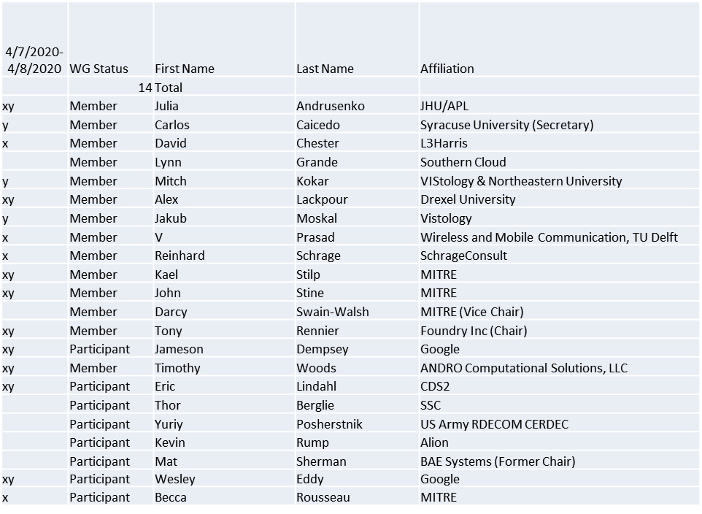

Quorum achieved on 4/7 and on 4/8 (x marks attendees for 4/7, y marks attendees for 4/8)

1.b. Approval of Agenda

Approval of Agenda from 5-20-0007-00

- Mover: Dave
Second: John
Vote: UC

1.c. Copyright slides
Copyright policy slides were presented. No comments came forward.

1.d. Patent slides / Notes on status
Patent related slides were presented, no issues came forward

1.e. Approval of recent minutes
Motion to approve 2/7/20 WG minutes contained in Doc #: 5-20-0005-00-mins
- Mover: John
Second: Dave
Vote: UC

Motion to approve 3/6/20 WG minutes contained in Doc #: 5-20-0008-00-mins
- Mover: Reinhard
Second: John
Vote: UC

2. Status on 1900.5.1

- 1900.5.1 Comment Resolution Group
  - Met 4/3
    - Reviewed comments
  - Proposal for WG on Comment Resolution likely to be presented at 4/8 WG closing meeting

- Schedule (Tentative)
  - Sponsor Recirculation ballot - 4/20 (Target date)
  - Sponsor Recirculation 2 - 6/20
  - Submit to REVCOM - 8/20
- Reinhard working on a reference implementation of 1900.5.1
  - Shooting for an April F2F demonstration - postponed
  - Looking at Java but doesn’t support operator overload, C++ a better option

3. Status of 1900.5.2a
- Continuing to make progress
- Changes will be reviewed in 1600 Ad-hoc
- Possible promotion to sponsor ballot in May

4. Status on Architecture / 1900.5 revision
- Preparing for ad-hoc 1400 today
- Received inputs from participants
- Will be presenting ideas for moving forward

5. Review of other DySPAN-SC activities

- March 2019 Leadership meeting – cancelled
- Updates from 4/7/20 meeting
  - Machine learning study group a few weeks out, Alex to Chair
  - DARPA SC2 spectrum challenge message format a possible candidate for standardization
    - John Chapin in the process of releasing a report on the SC2 findings
    - John Chapin interested in support our efforts

6. 1900.5 marketing inputs

- N/A

7. 1900.5 meeting planning and review

- 5/1/20 1900.5 WG 08:00 -10:00 EST

8. AoB
- 6 GHz WINN Forum group forming
  - P1900.5 should participate?
  - Will contact Andy Clegg just to see
  - MITRE is a member
    - John will look when he can

