an Working Group | IEEE DYSPAN-SC 1900.5
Title | Meeting minutes 0243 for the P1900.5 Meetings of – March 6, 2020
DCN | 5-20-0008-00-mins
Date Submitted | 4/5/2020
Source(s) | Carlos Caicedo (Syracuse University)  email: ccaicedo@syr.edu
Abstract | Minutes for the IEEE 1900.5 meetings held on March 6, 2020
Notice | This document has been prepared to assist the IEEE DYSPAN-SC. It is offered as a basis for discussion and is not binding on the contributing individual(s) or organization(s). The material in this document is subject to change in form and content after further study. The contributor(s) reserve(s) the right to add, amend or withdraw material contained herein.
Release | The contributor grants a free, irrevocable license to the IEEE to incorporate material contained in this contribution, and any modifications thereof, in the creation of an IEEE Standards publication; to copyright in the IEEE’s name any IEEE Standards publication even though it may include portions of this contribution; and at the IEEE’s sole discretion to permit others to reproduce in whole or in part the resulting IEEE Standards publication. The contributor also acknowledges and accepts that IEEE DYSPAN SC may make this contribution public.
Patent Policy | The contributor is familiar with IEEE patent policy, as outlined in Section 6.3 of the IEEE-SA Standards Board Operations Manual <http://standards.ieee.org/guides/opman/sect6.html#6.3> and in Understanding Patent Issues During IEEE Standards Development <http://standards.ieee.org/board/pat/guide.html>.
>.

1. Administrivia

1.a Roll Call

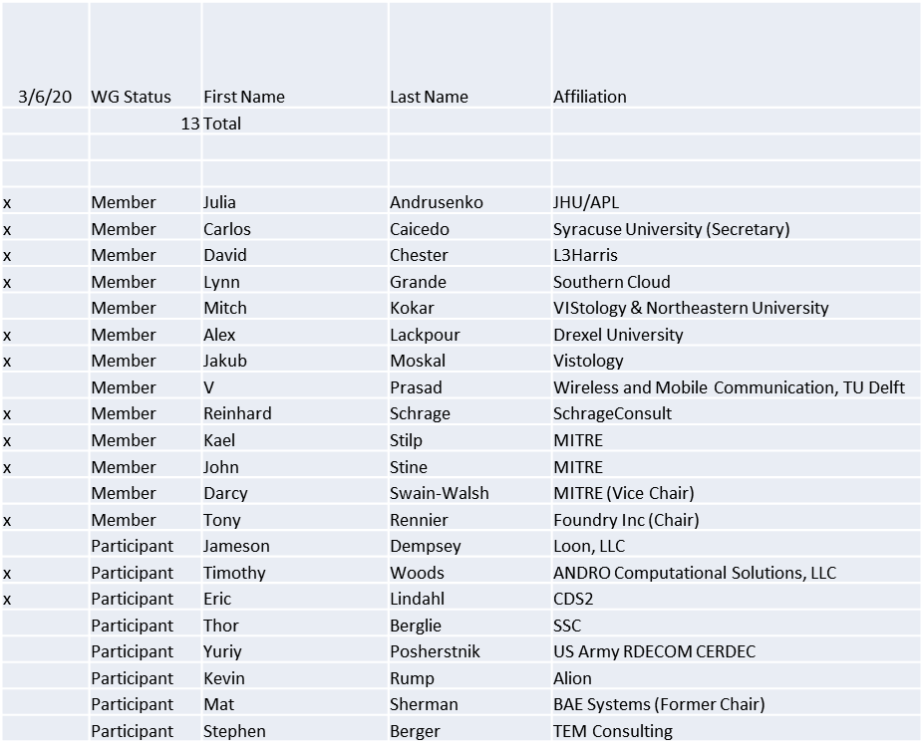

Meeting starts at 8:03 a.m. EST
Quorum was achieved

1.b. Approval of Agenda

Approval of Agenda from 5-20-0004-00

- Mover: Reinhard
Second: Carlos
Vote: UC

1.c. Copyright slides

Copyright policy slides were presented. No comments came forward.
1.d. Patent slides / Notes on status
Patent related slides were presented, no issues came forward

1.e. Approval of recent minutes
Motion to approve 2/7/20 WG minutes contained in Doc #: 5-20-0005-00-mins

Vote moved to next WG session.

2. Status on 1900.5.1

- 1900.5.1 Comment Resolution Group
  - Formed at last meeting
  - Met 2/18
    - Reviewed comments
    - Generated revealing discussion on the way the standard is intended to be used
    - Actions taken to further consider needed changes considering the usage description

- Schedule (Tentative)
  - Sponsor Recirculation ballot - 4/20
  - Sponsor Recirculation 2 - 6/20
  - Submit to REVCOM - 8/20
- Reinhard working on a reference implementation of 1900.5.1
  - Aiming for an April F2F demonstration
- Working on comment resolution
  - Planning another CRG meeting 2 or 3 weeks prior to F2F week of April

3. Status of 1900.5.2a

- Met with Carlos on schema changes
  - Specifying default values
- Editorial and rule updates coming in
- Still working toward a draft for approval for sponsor ballot at F2F

4. Status on Architecture / 1900.5 revision

- Last ad-hoc more details emerging from discussion
- Still at a fundamental stage
  - Scope is still a matter for debate
  - Working relationship between parent and .1 and .2
  - Establishing a sound systems engineering process

5. Review of other DySPAN-SC activities

Notes from 2/24/20 meeting:
- Upcoming Leadership Meetings
  - March 23rd (Monday)
  - Plenaries 1st week of April (April 7th - 9th)
- WG Reports
  - 1900.1 WG (Francesco)
    - Trying to enlarge the WG and gain more interest
    - Because 1900.1 PAR is expired, would like to create a study group on whether to revise 1900.1 and this will trigger a wide call for participation within the IEEE
    - Requesting approval to create a 1900.1 revision study group
    - Oliver requests that Francesco create a short description of the study group goals and scope that is voted on my the DySPAN-SC at the April meeting
  - 1900.2 WG (Stephen)
    - WG met on 2/21/20 to further discuss ideas for refreshing the standard
    - No commitment yet from members to work on the refresh
      - Default action is a limited revision for errata/improvements and reference update
    - 50/50 on the prospect of getting sponsor support for adding Risk Management to the standard
  - 1900.6
    - Made minor revisions to the draft
    - Started sponsor ballets within the WG a week ago
    - Planning on at least one session between the plenaries

- DARPA SC2 Language standardization
  - Alex sent email to John Chapin asking about his interest, but did not hear a response yet
  - John is working on a paper on the SC2 collaboration language
- Machine Learning standardization Study Group
  - No additional discussion
  - Action Oliver: Will initiate the email ballot on the ML Study Group
    - 14 day email voting ballot period
- National Spectrum Consortium
  - No response from NSC leadership (Sal)
- Restarting 1900.4 WG
  - Oliver needs to formalize status with chair

6. 1900.5 marketing inputs

- CBRS up and coming commercial services starting

7. 1900.5 meeting planning and review

- 4/7-9/20 DySPAN-SC Plenary with 1900.5 WG
  - Time Zone: Eastern Daylight Time (UTC - 4)
  - Initial planned Location: F2F in Cape Canaveral, Florida
  - Go/no go will depend on coronavirus situation
  - Planning to attend in person: Dave, Lynn, Oliver, Tony, Reinhart, Carlos is a maybe, Eric Lyndal, Julia TBD, Kael, Mitch or Jakub
  - Attempt to stick to meeting schedule that is compatible with Eastern USA Time Zones
    - Meeting times: 9am – 5:30pm EDT
    - Opening Plenary: 9am on April 7th
    - Closing Plenary: 2nd AM session on April 9th
    - Action Item (Alex, by Feb 15th): Send out scheduled times spreadsheet

8. AoB
None

Meeting adjourns at 9:25 a.m. EST

