an Working Group | IEEE DYSPAN-SC 1900.5
Title | Meeting minutes 0242 for the P1900.5 Meetings of – February 7, 2020
DCN | 5-20-0005-00-mins
Date Submitted | 3/5/2020
Source(s) | Carlos Caicedo (Syracuse University)  email: ccaicedo@syr.edu
Abstract | Minutes for the IEEE 1900.5 meetings held on February 7, 2020
Notice | This document has been prepared to assist the IEEE DYSPAN-SC. It is offered as a basis for discussion and is not binding on the contributing individual(s) or organization(s). The material in this document is subject to change in form and content after further study. The contributor(s) reserve(s) the right to add, amend or withdraw material contained herein.
Release | The contributor grants a free, irrevocable license to the IEEE to incorporate material contained in this contribution, and any modifications thereof, in the creation of an IEEE Standards publication; to copyright in the IEEE’s name any IEEE Standards publication even though it may include portions of this contribution; and at the IEEE’s sole discretion to permit others to reproduce in whole or in part the resulting IEEE Standards publication. The contributor also acknowledges and accepts that IEEE DYSPAN SC may make this contribution public.
Patent Policy | The contributor is familiar with IEEE patent policy, as outlined in Section 6.3 of the IEEE-SA Standards Board Operations Manual <http://standards.ieee.org/guides/opman/sect6.html#6.3> and in Understanding Patent Issues During IEEE Standards Development <http://standards.ieee.org/board/pat/guide.html>.
>.

1. Administrivia

1.a Roll Call

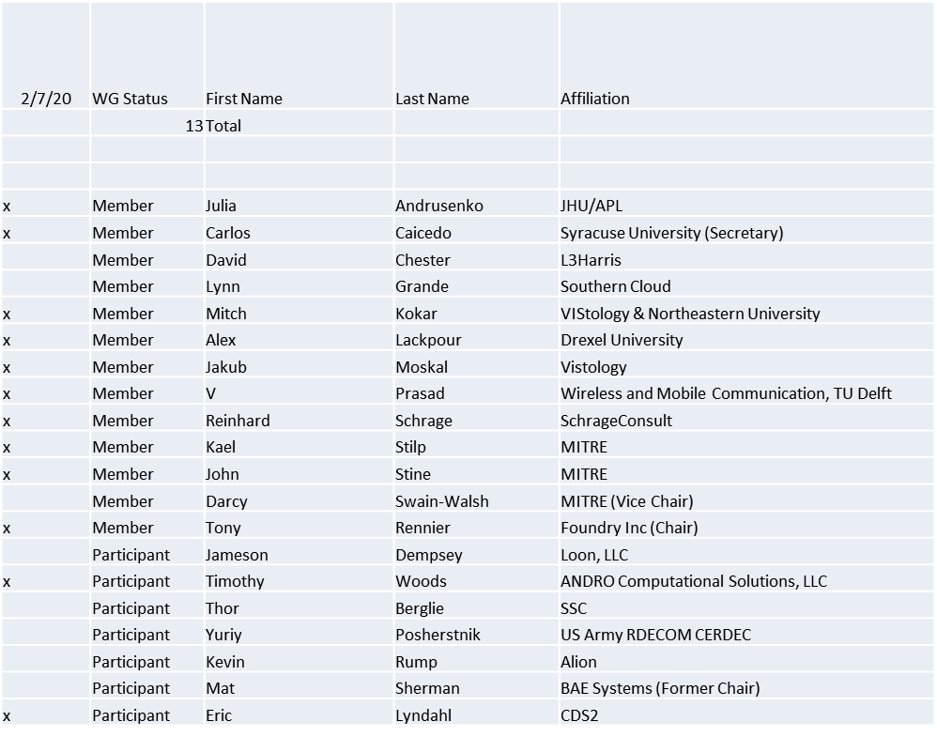

Meeting starts at 2:33 p.m. EST
Quorum was achieved

1.b. Approval of Agenda

Approval of Agenda from 5-20-0003-00

- Mover: Carlos
- Second: Reinhard
Vote: UC

1.c. Copyright slides

Copyright policy slides were presented. No comments came forward.

1.d. Patent slides / Notes on status
Patent related slides were presented, no issues came forward

1.e. Approval of recent minutes
Motion to approve 12/4/19 WG minutes contained in Doc #: 5-20-0002-00-mins

- Mover: John
- Second: Reinhard
Vote: UC

2. Status on 1900.5.1

- 1900.5 to form a Comment Resolution Group
  - Group to respond to comments and bring the results back to the WG
  - Total comments: 106, Must be satisfied comments: 92 (91 editorial, 1 substantive)
- Reinhard working on a reference implementation of 1900.5.1
  - Shooting for an April F2F demonstration
- Motion to approve the following membership in the 1900.5.1 Comment Resolution Group
  - Reinhard, Carlos, Tony, Mitch, Jakub
Mover: John
Second: Jakub
Vote: UC

- Motion to approve the 1900.5.1 Comment Resolution Group scope
  - CRG recommends responses to comments and submits those recommendations to full WG for approval.
Mover: Reinhard
Second: Carlos
Vote: UC

3. Status of 1900.5.2a

- Have a complete update along with schemas and verification rules
- Make decision on moving to sponsor ballot at April meeting
4. Status on Architecture / 1900.5 revision

Exploring ideas to set the scope for the revision of the 1900.5 standard

5. Review of other DySPAN-SC activities

1/27/19 Meeting Notes
  - Upcoming Leadership Meetings
    - Feb 24th (Monday)
    - Plenaries 1st week of April (April 7th - 9th)
  - WG Reports
    - 1900.1 WG (Francesco)
      - Trying to enlarge the WG and gain more interest.
    - 1900.2 WG (Stephen)
      - No updates from Stephen
      - WG did meet on 1/23/20 to discuss ideas for refreshing the standard
    - 1900.6 WG (Oliver reports)
      - 1900.6.b: Support of databases
        - Sponsor balloting period will close near end of January
      - Considering revision of 1900.6
        - Initial text for PAR has been written
  - DARPA SC2 Language standardization
      - According to John Chapin’s recent read out on CIL standardization:
        - Near/Mid term goal of the post-DARPA SC2 community
        - To be sponsored by Private Sector
      - Action Item (Alex): Email John Chapin to check on potential for standardizing CIL through DySPAN and how to contact interested Private Sector stakeholders
      - URL for DARPA’s Github repo of the CIL:
        - https://github.com/SpectrumCollaborationChallenge/CIL
  - Machine Learning standardization
    - Conclusion on discussing options with Johnathan:
      - Study group is the best approach versus Research Group (ComSoc specific)
      - 6 month duration
    - Action Item (Alex): Send an email motion to create a Study Group
        - Text: Move the creation of the Study Group
  - National Spectrum Consortium
    - Oliver will continue discussion of using/adopting DySPAN standards in NSC with Sal
  - Restarting 1900.4 WG
Oliver will send another email to the Chair to restart the WG

- Spectrum Sharing Standards
  - 1900.2 looking at risk-based sharing and LTE to X sharing

6. 1900.5 marketing inputs

- Waiting on response from Andy Clegg
- PACOM investigate spectrum sharing with coalition partners

7. 1900.5 meeting planning and review

- 3/6/20 1900.5 WG 08:00 -10:00 EST
- 4/7-9/20 DySPAN-SC Plenary with 1900.5 WG
  - Time Zone: Eastern Daylight Time (UTC - 4)
  - Location: F2F in Cape Canaveral, Florida
  - Planning to attend in person: Dave, Lynn, Oliver, Tony, Reinhart, Carlos is a maybe, Eric Lyndal, Julia TBD, Kael, Mitch or Jakub
  - Attempt to stick to meeting schedule that is compatible with Eastern USA Time Zones
    - Meeting times: 9am – 5:30pm EDT
    - Opening Plenary: 9am on April 7th
    - Closing Plenary: 2nd AM session on April 9th
    - Action Item (Alex, by Feb 15th): Send out scheduled times spreadsheet

8. AoB
None

Meeting adjourns at 3:35 p.m. EST

