an Working Group | IEEE DYSPAN-SC 1900.5
Title | Meeting minutes 0241 for the P1900.5 Meetings of – December 4, 2019
DCN | 5-20-0002-00-mins
Date Submitted | 2/5/2019
Source(s) | Carlos Caicedo (Syracuse University)  email: ccaicedo@syr.edu
Abstract | Minutes for the IEEE 1900.5 meetings held on December 4, 2019
Notice | This document has been prepared to assist the IEEE DYSPAN-SC. It is offered as a basis for discussion and is not binding on the contributing individual(s) or organization(s). The material in this document is subject to change in form and content after further study. The contributor(s) reserve(s) the right to add, amend or withdraw material contained herein.
Release | The contributor grants a free, irrevocable license to the IEEE to incorporate material contained in this contribution, and any modifications thereof, in the creation of an IEEE Standards publication; to copyright in the IEEE’s name any IEEE Standards publication even though it may include portions of this contribution; and at the IEEE’s sole discretion to permit others to reproduce in whole or in part the resulting IEEE Standards publication. The contributor also acknowledges and accepts that IEEE DYSPAN SC may make this contribution public.
Patent Policy | The contributor is familiar with IEEE patent policy, as outlined in Section 6.3 of the IEEE-SA Standards Board Operations Manual <http://standards.ieee.org/guides/opman/sect6.html#6.3> and in Understanding Patent Issues During IEEE Standards Development <http://standards.ieee.org/board/pat/guide.html>.
>.

1. Administrivia

1.a Roll Call

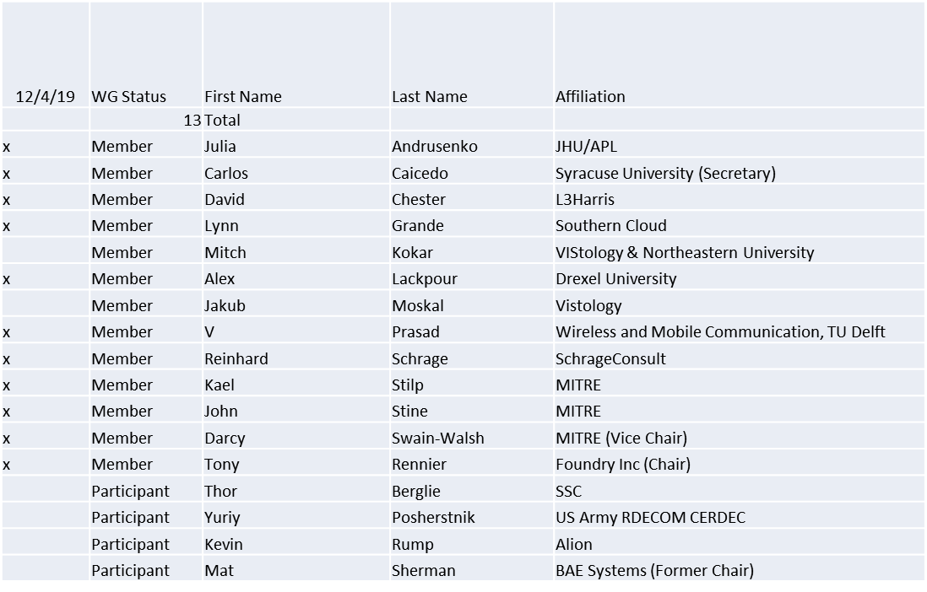

Meeting starts at 8:05 a.m. EST
Quorum was achieved

1.b. Approval of Agenda

Approval of Agenda from 5-19-0041-00

- Mover: Carlos
- Second: John
Vote: UC

1.c. Copyright slides

Copyright policy slides were presented. No comments came forward.

1.d. Patent slides / Notes on status
Patent related slides were presented, no issues came forward

1.e. Approval of recent minutes
Motion to approve 11/7-8/19 WG minutes contained in Doc #: 5-19-0042-00-mins

- Mover: Reinhard
- Second: Darcy
Vote: UC

2. Status on 1900.5.1

  - NESCOM approved one-year PAR extension on 11/7/19
  - Sponsor Ballot results
- Comments: 101
- Must be satisfied 91
- All comments are non-technical and from two reviewers (1 and 100) thus far
  - Looking for 1900.5 WG comments soon!
  - Schedule
- Full review of drafting - 3/17 √
- First WG Ballot - 2/19 √
- WG Recirc - 10/19 √
- Sponsor Ballot - 11/19 √
- Sponsor Recirc - 2/20
- Sponsor Recirc 2 - 5/20
- Submit to REVCOM - 8/20

Ballot details:
BALLOT OPEN DATE: 04-Nov-2019
BALLOT CLOSE DATE: 10-Jan-2020
COMMENTS: 101
MUST BE SATISFIED COMMENTS: 91

RESPONSE RATE
This ballot has not yet met the 75% returned ballot requirement.
(13 more people must return their ballots.)

43 eligible people in this ballot group.

17 affirmative votes
1 total negative votes with comments
1 negative votes with new comments
0 negative votes without comments
2 abstention votes: (Lack of expertise: 1, Other: 1)
===
20 votes received = 46% returned
10% abstention

APPROVAL RATE
The 75% affirmation requirement is being met.
17 affirmative votes
1 negative votes with comments
===
18 votes = 94% affirmative

3. Status of 1900.5.2a

- Last F2F meeting held in November
- John is continuing to identify/make changes
- Expected December completion
- Planning a January WG review

4. Status on Architecture / 1900.5 revision

- Foundational items for discussions on 1900.5a
- Looking for a new time to meet
- Next meeting 12/20 1pm EST

5. Review of other DySPAN-SC activities

  - Leadership Meetings
    - Plenaries 12/3 0800 EST and 12/5 0800 EST
  - WG Reports (none for November)
  - DySPAN-SC Elections
    - Nominations are complete and all nominees have accepted
    - Elections are imminent
  - Potential New Projects
    - DARPA SC2 Language standardization
To be opened sourced including validation
    - Machine Learning standardization
Study proposal being considered
Sending out a draft to 1900.5
  - National Spectrum Consortium
    - Oliver emailed Sal (NSC Chair), waiting for response
    - Potential new standards on DSA coming out of the NSC
  - Restarting the 1900.4 WG
    - Used within academia as a benchmark for DSA architecture
    - Planning move to a individual vs entity based WG

  - Spectrum sharing standards
    - DySPAN paper well received

6. 1900.5 marketing inputs

Andy Clegg (Google) interested again in SCM
- PAL protection of interest
- DAA coordination
- WG1 WINNForum
John contemplating new SCM related projects within DOD

7. 1900.5 meeting planning and review

- 1/3/20 1900.5 WG 08:00 -10:00 EST
  - Friday after New Years
  - Member’s availability?
    - Target 1/10/19

8. AoB
None

Meeting adjourns at 9:35 a.m. EST

