an Working Group | IEEE DYSPAN-SC 1900.5
Title | Meeting minutes 0240 for the P1900.5 Meetings of – November 7 and 8, 2019
DCN | 5-19-0042-00-mins
Date Submitted | 12/2/2019
Source(s) | Carlos Caicedo (Syracuse University)  email: ccaicedo@syr.edu
Abstract | Minutes for the IEEE 1900.5 meetings held on November 7 and 8, 2019
Notice | This document has been prepared to assist the IEEE DYSPAN-SC. It is offered as a basis for discussion and is not binding on the contributing individual(s) or organization(s). The material in this document is subject to change in form and content after further study. The contributor(s) reserve(s) the right to add, amend or withdraw material contained herein.
Release | The contributor grants a free, irrevocable license to the IEEE to incorporate material contained in this contribution, and any modifications thereof, in the creation of an IEEE Standards publication; to copyright in the IEEE’s name any IEEE Standards publication even though it may include portions of this contribution; and at the IEEE’s sole discretion to permit others to reproduce in whole or in part the resulting IEEE Standards publication. The contributor also acknowledges and accepts that IEEE DYSPAN SC may make this contribution public.
Patent Policy | The contributor is familiar with IEEE patent policy, as outlined in Section 6.3 of the IEEE-SA Standards Board Operations Manual <http://standards.ieee.org/guides/opman/sect6.html#6.3> and in Understanding Patent Issues During IEEE Standards Development <http://standards.ieee.org/board/pat/guide.html>.
>.

1. Administrivia

1.a Roll Call

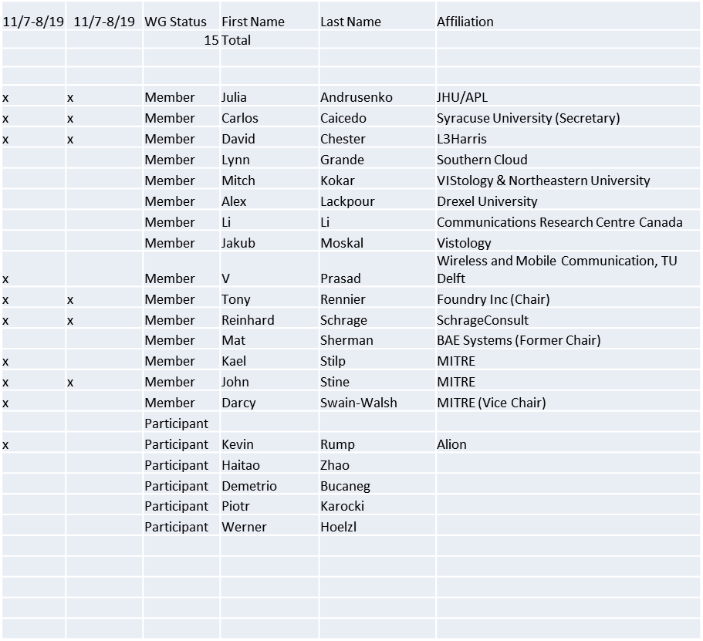

Session of 11/7 had quorum – meeting started at 9:15 a.m.

1.b. Approval of Agenda

Approval of Agenda from 5-19-0037-00

- Mover: John
- Second: Reinhard
Vote: UC

1.c. Copyright slides

Copyright policy slides were presented. No comments came forward.

1.c. Patent slides / Notes on status
Patent related slides were presented, no issues came forward

1.d. Approval of recent minutes

Motion to approve 9/6/19 WG minutes contained in Doc #: 5-19-0038-00-mins

- Mover: Reinhard
- Second: Carlos
Vote: UC

Motion to approve 10/4/19 WG minutes contained in Doc #: 5-19-0039-00-mins

- Mover: Reinhard
- Second: Darcy
Vote: UC

2. Status on 1900.5.1

- 1900.5 WG Letter Ballot to being Sponsor Ballot completed 10/7/19, final tally was 14 approve and 1 abstain
- 1900 Letter Ballot on Moving P1900.5.1 Draft 1.0 to Sponsor Ballot completed 10/26/19, final tally was 6 approve and 1 abstain
- Sponsor Ballot Group formed 10/17/19
- MEC provided comments 10/22/19
- Reinhard addressed MEC comments 11/4/19
- Sponsor Ballot Initiated 11/5/19
- NESCOM consideration for one year PAR extension 11/7/19

3. Status of 1900.5.2a

- Oct Ad-hoc Changes
- New changes
  - Models are stable
  - Added schemas XSD and JSON
  - Updated verification rules
- Planning Jan WG ballot
- Look into putting a pointer to DySPAN-SC into the standards

4. Status on Architecture / 1900.5 revision

- NTR

5. Review of other DySPAN-SC activities

October 2019 leadership meetings
- WG Reports
  - 1900.1 WG (Francesco reports)
    - No updates
  - 1900.2 WG (Stephen reports)
    - Minimal revision is required, updating references
    - Planning to issue a letter ballot soon, should attract attention from WG members and spur member participation
    - Stephen plans to have a 1900.2 WG meeting soon to formalize the membership
  - 1900.5 WG (Tony reports)
    - Committee to discuss PAR review meets in early November
    - DySPAN-SC approved moving to sponsor ballot – waiting for MEC approval
    - F2F meeting next week, McLean, VA
    - 1900.5 becomes an inactive standard if it isn’t revised by the end of the year. It’s not a major issue if the standard becomes non-active for a short time. It will become active once it is revised.
  - 1900.6 WG (Oliver reports)
    - Continuing with formal WG meetings
    - Final circulation ballot on 1900.6b
    - Move to a sponsor ballot soon after it is approved in the WG
    - Need having comment resolution ballot meetings on 1900.6b

- DySPAN-SC Elections
  - Nominations are open until 11/18/19
- Potential New Projects
  - DARPA SC2 Language standardization
    - Action Item (Alex, by Nov 14th) engage Paul Tilghman at DySPAN workshop and discuss his progress on standardizing SC2’s inter-network/PU dynamic collaboration language
  - Machine Learning standardization
    - Action Item (Alex, by Nov 14th): engage Paul Tilghman at DySPAN workshop and discuss his progress on standardizing ML for wireless networks within 3GPP, 802.11, etc...
    - Discussion on the ITU’s new WGs on Machine Learning
      - Focus appears to be on standardizing the format of data in training datasets and the process by which ML models are trained and validated using datasets
      - Option 1: Study Group – 6 month duration
        - Assess the potential of such a standard (define the bounds)
        - Presumes that there is a high probability of a standard being created
      - Option 2: Research group – 1 year duration
        - Study the feasibility of a new topic
      - The study and research groups can be created within the IEEE SA
      - Action Item (Alex, by Nov 18th): Write a description of the goals of the study/research group for defining the scope of the P1900 ML WG
      - Action Item (Oliver, by end of November): Approach Jonathan @ IEEE about creating an appropriate WG option for a “AI/ML for DSA” study

- Potential New Projects (cont)
  - National Spectrum Consortium
    - Oliver emailed Sal (NSC Chair), waiting for response
    - Potential new standards on DSA coming out of the NSC
  - Restarting the 1900.4 WG
    - Used within academia as a benchmark for DSA architecture
    - Planning move to a individual vs entity based WG
- Proposed next Plenary meeting date and location:
  - Meet the 1st week of December (Dec 3rd - 5th)
  - Time Zone: Asia-Pacific
  - Location: Online (no host)
  - Schedule: Draft (last slide)

- Spectrum Sharing Standards
  - Paper presented at DySPAN 11/11/19

6. 1900.5 marketing inputs

- AOC Panel Chair John (EMBM)
- MILCOM Panel Chair John (EMBM)
- Socialize at high levels at DoD
- DySPAN Workshop chair Carlos
- INGF 5G Reinhard co-chair SBB
- DSO Sponsorship Julia

7. 1900.5 meeting planning and review

- 12/3-5/19 DySPAN-SC Plenary with 1900.5 WG
  - See next slide
  - 10am Tues 12/3
- 1/3/20 1900.5 WG 08:00 -10:00 EST
  - Friday after New Years
  - Member’s availability?
    - Target 1/10/19

8. AoB
None

Meeting adjourns at 10:40 a.m.

Ad-hoc sessions

Ad-hoc meetings took place on November 8

