an Working Group | IEEE DYSPAN-SC 1900.5
Title | Meeting minutes 0239 for the P1900.5 Meetings of – October 4, 2019
DCN | 5-19-0039-00-mins
Date Submitted | 11/5/2019
Source(s) | Carlos Caicedo (Syracuse University)  email: ccaicedo@syr.edu
Abstract | Minutes for the IEEE 1900.5 meeting of October 4, 2019
Notice | This document has been prepared to assist the IEEE DYSPAN-SC. It is offered as a basis for discussion and is not binding on the contributing individual(s) or organization(s). The material in this document is subject to change in form and content after further study. The contributor(s) reserve(s) the right to add, amend or withdraw material contained herein.
Release | The contributor grants a free, irrevocable license to the IEEE to incorporate material contained in this contribution, and any modifications thereof, in the creation of an IEEE Standards publication; to copyright in the IEEE’s name any IEEE Standards publication even though it may include portions of this contribution; and at the IEEE’s sole discretion to permit others to reproduce in whole or in part the resulting IEEE Standards publication. The contributor also acknowledges and accepts that IEEE DYSPAN SC may make this contribution public.
Patent Policy | The contributor is familiar with IEEE patent policy, as outlined in Section 6.3 of the IEEE-SA Standards Board Operations Manual <http://standards.ieee.org/guides/opman/sect6.html#6.3> and in Understanding Patent Issues During IEEE Standards Development <http://standards.ieee.org/board/pat/guide.html>.
>.

1. Administrivia

1.a Roll Call

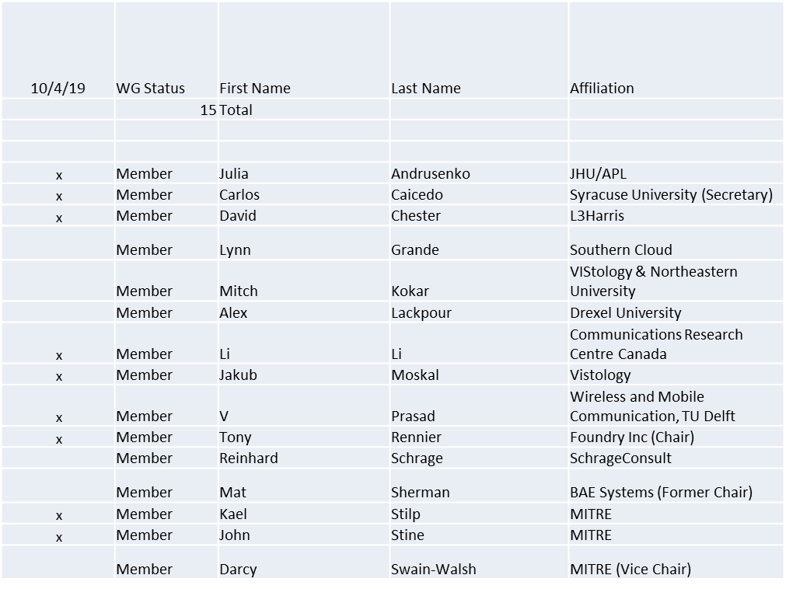

Quorum achieved.
Meeting starts at 2:05 p.m. EDT

1.b. Approval of Agenda

Approval of Agenda from 5-19-0035-00-agen

- Mover: John
- Second: Jakub
Vote: UC

1.c. Patent slides / Notes on status
Patent related slides were presented, no issues came forward

1.d. Approval of recent minutes

Moved to next meeting

2. Status on 1900.5.1

- Reinhard to deliver a final draft of 1900.5.1 on 9/17/19
- Jenn helped Reinhard obtain IEEE approval for the use of any copyrights material in the draft.
- Reinhard obtained W3C approval for use of any of their copyright material in the draft.
- Tony submitted that draft to MEC on 9/18/19
- Tony initiated the start of the 30 day ballot invitation on 9/16/19
- Tony distributed the draft and initiated 1900.5 WG letter ballot for a NLT 10/5/19 response to begin a sponsor ballot on 9/21/19
- Oliver to initiate a 1900 letter ballot for approval to begin sponsor ballot as soon as the 1900.5 WG letter ballot achieves 2/3 approval
- Reinhard to address any MEC comments on the draft as they come in
- Tony to take whatever other steps are necessary to ensure that sponsor ballot opens by 10/16/19

3. Status of 1900.5.2a

- Held two ad-hocs in Sept
- Noted some recent required changes
- Completed draft standard document planned for the end of October
  - Possible ad-hoc afternoon 18th of October 2pm EDT
- Possible sponsor ballot after F2F (Dec 2019)

4. Status on Architecture / 1900.5 revision

Nothing to report

5. Review of other DySPAN-SC activities

- Sept 2019 Leadership meetings
  - WG Reports
    - 1900.1 WG (Francisco reports)
      - Planning to include new terms generated in the 1900.5 standards
      - Planning for next elections
    - 1900.2 WG (Stephen reports)
      - Focusing on developing test methodology
      - Stephen is investigating who is using the standard and their experience
        - Stephen has used it in FCC proceedings and found it useful, but was looking for other users and their feedback
      - Original purpose: bring objectivity to new spectrum use proposals, such as DSA networks
        - Question: are we serving that purpose or is the standard being used for other applications?
      - Oliver: it is being used heavily in academia (Universities are purchasing it)
        - Used as a benchmark for the analysis of interference in academic research
      - Action Item (Stephen): Request information from IEEE’s Jonathan Goldberg about who is using 1900.2 standard and their motivations.
        - Oliver: could catalog publications that reference the standard
      - Action Item (Stephen): Discuss the use of 1900.2 within the FCC and NTIA
    - 1900.6 WG (Oliver reports)
      - 1900.6b PAR extension
        - Has been approved
        - Outstanding work: analysis of the new use cases and their alignment with the base standard use cases
        - Significant effort to complete this process

- Potential New Projects
  - DARPA SC2 Language standardization
    - Action Item (Alex, by Nov 14th) engage Paul Tilghman at DySPAN workshop and discuss his progress on standardizing SC2’s inter-network/PU dynamic collaboration language
  - Machine Learning standardization
    - Action Item (Alex, by Nov 14th): engage Paul Tilghman at DySPAN workshop and discuss his progress on standardizing ML for wireless networks within 3GPP, 802.11, etc...
  - National Spectrum Consortium
    - Action Item (Oliver, by Oct 5th): Continue email discussion with Mat and Apura about use of P1900 standards within NSC projects
  - Restarting the 1900.4 WG
    - Used within academia as a benchmark for DSA architecture
    - Considering how to restart the WG
    - Action Item (Oliver, by Oct 5th): contact Jonathan and ask for advice about best approach for restarting the 1900.4 standard
- Proposed next Plenary meeting date and location:
  - Meet the 1st week of December (Dec 3rd - 5th)
  - Time Zone: Asia-Pacific
  - Location: Online (no host)
  - Action Item (ALL, by Sep 27th)
    - All WG Chairs to verify that Dec 3rd - 5th works for plenary & WG meetings for a sufficient number of their WG members

6. 1900.5 marketing inputs

- DySPAN paper 1900.5.1 accepted and on the conference program

7. 1900.5 meeting planning and review

- 1900.5 F2F meeting for Noveber 7 and 8 to take place at MITRE’s facility in McLean, VA. John to host

8. AoB
- None

