an Working Group | IEEE DYSPAN-SC 1900.5
Title | Meeting minutes 0237 for the P1900.5 Meetings of – July 23-25, 2019
DCN | 5-19-0034-00-mins
Date Submitted | 9/5/2019
Source(s) | Carlos Caicedo (Syracuse University)  email: ccaicedo@syr.edu
Abstract | Minutes for the IEEE 1900.5 meetings held on July 23-25, 2019
Notice | This document has been prepared to assist the IEEE DYSPAN-SC. It is offered as a basis for discussion and is not binding on the contributing individual(s) or organization(s). The material in this document is subject to change in form and content after further study. The contributor(s) reserve(s) the right to add, amend or withdraw material contained herein.
Release | The contributor grants a free, irrevocable license to the IEEE to incorporate material contained in this contribution, and any modifications thereof, in the creation of an IEEE Standards publication; to copyright in the IEEE’s name any IEEE Standards publication even though it may include portions of this contribution; and at the IEEE’s sole discretion to permit others to reproduce in whole or in part the resulting IEEE Standards publication. The contributor also acknowledges and accepts that IEEE DYSPAN SC may make this contribution public.
Patent Policy | The contributor is familiar with IEEE patent policy, as outlined in Section 6.3 of the IEEE-SA Standards Board Operations Manual <http://standards.ieee.org/guides/opman/sect6.html#6.3> and in Understanding Patent Issues During IEEE Standards Development <http://standards.ieee.org/board/pat/guide.html>.
>.

1. Administrivia

1.a Roll Call

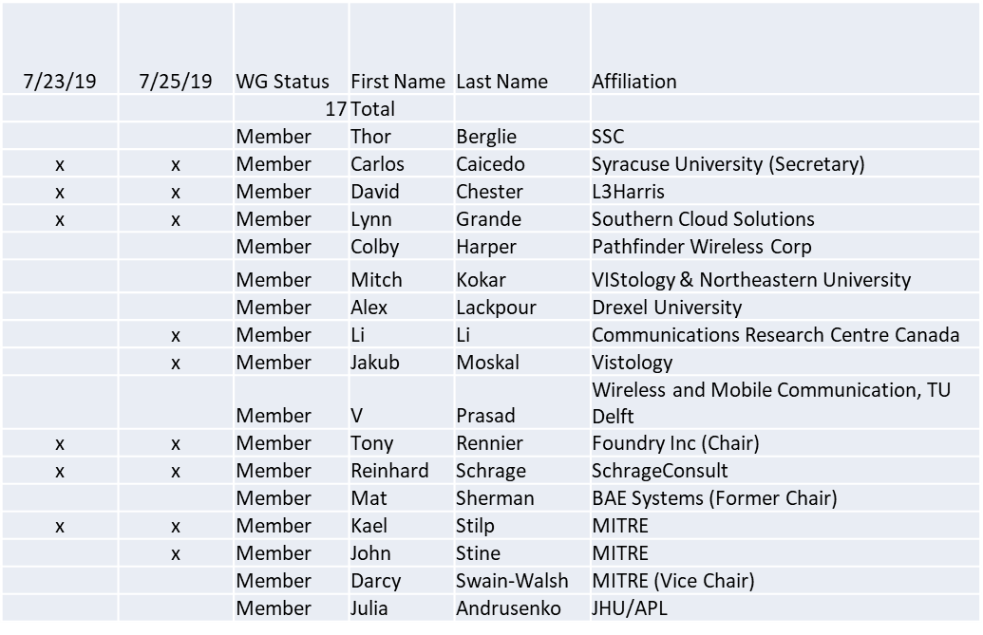

Session of 7/23 did not have quorum. Approvals were moved to session of 7/25/19
Session of 7/25 did have quorum

1.b. Approval of Agenda

Approval of Agenda from 5-19-0029-00

- Mover: John
- Second: Lynn
Vote: UC

1.c. Patent slides / Notes on status
Patent related slides were presented, no issues came forward

1.d. Approval of recent minutes

Motion to approve 6/7/19 WG minutes contained in Doc #: 5-19-0030-00-mins

- Mover: John
- Second: Jakub
Vote: UC

2. Status on 1900.5.1

- PAR Extension approved by email vote (10 members voted to approve)
- PAR Extension submitted to DySPAN approved (NesCom status pending)
- Recirculating planned for 8/5/19
- Lynn checking on the latitude for changes
- Use email coordination on how to properly move forward

3. Status of 1900.5.2a

- PAR Request submitted to DySPAN (status pending)
- John coordinated with Carlos and we agreed that Tony should be making a push to update the spec with all changes that have an effect on the schema.
- Conduct ad hoc on Wednesday (7/24) to go over everything we proposed changing and how those changes were put into the standard. There are quite a few changes.
- Ad hoc on 7/25 (Thursday) for further discussion about those changes and to map out work we should do to clean up what still needs to be done
- Likely we will need to schedule a 1900.5.2a ad hoc in August.

4. Status on Architecture / 1900.5 revision

- Ad-hoc held on 6/28/19

5. Review of other DySPAN-SC activities (Full WG)

- Leadership meetings
  - 7/23/19
- Spectrum Sharing Standards
  - 7/23
    - Panel for DySPAN conference (11/14/19 – workshop, Newark NJ) (Carlos and Alex planning)
      - Looking for 1900.5 panel participation
      - Can we use inputs for spectrum sharing (planning and coordination) language development coming out of the DARPA competition?
    - DSO on hold SA

6. 1900.5 marketing inputs

  - Paper on 1900.5.1 submitted to DySPAN conference
  - International Future Networks (5G and Beyond) conference in Silicon Valley
    - Reinhard received interest in the .1 Policy language will follow up

7. 1900.5 meeting planning and review

- WG electronic only meeting (TBR)
  - 2:30 PM EDT on 8/2/2019

- WG electronic only meeting (TBR)
  - 8:00 AM EDT on 9/6/2019

- Tentative 1900.5 F2F October/November???
  - Review 1900.5.1 update?
  - Deep dive on 1900.5 Rev?
  - Deep dive on 1900.5.2a?

8. AoB
None

