an Working Group | IEEE DYSPAN-SC 1900.5
Title | Meeting minutes 0236 for the P1900.5 Meetings of – June 7, 2019
DCN | 5-19-0030-00-mins
Date Submitted | 7/22/2019
Source(s) | Carlos Caicedo (Syracuse University)  email: ccaicedo@syr.edu
Abstract | Minutes for the IEEE 1900.5 meeting of June 7, 2019
Notice | This document has been prepared to assist the IEEE DYSPAN-SC. It is offered as a basis for discussion and is not binding on the contributing individual(s) or organization(s). The material in this document is subject to change in form and content after further study. The contributor(s) reserve(s) the right to add, amend or withdraw material contained herein.
Release | The contributor grants a free, irrevocable license to the IEEE to incorporate material contained in this contribution, and any modifications thereof, in the creation of an IEEE Standards publication; to copyright in the IEEE’s name any IEEE Standards publication even though it may include portions of this contribution; and at the IEEE’s sole discretion to permit others to reproduce in whole or in part the resulting IEEE Standards publication. The contributor also acknowledges and accepts that IEEE DYSPAN SC may make this contribution public.
Patent Policy | The contributor is familiar with IEEE patent policy, as outlined in Section 6.3 of the IEEE-SA Standards Board Operations Manual <http://standards.ieee.org/guides/opman/sect6.html#6.3> and in Understanding Patent Issues During IEEE Standards Development <http://standards.ieee.org/board/pat/guide.html>.
>.

1. Administrivia

1.a Roll Call

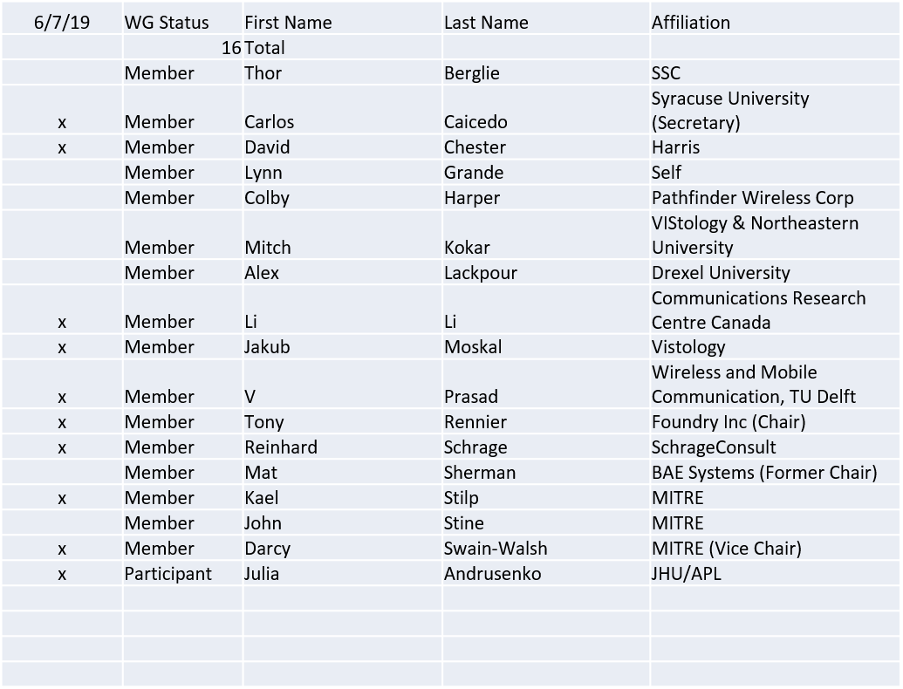

Quorum achieved.
Meeting starts at 2:05 p.m. EDT

1.b. Approval of Agenda

Approval of Agenda from 5-19-0024-00

- Mover: Carlos
- Second: Dave
Vote: UC

1.c. Patent slides / Notes on status
Patent related slides were presented, no issues came forward

1.d. Approval of recent minutes

Motion to approve 5/3/19 WG meeting minutes contained in Doc #:5-19-0026-00-mins
- Mover: Reinhard
- Second: Jakub
Vote: UC

2. Status on 1900.5.1

- Ad hoc scheduled to cover latest document changes
- Recirculation planned for 7/31/2019

Vote on 1900.5.1 PAR extension contained in Doc #5-19-0025-00-mmat will be conducted by e-mail. It extends the PAR to 12/31/2020.

3. Status of 1900.5.2a

- Still working on schema setup
  - Carlos - making more improvement for the next month
  - Kael - Working on XSLT to match the schema
  - Still working on conceptual rules

4. Status on Architecture / 1900.5 revision

- Ad/hoc took place on 5/31/2019
- Dave has made a significant contribution
- Encourage everyone to read and comment

5. Review of other DySPAN-SC activities

- Resolving feedback on DySPANS-SC P&Ps from reviewers
- DySPAN-SC July Meeting Update
  - Meeting dates: July 23rd - 25th
  - No one traveling – therefore virtual meetings
    - 9 – 5:30pm BST
    - Estimated time per WG
    - 1900.1: one ad hoc session
      - Future work: e.g., incorporating 1900.5 terms into 1900.1
    - 1900.2: one ad hoc session
    - 1900.5: Several sessions, tbd...
      - General meeting
      - Architecture ad hoc
    - 1900.6: three sessions – one per day

6. 1900.5 marketing inputs

  - DySPAN papers extended to 6/25 Carlos and Reinhard working on a paper – looking good
  - Spectrum Collaboration challenge Workshop paper deadline the middle of September
  - Dave’s paper on 1900.5a is the start

7. 1900.5 meeting planning and review
- WG electronic only meeting (TBR)
  - 8:00 AM EDT (UTC-4) on 7/5/2019
    - Mat indicates that the “ask” for alternating meeting times should be revised. Do we want to continue or pick a standard time?
  - Meeting of July 5, moved to the 7/23 – 7/25 dates
    - Motion to move voted on and approved UC
      - Mover: Reinhard
      - Second: Carlos
      - Vote: UC

- Planning for the DySPAN-SC July virtual meeting in London
  - July 23-25
  - Final schedule will be sent/defined in a few days

Tentative F2F meeting for September.

8. AoB
- None

