an Working Group | IEEE DYSPAN-SC 1900.5
Title | Meeting minutes 0235 for the P1900.5 Meetings of – May 3, 2019
DCN | 5-19-0026-00-mins
Date Submitted | 6/3/2019
Source(s) | Carlos Caicedo (Syracuse University)  email: ccaicedo@syr.edu
Abstract | Minutes for the IEEE 1900.5 meeting of May 3, 2019
Notice | This document has been prepared to assist the IEEE DYSPAN-SC. It is offered as a basis for discussion and is not binding on the contributing individual(s) or organization(s). The material in this document is subject to change in form and content after further study. The contributor(s) reserve(s) the right to add, amend or withdraw material contained herein.
Release | The contributor grants a free, irrevocable license to the IEEE to incorporate material contained in this contribution, and any modifications thereof, in the creation of an IEEE Standards publication; to copyright in the IEEE’s name any IEEE Standards publication even though it may include portions of this contribution; and at the IEEE’s sole discretion to permit others to reproduce in whole or in part the resulting IEEE Standards publication. The contributor also acknowledges and accepts that IEEE DYSPAN SC may make this contribution public.
Patent Policy | The contributor is familiar with IEEE patent policy, as outlined in Section 6.3 of the IEEE-SA Standards Board Operations Manual <http://standards.ieee.org/guides/opman/sect6.html#6.3> and in Understanding Patent Issues During IEEE Standards Development <http://standards.ieee.org/board/pat/guide.html>.
>.

1. Administrivia

1.a Roll Call

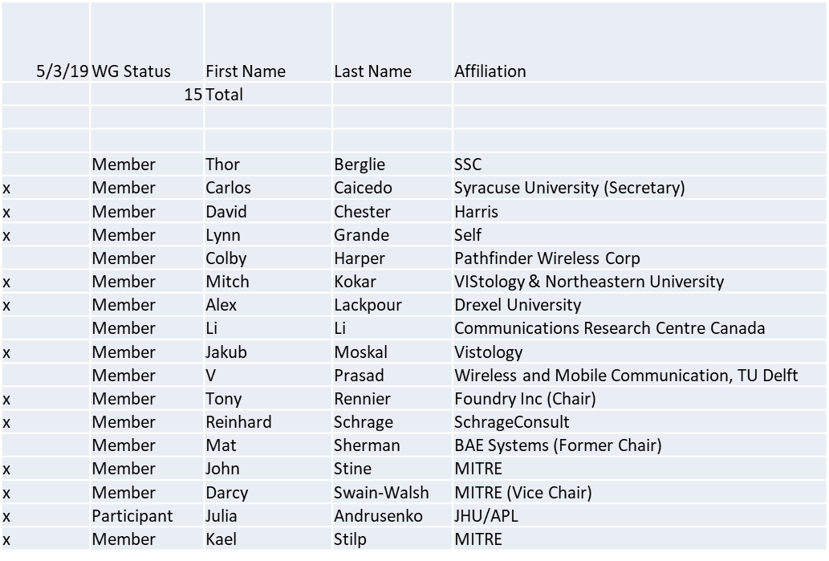

Quorum achieved.
Meeting starts at 8:05 a.m. EDT

1.b. Approval of Agenda

Approval of Agenda from 5-19-0021-00

- Mover: Dave
- Second: Lynn
Vote: UC

1.c. Patent slides / Notes on status
Patent related slides were presented, no issues came forward

1.d. Approval of recent minutes

Motion to approve 4/5/19 WG meeting minutes contained in Doc #:5-19-0020-00-mins
- Mover: Dave
- Second: Jakub
Vote: UC

2. Status on 1900.5.1

- Addressing comments made in the F2F
  - Making progress
- Working on boilerplate for using the policy language
  - Started on a geo policy
  - Reinhard to post material for review in ad-hoc
- Spent time discussing RDL with RIF Core because of problems
  - RIF core abandoned but Oxford representation on OWL 2 EL showed fatal flaw
  - Developed a filter to disallow the combination that leads to failure
  - Lynn to review standards procedure to find out how to address changes to the 1900.5.1 draft that have taken place since it was submitted to draft ballot
Proposed updated schedule for standard development requires PAR extension.

3. Status of 1900.5.2a

- Carlos met with John and Kael on .2a revised PAR
- Two parallel efforts to update synchronously
  - Schemas and validation rules
  - Document
- Lynn to research if we need to coordinate with DySPAN on PAR items
- Tony to submit revised PAR once approved

4. Status on Architecture / 1900.5 revision

- No contributions were available for April meeting
- Lynn and Dave working on contributions for May meeting

5. Review of other DySPAN-SC activities

Leadership meetings:

- 4/29/19 Meeting Postponed and will become an email meeting – Tony to submit .2a revised PAR

Spectrum sharing standards:
- Proposal to create Dynamic spectrum sharing collaborating language
  - Email into John Chapin who is sharing with DARPA
- AWS-3 R&D work awaiting sponsor approval

6. 1900.5 Marketing inputs
- Mark Norton briefed on standards related to 5G at recent NSC event
  - Didn’t mention 1900 only 802, need to establish 1900.5 as part of 5G
  - Mark is aware but we need to make the case
    - We need to come to consensus before we engage Mark
- Carlos still working on .1 paper for DySPAN
  - Will discuss with Reinhard within 2 weeks
- Carlos is the DySPAN’s conference workshop Chair – Conference to take place in Newark NJ in Nov – Call for papers deadline is currently 5/31/2019
  - Spectrum collaboration
  - MM wave comms
- Dave still working on paper

7. 1900.5 meeting planning and review

- WG electronic only meeting
  - 2:30 PM EDT (UTC-4) on 6/7/2019
- WG electronic only meeting (TBR)
  - 8:00 AM EDT (UTC-4) on 7/5/2019
- Planning for the DySPAN-SC July F2F meeting in London
  - 1 room. 5 people?
  - Plenary timings: PM1 first day, and PM2 last day.
  - London time zone. 9-5.30. 4x1.5 hour sessions
  - 2nd week in July

Tentative F2F meeting for September.

8. Aproval of 1900.5.2a revised PAR

- Motion to approve 1900.5.2a Revised PAR in Doc #: 5-19-0022-00-mmat
  - Mover: Carlos
  - Second: Lynn
  - Vote: UC

9. Approval of 1900.5.1 WG Ballot Comment Responses
- Motion to approve 1900.5.1 Response to WG Ballot Comments in Document#: 5-19-0019-00-subs
  - Mover: Reinhard
  - Second: Lynn
  - Vote: UC

10. AoB
- None

Meeting ends at 9:37 a.m. EST.

