an Working Group | IEEE DYSPAN-SC 1900.5
Title | Meeting minutes 0234 for the P1900.5 Meetings of – April 5, 2019
DCN | 5-19-0020-00-mins
Date Submitted | 5/1/2019
Source(s) | Carlos Caicedo (Syracuse University)  email: ccaicedo@syr.edu
Abstract | Minutes for the IEEE 1900.5 meeting of April 5, 2019
Notice | This document has been prepared to assist the IEEE DYSPAN-SC. It is offered as a basis for discussion and is not binding on the contributing individual(s) or organization(s). The material in this document is subject to change in form and content after further study. The contributor(s) reserve(s) the right to add, amend or withdraw material contained herein.
Release | The contributor grants a free, irrevocable license to the IEEE to incorporate material contained in this contribution, and any modifications thereof, in the creation of an IEEE Standards publication; to copyright in the IEEE’s name any IEEE Standards publication even though it may include portions of this contribution; and at the IEEE’s sole discretion to permit others to reproduce in whole or in part the resulting IEEE Standards publication. The contributor also acknowledges and accepts that IEEE DYSPAN SC may make this contribution public.
Patent Policy | The contributor is familiar with IEEE patent policy, as outlined in Section 6.3 of the IEEE-SA Standards Board Operations Manual <http://standards.ieee.org/guides/opman/sect6.html#6.3> and in Understanding Patent Issues During IEEE Standards Development <http://standards.ieee.org/board/pat/guide.html>.
>.

1. Administrivia

1.a Roll Call

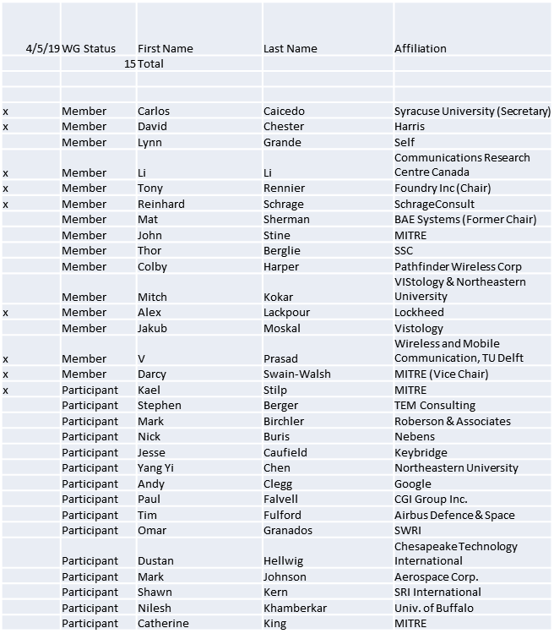

Quorum achieved.
Meeting starts at 2:35 p.m. EDT

1.b. Approval of Agenda

Approval of Agenda from 5-19-0017-00

- Mover: Carlos
- Second: Darcy
Vote: UC

1.c. Patent slides / Notes on status
Patent related slides were presented, no issues came forward

1.d. Approval of recent minutes

Motion to approve 2/1/19 WG minutes contained in Doc #:5-19-0015-00-mins
- Mover: Carlos
- Second: Darcy
Vote: UC

Motion to approve 3/5-7/19 WG minutes contained in Doc #:5-19-0016-00-mins
- Mover: Dave
- Second: Li
Vote: UC

2. Status on 1900.5.1

- Working on comments to the draft ballot
- Adding view from the application’s point of view
  - Inputs from John Stine
  - John may be providing more exemplars
Comment resolution has been re-circulated to the WG
Submission to sponsor ballot planned for June/2019.
Proposed updated schedule for standard development requires PAR extension.

3. Status of 1900.5.2a

- Draft update to PAR created
  - Draft under review
- Carlos collaborating with Kael/John et. al.
  - Working toward refining the schema
  - Looking at rule set and ensuring that they are consistent
  - 2 weeks to get through current material

4. Status on Architecture / 1900.5 revision

PAR approved 3/21/19.
An ad-hoc meeting will take place in April

5. Review of other DySPAN-SC activities

Discussion with 1900.2 WG on the opportunities for Spectrum Sharing Standards

6. 1900.5 marketing inputs

- DySPAN Conference will take place in Newark NJ
  - 5/31/19 is the deadline for papers
  - Looking to submit paper on .1 – Carlos to start
    - Have a draft by May WG meeting
  - Dave to look at 1900.5 update paper radio->network

- IEEE Communications Standards Conference
  - 6/1/19 paper deadline
  - Maybe submit a paper on .2a…

7. 1900.5 meeting planning and review

WG electronic only meetings:
8:00 AM EDT (UTC-4) on 5/3/2019
2:30 PM EDT (UTC-4) on 6/7/2019

Tentative F2F meeting for September.

8. AoB
- None

9. Approval of 1900.5.2a Revised PAR

Postponed to May meeting. John and Carlos to provide additional revisions to PAR document.

10. Approval of 1900.5.1 WG Ballot Comment Responses

Postponed to May meeting

Meeting ends at 3:35 p.m. EST.

