an Working Group | IEEE DYSPAN-SC 1900.5
Title | Meeting minutes 0233 for the P1900.5 Meetings of – March 5-7, 2019
DCN | 5-19-0016-00-mins
Date Submitted | 3/15/2019
Source(s) | Carlos Caicedo (Syracuse University)  email: ccaicedo@syr.edu
Abstract | Minutes for the IEEE 1900.5 F2F meetings held on March 5-7, 2019
Notice | This document has been prepared to assist the IEEE DYSPAN-SC. It is offered as a basis for discussion and is not binding on the contributing individual(s) or organization(s). The material in this document is subject to change in form and content after further study. The contributor(s) reserve(s) the right to add, amend or withdraw material contained herein.
Release | The contributor grants a free, irrevocable license to the IEEE to incorporate material contained in this contribution, and any modifications thereof, in the creation of an IEEE Standards publication; to copyright in the IEEE’s name any IEEE Standards publication even though it may include portions of this contribution; and at the IEEE’s sole discretion to permit others to reproduce in whole or in part the resulting IEEE Standards publication. The contributor also acknowledges and accepts that IEEE DYSPAN SC may make this contribution public.
Patent Policy | The contributor is familiar with IEEE patent policy, as outlined in Section 6.3 of the IEEE-SA Standards Board Operations Manual <http://standards.ieee.org/guides/opman/sect6.html#6.3> and in Understanding Patent Issues During IEEE Standards Development <http://standards.ieee.org/board/pat/guide.html>.
>.

1. Administrivia

1.a Roll Call

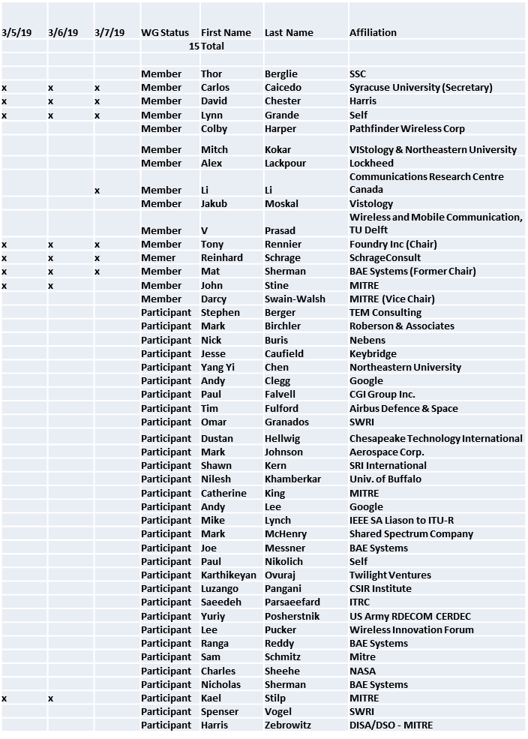

General meeting session of 3/5/ 2019 starts at 11:15 a.m. However these minutes capture information and decisions deliberated in ad-hoc session held from March 5 to March 7/2019.

1.b. Approval of Agenda

Approval of Agenda from 5-19-0011-00

No quorum

1.c. Patent slides / Notes on status
Patent related slides were presented, no issues came forward

1.d. Approval of recent minutes

No minutes brought to approval. Deferred to April session

2. Status on 1900.5.1

- WG Draft Ballot approved
- Draft responses to comments created
- PAR Extension beyond 6/19 will be required
- From ad-hoc of March 6
  - RIF-SCM language is defined in the standard
  - Minimum Herbrand semantics used in RIF-SCM
  - Reinhard using SCMs with random values in current examples mentioned in the draft standard

3. Status of 1900.5.2a

- Carlos provided feedback to John’s team.
- A second draft of the standard has been created by John’s team along with:
  - Java classes, JSON schema and XML schema
  - POC created – to be shown in ad-hoc (March 5)
- Good progress/moving fast/need schedule

- (From ad-hoc of March 5) John presented on the need to expand scope of 1900.5.2a to include improvements to the 1900.5.2 base standard.
  - ACTION: Tony needs to convert 1900.5.2a from a PAR that specifies an amendment of 1900.5.2 to one that specifies a revision to 1900.5.2. The revision will include:
    - Fix errors
    - Add validation rules
    - Provide normative schemas

4. Status on Architecture / 1900.5 revision

- 2/22/19 ad-hoc held reviewed possible high-level use cases and requirements
- Still fielding request to update PAR language
- (From ad-hoc of March 6) Discussed the need for the architecture to be a systems architecture and that it be SOA-based
  - Focus on a control plane architecture
  - Hierarchical reasoners + Peer reasoners
  - Need to define interactions between reasoners
- (From ad-hoc of March 7) Discussed network node modeling and the need for concrete definitions for each term. May request update to .1
  - Need to define specific capabilities of a reasoner or separate classes of reasoners with different capabilities.

5. Review of other DySPAN-SC activities

From: Leadership meeting of March 5/2019
- Finances good
- Discussion on P&Ps
- Possible new PAR on Standard Language for Enabling Spectrum Sharing
- Possible exploration of .2 for non-cognitive spectrum sharing

6. 1900.5 marketing inputs

- Paper on 1900.5.2 published
- Paper on vita49 and 1900.5.2

7. 1900.5 meeting planning and review

- Next WG electronic only meeting
  - 2:30 PM EDT (UTC-4) on 4/5/2019

8. AoB
- None

Meeting ends at 3:35 p.m. EST.

