an Working Group | IEEE DYSPAN-SC 1900.5
Title | Meeting minutes 0232 for the P1900.5 Meeting of February 1, 2019
DCN | 5-19-0015-00-mins
Date Submitted | 03/14/2019
Source(s) | Carlos Caicedo (Syracuse University)  email: ccaicedo@syr.edu
Abstract | Minutes for the IEEE 1900.5 meeting held on February 1, 2019
Notice | This document has been prepared to assist the IEEE DYSPAN-SC. It is offered as a basis for discussion and is not binding on the contributing individual(s) or organization(s). The material in this document is subject to change in form and content after further study. The contributor(s) reserve(s) the right to add, amend or withdraw material contained herein.
Release | The contributor grants a free, irrevocable license to the IEEE to incorporate material contained in this contribution, and any modifications thereof, in the creation of an IEEE Standards publication; to copyright in the IEEE’s name any IEEE Standards publication even though it may include portions of this contribution; and at the IEEE’s sole discretion to permit others to reproduce in whole or in part the resulting IEEE Standards publication. The contributor also acknowledges and accepts that IEEE DYSPAN SC may make this contribution public.
Patent Policy | The contributor is familiar with IEEE patent policy, as outlined in Section 6.3 of the IEEE-SA Standards Board Operations Manual <http://standards.ieee.org/guides/opman/sect6.html#6.3> and in Understanding Patent Issues During IEEE Standards Development <http://standards.ieee.org/board/pat/guide.html>.
>.

1. Administrivia

1.a Roll Call

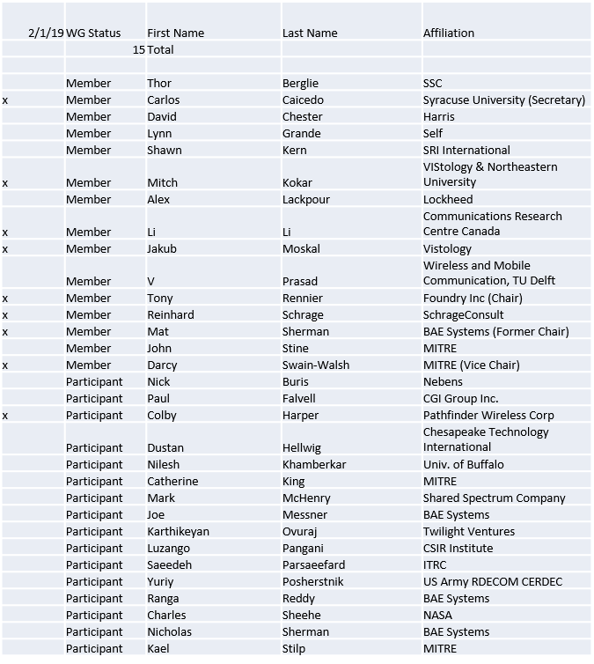

Quorum achieved.
Meeting starts at 2:35 p.m. EST

1.b. Approval of Agenda

Approval of Agenda contained in 5-19-0006-00
- Mover: Mat
- Second: Carlos

Vote: UC

1.c. Patent slides / Notes on status
Patent related slides were presented, no issues came forward

1.d. Approval of recent minutes

Motion to approve 12/6-7/18 WG minutes contained in Doc #:5-19-0002-00-mins
- Mover: Mat
- Second: Carlos

Vote: UC

Motion to approve 1/18/19 WG minutes contained in Doc #:5-19-0005-00-mins
- Mover: Li
- Second: Darcy

Vote: UC

2. Status on 1900.5.1

- Reinhard used one of John’s December example to make RIF examples
- PAR Extension beyond 6/19 will be required
- Further discussion on .5.1 in ad-hoc today

3. Status of 1900.5.2a

- John submitted draft document
  - Uses Java to define structure and the rules
  - Is addressing some concerns (constructs and naming)
- Carlos working with XML and matching 1900.5.2
  - Some corrections need to be made
- Looking toward a mutual verification at March meeting

4. Status on Architecture / 1900.5 revision

- Ad-hoc held 1/25/19 1-3pm EST
- Add
  - Identify business process (and definition) as a higher org than use case.
  - Use of Evidence that is not Policy i.e. Spectrum Sensor outputs
  - Machine Learning
- Next ad-hoc is planned for 2/22/19 1-2:30pm EST

5. Review of other DySPAN-SC activities

Status of DySPAN workgroups discussed:
- .1 Definitions going to hibernation
- .2 NTR (most popular)
- .4 Hibernation
- .5 Awesome
- .6 Kicking along
- .7 Hibernation

DySPAN-SC Finances are good

- Architecture / API Study Group
  - Dormant

- Machine Learning Study Group
  - Mat suggests that the group should be combined with 1900.5 architecture

6. 1900.5 marketing inputs

NTR

7. 1900.5 meeting planning and review

- Face to Face in March for DySPAN-SC
  - Cape Canaveral, FL
  - March 5-7 / 2019

- Next WG electronic only meeting
  - 2:30 PM EDT (UTC-4) on 4/5/2019

8. AoB
- None

Meeting ends at 3:35 p.m. EST.

