an Working Group | IEEE DYSPAN-SC 1900.5
Title | Meeting minutes 0231 for the P1900.5 Meeting of January 18, 2019
DCN | 5-19-0005-00-mins
Date Submitted | 01/31/2019
Source(s) | Carlos Caicedo (Syracuse University)  email: ccaicedo@syr.edu
Abstract | Minutes for the IEEE 1900.5 meeting held on January 18, 2019
Notice | This document has been prepared to assist the IEEE DYSPAN-SC. It is offered as a basis for discussion and is not binding on the contributing individual(s) or organization(s). The material in this document is subject to change in form and content after further study. The contributor(s) reserve(s) the right to add, amend or withdraw material contained herein.
Release | The contributor grants a free, irrevocable license to the IEEE to incorporate material contained in this contribution, and any modifications thereof, in the creation of an IEEE Standards publication; to copyright in the IEEE’s name any IEEE Standards publication even though it may include portions of this contribution; and at the IEEE’s sole discretion to permit others to reproduce in whole or in part the resulting IEEE Standards publication. The contributor also acknowledges and accepts that IEEE DYSPAN SC may make this contribution public.
Patent Policy | The contributor is familiar with IEEE patent policy, as outlined in Section 6.3 of the IEEE-SA Standards Board Operations Manual <http://standards.ieee.org/guides/opman/sect6.html#6.3> and in Understanding Patent Issues During IEEE Standards Development <http://standards.ieee.org/board/pat/guide.html>.
>.

1. Administrivia

1.a Roll Call

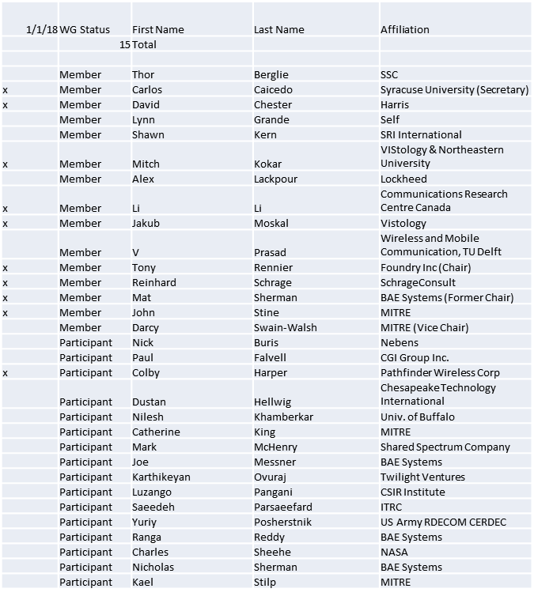
Quorum achieved.
Meeting starts at 8:07 a.m. EST

1.b. Approval of Agenda

Approval of Agenda contained in 5-18-0039-01
- Mover: Mat
- Second: Reinhard

Vote: UC

1.c. Patent slides / Notes on status
Patent related slides were presented, no issues came forward

1.d. Approval of recent minutes

Motion to approve WG minutes
- Moved to next meeting

2. Status on 1900.5.1

- SHACL Review
  - Possible issue combining RIF with OWL; can’t import Turtle
- Assessing examples from John
  - More coming from John by the next meeting...
- Active ballot for standard due 2/15/19

3. Status of 1900.5.2a

- MITRE team working on schemas, JAVA conversion to JSON first then XML
  - Planning to have some early release prior to next monthly
- Still looking at correctness of current schema
  - Noted some small tweaks between JSON and XML schema

4. Status on Architecture / 1900.5 revision
- Architecture Status
  - PAR submitted by Mat
    - From December meeting
      - PAR approved by DySPAN-SC on 11/29/18 unanimously
      - Submitting PAR to NesCom (Lynn Grande has action)
  - Ad-hoc planned for 1/23/19 9-11 am

5. Review of other DySPAN-SC activities
- Leadership meetings
  - Nothing to report
- Architecture / API Study Group
  - Going away. We are the 1900.5 Architecture group
- Machine Learning Study Group
  - Focus: Should we change anything to facilitate the advances in ML into cognitive radio/network design/operations
  - May go inactive…

6. 1900.5 marketing inputs

- NSC – Status
  - Some progress on .2
  - More difficult with .1. It is difficult to market it and make people understand it (Currently)

7. 1900.5 meeting planning and review

- Monthly Moving to Friday’s
  - Use the 1st Friday of each month
  - Alternate between morning and afternoon starting times every other month
- Next WG Electronic meeting
  - 2:30 PM EST (UTC-5) on 2/1/2019
  - Note Time Change!
    - Will flip between 8 AM and 2:30 PM alternate meetings…
- Face to Face in March for DySPAN-SC
  - Cape Canaveral, FL
  - March 5-7 / 2019

8. AoB
- Need to close the 1900.5.1 ballot 1 week prior to the F2F 2/25/19

Meeting ends at 9:25 a.m. EST.

