an Working Group | IEEE DYSPAN-SC 1900.5
Title | Meeting minutes 0230 for the P1900.5 Meetings of – December 6-7, 2018
DCN | 5-19-0002-00-mins
Date Submitted | 1/20/2019
Source(s) | Carlos Caicedo (Syracuse University)  email: ccaicedo@syr.edu
Abstract | Minutes for the IEEE 1900.5 F2F meetings held on December 6-7, 2018
Notice | This document has been prepared to assist the IEEE DYSPAN-SC. It is offered as a basis for discussion and is not binding on the contributing individual(s) or organization(s). The material in this document is subject to change in form and content after further study. The contributor(s) reserve(s) the right to add, amend or withdraw material contained herein.
Release | The contributor grants a free, irrevocable license to the IEEE to incorporate material contained in this contribution, and any modifications thereof, in the creation of an IEEE Standards publication; to copyright in the IEEE’s name any IEEE Standards publication even though it may include portions of this contribution; and at the IEEE’s sole discretion to permit others to reproduce in whole or in part the resulting IEEE Standards publication. The contributor also acknowledges and accepts that IEEE DYSPAN SC may make this contribution public.
Patent Policy | The contributor is familiar with IEEE patent policy, as outlined in Section 6.3 of the IEEE-SA Standards Board Operations Manual <http://standards.ieee.org/guides/opman/sect6.html#6.3> and in Understanding Patent Issues During IEEE Standards Development <http://standards.ieee.org/board/pat/guide.html>.
>.

1. Administrivia

1.a Roll Call

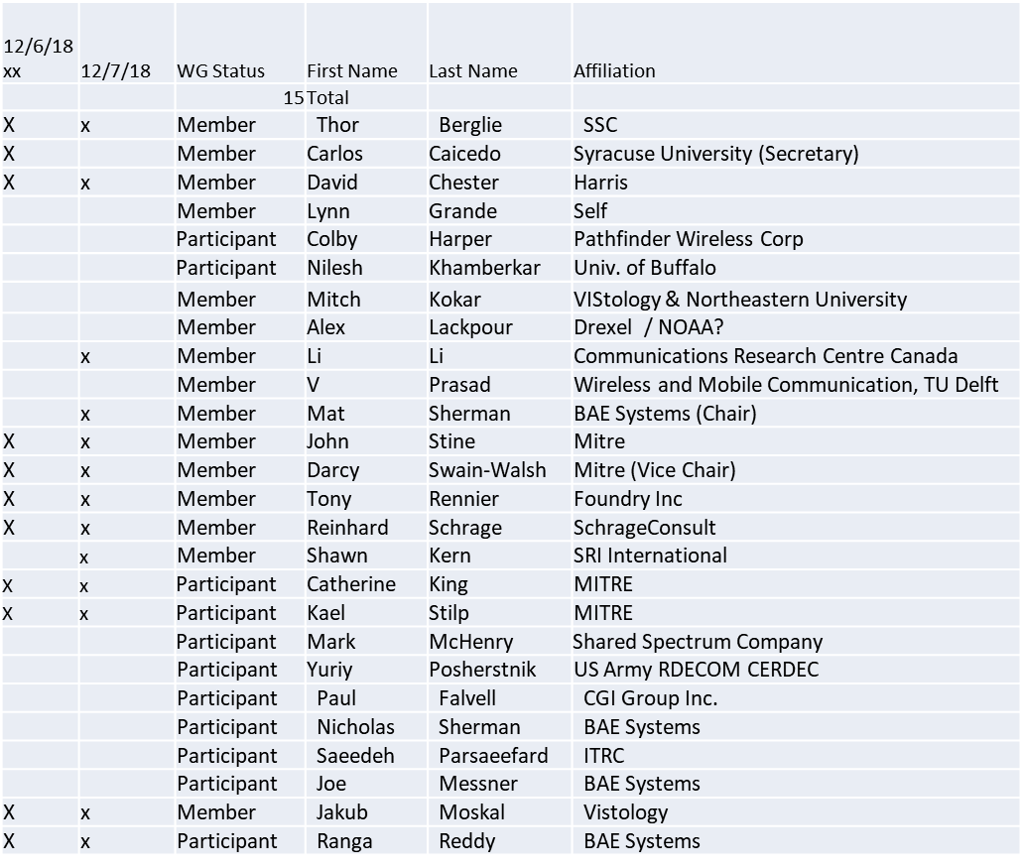

1.b. Approval of Agenda

Approval of Agenda from 5-18-0047-02

Deferred to December 7 session

1.c. Patent slides / Notes on status
Patent related slides were presented, no issues came forward

1.d. Approval of recent minutes

No minutes brought to approval. Deferred to December 7 session

1.e. WG Rules & Election Update

Carlos prefers to keep working as secretary
Several attendees, including Carlos prefer that Tony be nominated for chair.

2. Review of other DySPAN-SC activities (Full WG)

- Leadership sessions
  - Held 2 sessions week on 11/29
  - Discussion points
    - How to re-establish WG after hibernation (membership)
    - P&P Updates – Approved!
      - New WG P&P should go into effect 01 Jan 2019
        - 2 year term for WG officers instead of just 1 year.
      - New DySPAN-SC P&P goes into effect when posted by AudCom
  - DySPAN-SC may make an “offer” to IEEE on a GET DySPAN-SC program
    - Make DySPAN-SC standards available for free after 6 months (TBD)
  - Discussions on Cloud sensing, Machine Learning, Architecture
    - IEEE 802 may have interest in the Cloud sensing (may prefer PAR there)
- Architecture / API Study Group
  - Looks Like 1900.5 has the lead for overall of DySPAN-SC
- Machine Learning Study Group
  - No clear direction
  - Suggest architecture should allow for variety of ML methods

3. 1900.5 marketing inputs

- Working on “Get DySPAN-SC” Program: Seems a long shot.
- NSC – Status (Several projects targeting 1900.5 compliance)
  - Working towards release of project list
- Standards paper in process
  - Communications Magazine – No update
    - 1900.5.1 tutorial in works
    - 1900.5.2 paper accepted (Publication date December?)
  - Paper on 1900.5.2 over VITA 49 Accepted but stalled
    - Review response completed and being resubmitted for consideration
- General set of DySPAN-SC papers for Pub
  - Issue in communications standards magazine
    - Spectrum related standards
    - Issues stalled – ????
    - AI Mat – Ask about this at DySPAN-SC meeting….
      - Response: Sounds like Francesco Benedetto (1900.1 Chair) may lead an effort here

4. Status on Architecture
- PAR approved by DySPAN-SC on 11/29/18 unanimously
  - Submitting PAR to NesCom (Lynn Grande has action)

5. Status on 1900.5.2a / Contributions (Ad Hoc)
- Review of 5-18-0044-00 & 5-18-0045-00

Conversions from Java Classes to JSON schema can be carried out. Should be extended to conversion to XML schema.
- Need to verify Carlos’ XML schema vs. others
SHACL contraints could be added as part of another PAR.

Tools by MITRE will be open source.

Outline for 1900.5.2a document structure was produced and documented in a slide.

Afternoon session
Stine presents from 5-18-0045-00

Should elaborate examples of the policy types that are required in .1 with SCMs as part of the policy, if possible.

SCMs as primitive for .1

Move to USE CASES
- Based on the policy examples?
Main questions (when using SCMs):
Can I use this spectrum ?
What spectrum can be used?

Moved to 1900.5.1 discussion at 4:30 p.m.
- Reinhard presented on the undecidability limitations plaguing first order logic
- OWL Ontology as a knowledge representation tool

December 7 session

Approval of agenda

Motion to approve Agenda contained in 5-18-0047-02
- Mover: John
- Second: Reinhard
Vote: UC

Minutes for approval

Motion to approve WG minutes contained in 5-18-0048-00 & 5-18-0049-00.
- Mover: Tony
- Second: John
Vote: UC

Election status

- New WG rules take effect 1/1/2019
  - Term will be 01/01/2019-01/01/2021 (2 years)
- Review of Nominations received
  - Dave Chester, Elections Officer
    - Chair: Tony
    - Vice Chair: Darcy
    - Secretary: Carlos
- Election Ballot Planning
  - Nominally 14 days closing 12/23/19
    - WG members only
  - Election results to be announced prior to 1/1/19

Motion on 1900.5.1

Approval for WG Chair to ballot with editorial changes as necessary the document 5-18-0050-00 for acceptance as the 1900.5.1 WG Draft. Ballot shall be no less than 45 days.
- Mover: Reinhard
- Second: Tony
Vote:
  - 10 Approve
  - 0 Disapprove
  - 0 Abstain

1900.5 meeting planning and review

- Next WG Electronic meeting
  - 8 AM EST (UTC-5) on Tuesday 08 January 2018
  - Meeting deferred 1 week to avoid Jan 1 Holiday
  - Note Time Change!
    - Will flip between 8 AM and 2:30 PM alternate meetings…
- Face to Face in March for DySPAN-SC
  - Cape Canaveral, FL

AoB
None

