an Working Group | IEEE DYSPAN-SC 1900.5
Title | Meeting minutes 0229 for the P1900.5 Meeting of November 28, 2018
DCN | 5-18-0049-00-mins
Date Submitted | 12/5/2018
Source(s) | Carlos Caicedo (Syracuse University)  email: ccaicedo@syr.edu
Abstract | Minutes for the IEEE 1900.5 meeting held on November 28, 2018
Notice | This document has been prepared to assist the IEEE DYSPAN-SC. It is offered as a basis for discussion and is not binding on the contributing individual(s) or organization(s). The material in this document is subject to change in form and content after further study. The contributor(s) reserve(s) the right to add, amend or withdraw material contained herein.
Release | The contributor grants a free, irrevocable license to the IEEE to incorporate material contained in this contribution, and any modifications thereof, in the creation of an IEEE Standards publication; to copyright in the IEEE’s name any IEEE Standards publication even though it may include portions of this contribution; and at the IEEE’s sole discretion to permit others to reproduce in whole or in part the resulting IEEE Standards publication. The contributor also acknowledges and accepts that IEEE DYSPAN SC may make this contribution public.
Patent Policy | The contributor is familiar with IEEE patent policy, as outlined in Section 6.3 of the IEEE-SA Standards Board Operations Manual <http://standards.ieee.org/guides/opman/sect6.html#6.3> and in Understanding Patent Issues During IEEE Standards Development <http://standards.ieee.org/board/pat/guide.html>.
>.

1. Administrivia

1.a Roll Call

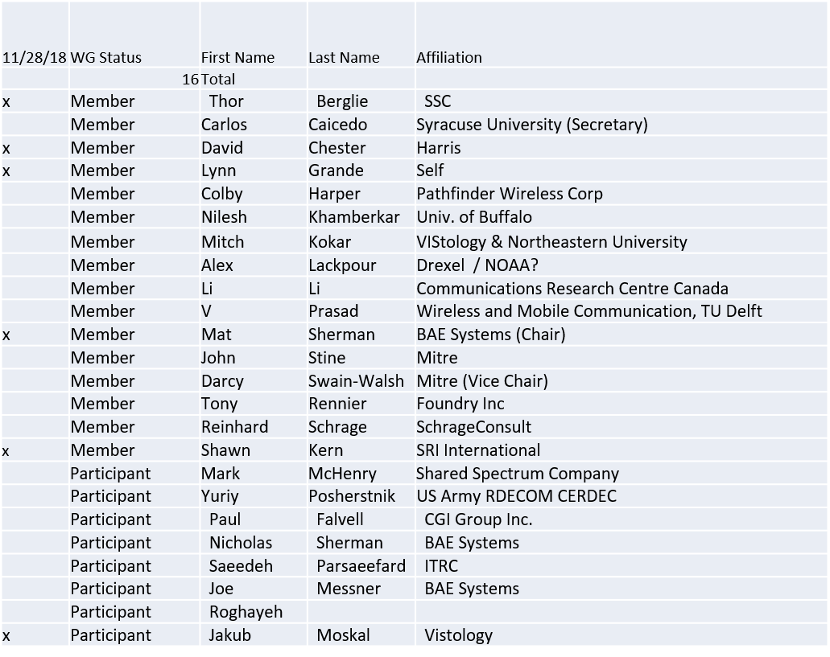

Quorum was not achieved.

1.b. Approval of Agenda

Approval of Agenda contained in 5-18-0042-00

No quorum to approve

1.c. Patent slides / Notes on status
Patent related slides were presented, no issues came forward

1.d. Approval of recent minutes
No minutes available to approve

1.e. Yearly 1900.5 elections
- Per tradition, term of office is Jan 1-Jan 1 (UTC)
- Dave Chester (tentatively) appointed Elections Officer
- Nominations are now open through Dec 6.
- Will conduct electronic ballot for election prior to end of year for 2019 officers of 1900.5

2. Status on 1900.5.1

- Planning completed draft for Dec. Face to Face

3. Status of 1900.5.2a

- Waiting on MITRE contribution for XML and JSON Schemas

4. Status on Architecture
- Editorial update to PAR posted
  - Resolves the one comment received during the original WG ballot on the PAR
- Submitted to DySPAN-SC for consideration
  - Anticipate vote on 11/29

5. Review of other DySPAN-SC activities
- Leadership meetings
  - Report on open leadership meeting for Plenary…
  - P&P Update status – Approved!
    - New WG P&P should go into effect 01 Jan 2019
    - New DySPAN-SC P&P goes into effect when posted by AudCom
  - GET DySPAN-SC status
- Architecture / API Study Group
  - No Update presented
- Machine Learning Study Group
  - No Update presented

6. 1900.5 marketing inputs

- Working on “Get DySPAN-SC” Program
- NSC – Status
  - Working towards release of project list
- Standards paper in process
  - Communications Magazine
    - 1900.5.1 tutorial in works
    - 1900.5.2 paper accepted (Publication moving along – December ?)
  - Paper on 1900.5.2 over VITA 49 Accepted but stalled
    - New review to be answered and pushed to next issue
- General set of DySPAN-SC papers for Pub
  - Issue in communications standards magazine
    - Spectrum related standards
    - Issues stalled ??
    - Task Mat – Ask about this at DySPAN-SC meeting

7. 1900.5 meeting planning and review

- Next WG meeting is a Face to Face (1900.5 only)
  - Dec. 6-7 @ MITRE in Mclean VA (John Stine)
    - Electronic access will also be provided
  - Agenda pending
    - Mostly Ad hoc with short formal WG meeting at beginning and end to organize work and approve results
- Next WG Electronic meeting
  - 8 AM EST (UTC-5) on Tuesday 08 January 2018
  - Meeting deferred 1 week to avoid Jan 1 Holiday
  - Note Time Change!
    - Will flip between 8 AM and 2:30 PM alternate meetings…

- Face to Face in March for DySPAN-SC
  - FL , Cape Canaveral

8. AoB

Meeting ends at 3:20 P.M. EDT.

