an Working Group | IEEE DYSPAN-SC 1900.5
Title | Meeting minutes 0228 for the P1900.5 Meeting of November 6, 2018
DCN | 5-18-0048-00-mins
Date Submitted | 12/4/2018
Source(s) | Carlos Caicedo (Syracuse University)  email: ccaicedo@syr.edu
Abstract | Minutes for the IEEE 1900.5 meeting held on November 6, 2018
Notice | This document has been prepared to assist the IEEE DYSPAN-SC. It is offered as a basis for discussion and is not binding on the contributing individual(s) or organization(s). The material in this document is subject to change in form and content after further study. The contributor(s) reserve(s) the right to add, amend or withdraw material contained herein.
Release | The contributor grants a free, irrevocable license to the IEEE to incorporate material contained in this contribution, and any modifications thereof, in the creation of an IEEE Standards publication; to copyright in the IEEE’s name any IEEE Standards publication even though it may include portions of this contribution; and at the IEEE’s sole discretion to permit others to reproduce in whole or in part the resulting IEEE Standards publication. The contributor also acknowledges and accepts that IEEE DYSPAN SC may make this contribution public.
Patent Policy | The contributor is familiar with IEEE patent policy, as outlined in Section 6.3 of the IEEE-SA Standards Board Operations Manual <http://standards.ieee.org/guides/opman/sect6.html#6.3> and in Understanding Patent Issues During IEEE Standards Development <http://standards.ieee.org/board/pat/guide.html>.
>.

1. Administrivia

1.a Roll Call

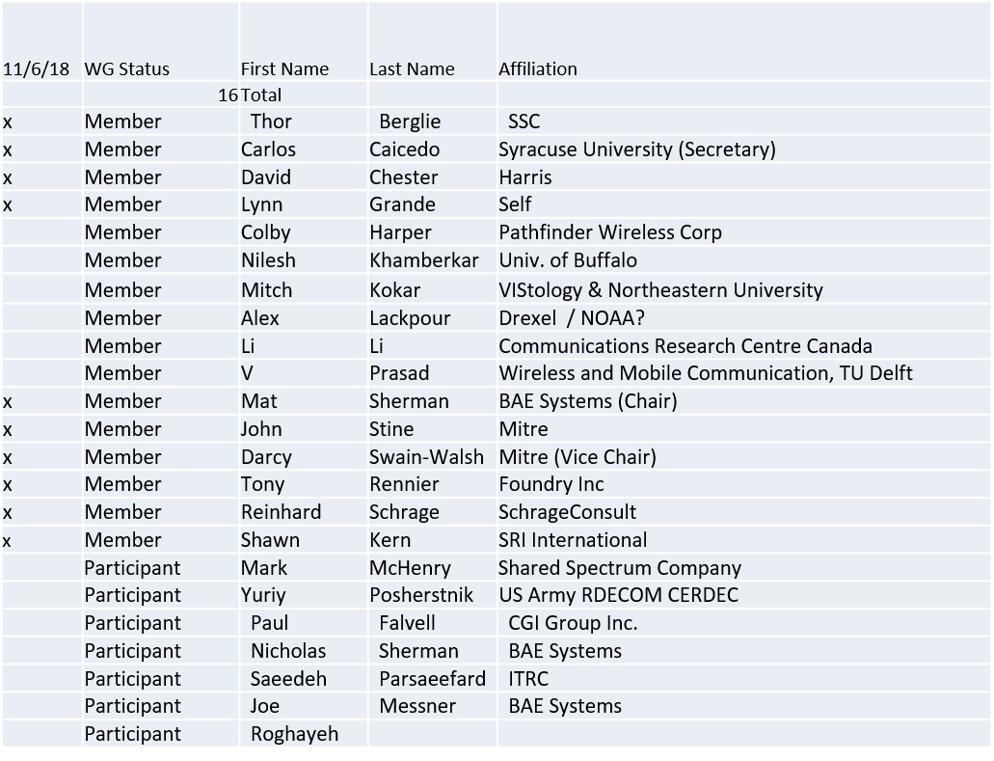

Quorum achieved.

1.b. Approval of Agenda

Approval of Agenda contained in 5-18-0039-01
- Mover: Tony
- Second: Lynn

Vote: UC

1.c. Patent slides / Notes on status
Patent related slides were presented, no issues came forward

1.d. Approval of recent minutes

Motion to approve WG minutes contained in 5-18-0036-00 and 5-18-0040-01

Mover: Reinhard
Second: Tony

Vote: UC

2. Status on 1900.5.1

- Tentative ad-hoc at the end of meeting
- Aligning draft with 1900.5-2011 standard
- Should be ready for vote in December…

3. Status of 1900.5.2a

- PAR Approved
- Editor for the standard: Carlos
- Contributions?
- Call for Contributions?
- Same status as 2 months ago
- Double checking that standard matches schema
- MITRE working XML and JSON versions

4. Status on Architecture
- Proposed 1900.5 Revision PAR approved by WG
  - Should conduct some comment resolution
- Motion to adopt changes suggested by comments in the electronic ballot for the PAR - EB2018-01?
Not forwarding to DySPAN-SC till resolution on language

- Electronic Ballot on Architecture PAR EB2018-01
- Mover: Lynn Grande
- Second: Darcy Swain Walsh
- Vote: Approve: 11 Disapprove: 1 Abstain 1 DNV: 3
MOTION PASSES…

5. Review of other DySPAN-SC activities
- Leadership meetings
  - October meeting deferred
  - Primary focus on updates to WG P&P
  - Planning virtual “far east” plenary Nov 27-29
    - Sync with time in China / Japan
    - When will 1900.5 F2F be
- Architecture / API Study Group
  - No Update presented
- Machine Learning Study Group
  - No Update presented

6. 1900.5 marketing inputs

- Working on “Get DySPAN-SC” Program
- NSC – Status
  - Working towards release of project list
- Standards paper in process
  - Communications Magazine
    - 1900.5.1 tutorial in works
    - 1900.5.2 paper accepted (Publication moving along – December ?)
  - Paper on 1900.5.2 over VITA 49 Accepted but stalled
    - New review to be answered and pushed to next issue
- General set of DySPAN-SC papers for Pub
  - Issue in communications standards magazine
    - Spectrum related standards
    - Issues stalled ??
    - Task Mat – Ask about this at DySPAN-SC meeting

7. 1900.5 meeting planning and review

- Next WG meeting 2:30 PM EST (UTC-5) on Tuesday 04 December 2018 (if no F2F)
  - Doodle Poll on time change suggests 8 AM Tuesday
    - But some key people may be unavailable
    - Skip for December….
  - Other possibilities
    - Rotating schedule between two times
    - Produce minutes earlier to allow non attendees easier engagement
    - Tentative: Mat will flip schedules between 2:30 PM and 8 AM each month
- Face to Face for December? (1900.5 only)
  - Planning virtual “far east” plenary Nov 27-29
    - Mat will schedule one teleconference week of Nov 27-29
    - Call for candidates for elections….
  - Dec. 6-7 Mclean VA (John Stine)
    - Strawpoll: Can attend at least one day: 7+2

- Face to Face in March for DySPAN-SC
  - FL , Cape Canaveral

8. AoB
- FCC released next version of proceeding 3.7-4 GHz…
  - Comments submitted by workgroup seem to have been favorably received

Meeting ends at 3:25 P.M. EDT.

