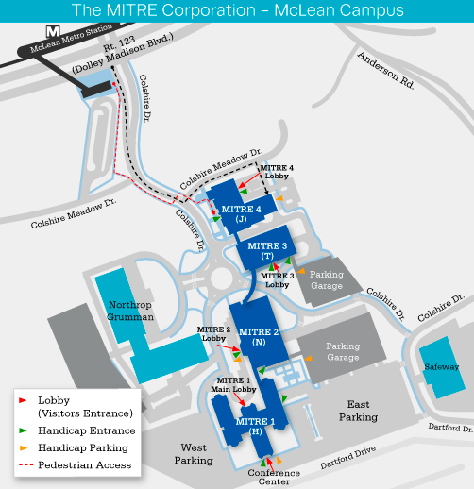

The MITRE Corporation
MITRE 4 Bldg.
7596 Colshire Drive
McLean, VA

Directions to The MITRE Corporation – MITRE 4 Building (J)
From Reagan National Airport
Take the George Washington Parkway North approx. 6 miles to Route 123 South, McLean exit. Exit onto Route 123 (also called Dolley Madison Blvd.) follow south for approx. four miles to traffic light at Colshire Drive (on left). Turn left onto Colshire Drive. Turn left onto Colshire Meadow Drive. Turn right into MITRE 4 parking area, proceed straight into MITRE 4 parking garage (all levels). MITRE 4 Lobby is located on the top level of the garage.
- or -
Take I-66 West. Take Exit 67 to Route 267 (Dulles Toll Road). Take Exit 19A, following signs to Route 123 South, (also called Dolley Madison Blvd.) Tysons Corner. Go to second traffic light, Colshire Drive (on left). Turn left onto Colshire Drive. Turn left onto Colshire Meadow Drive. Turn right into MITRE 4 parking area, proceed straight into MITRE 4 parking garage (all levels). MITRE 4 Lobby is located on the top level of the garage.
From Dulles Airport
Take the Dulles Airport Access and Toll Road to Exit 19. Take Exit 19A, following signs to Route 123 South, (also called Dolley Madison Blvd.), Tysons Corner. Bear right onto Route 123. Go to first traffic light, Colshire Drive (on the left). Turn left onto Colshire Drive. Turn left onto Colshire Meadow Drive. Turn right into MITRE 4 parking area, proceed straight into MITRE 4 parking garage (all levels). MITRE 4 Lobby is located on the top level of the garage.
From Route 495 (Beltway)
Take Exit 46B (McLean, Route 123). Take Route 123 (also called Dolley Madison Blvd) North to the second traffic light and turn right onto Colshire Drive. Turn left onto Colshire Meadow Drive. Turn right into MITRE 4 parking area, proceed straight into MITRE 4 parking garage (all levels). MITRE 4 Lobby is located on the top level of the garage.
By Metrorail
Take the Metro Silver Line train to the McLean Station. After exiting the fare gates, stay to the right and follow signs for "South Entrance/Buses/Parking/Kiss and Ride." Cross the pedestrian bridge over Dolley Madison Blvd. (Rt. 123) and then take the escalator/elevator down to street level before walking uphill on Colshire Drive toward the main MITRE campus. Walking from the fare gates to the MITRE 4 lobby takes about 6 to 10 minutes.
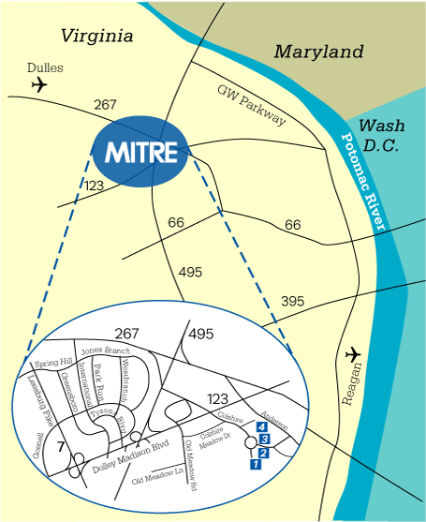

Some Hotels in the Area:
HILTON MCLEAN TYSONS CORNER
7920 Jones Branch Dr.
McLean, VA 22102
Ph: 1-703-847-5000
Parking and an area shuttle are complimentary.

STAYBRIDGE STES MCLEAN
6845 Old Dominion Drive
McLean, VA 22101
Ph: 1-703-448-5400

THE RITZ CARLTON TYSONS CORNER
1700 Tysons Blvd
McLean, VA 22102
Ph: 1-703-506-4300

TYSONS CORNER MARRIOT
8028 Leesburg Pike
Tysons, VA 22182
Ph: 1-703-734-3200

DOUBLETREE BY HILTON MCLEAN TYSONS
1960 Chain Bridge Rd.
McLean, VA 22102
Ph: 1-703-893-2100
An area shuttle is complimentary.

COURTYARD BY MARRIOTT TYSONS CORNER FAIRFAX
1960-A Chain Bridge Rd.
McLean, VA 22102
Ph: 1-703-790-0207

