an Working Group | IEEE DYSPAN-SC 1900.5
Title | Meeting minutes 0227 for the P1900.5 Meeting of October 2, 2018
DCN | 5-18-0040-01-mins
Date Submitted | 11/4/2018
Source(s) | Carlos Caicedo (Syracuse University)  email: ccaicedo@syr.edu
Abstract | Minutes for the IEEE 1900.5 meeting held on October 2, 2018
Notice | This document has been prepared to assist the IEEE DYSPAN-SC. It is offered as a basis for discussion and is not binding on the contributing individual(s) or organization(s). The material in this document is subject to change in form and content after further study. The contributor(s) reserve(s) the right to add, amend or withdraw material contained herein.
Release | The contributor grants a free, irrevocable license to the IEEE to incorporate material contained in this contribution, and any modifications thereof, in the creation of an IEEE Standards publication; to copyright in the IEEE’s name any IEEE Standards publication even though it may include portions of this contribution; and at the IEEE’s sole discretion to permit others to reproduce in whole or in part the resulting IEEE Standards publication. The contributor also acknowledges and accepts that IEEE DYSPAN SC may make this contribution public.
Patent Policy | The contributor is familiar with IEEE patent policy, as outlined in Section 6.3 of the IEEE-SA Standards Board Operations Manual <http://standards.ieee.org/guides/opman/sect6.html#6.3> and in Understanding Patent Issues During IEEE Standards Development <http://standards.ieee.org/board/pat/guide.html>.
>.

1. Administrivia

1.a Roll Call

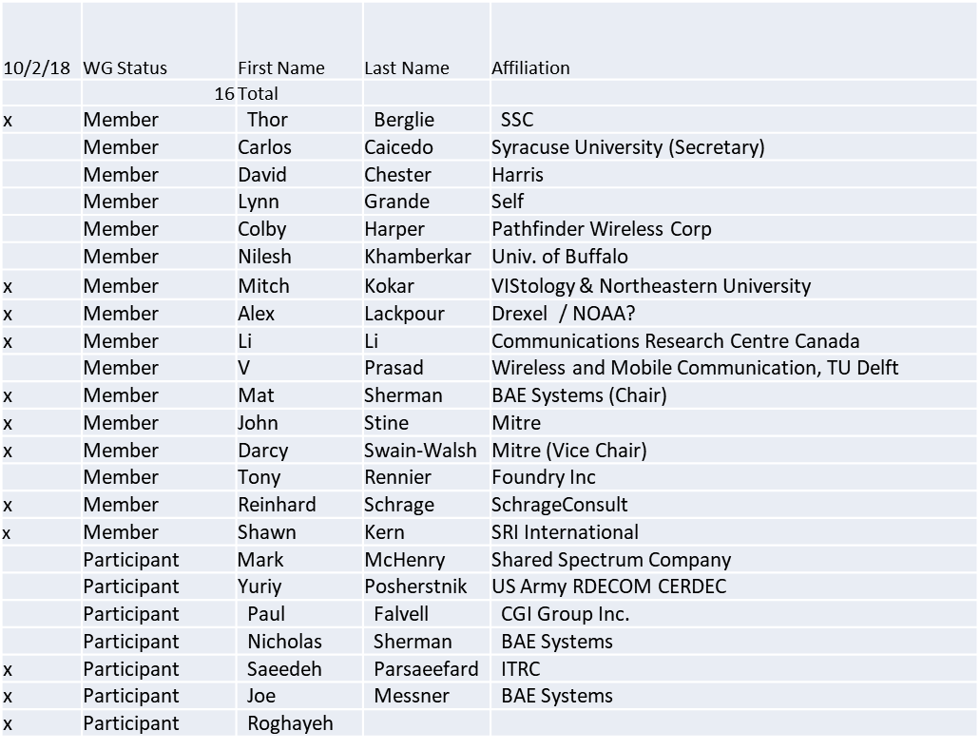

Quorum not achieved. Different people came and went during the meeting but no full quorum at any point.

1.b. Approval of Agenda

Approval of Agenda contained in 5-18-0035-00
- Mover:
- Second:

No quorum for vote

1.c. Patent slides / Notes on status
Patent related slides were presented, no issues came forward
1.d. Approval of recent minutes

Motion to approve WG minutes contained in 5-18-0036-00

Mover:
Second:

No quorum for vote. Moved to next meeting

2. Status on 1900.5.1

- Reinhard provided a status
- The schedule is delayed
- The Chair proposed that some of the work be distributed to others to help with the workload
- Reinhard agreed to prepare something for the ad-hoc that shows where the challenge areas lie

3. Status of 1900.5.2a

- PAR Approved
- Editor for the standard: Carlos
- Contributions?
- Call for Contributions? Not addressed.

4. Status on Architecture
- Proposed 1900.5 Revision PAR approved by WG
  - Should conduct some comment resolution
- Motion to adopt changes suggested by comments in the electronic ballot for the PAR - EB2018-01?
Not forwarding to DySPAN-SC till resolution on language

- Presentation on Cloud Sensing Model for Coexistence of Wi-Fi and Cellular Wireless Networks, ITRC
  - Alex Lackpour asked what piece of this topic we were trying to standardize
    - What information needs to be exchanged and what is needed to make a decision
    - The specific algorithms should not be standardized
    - Should expand to generalized radio networks, not specific standards and protocols
  - This could be applicable in the context of how it influences 1900.5 architecture discussions

- Electronic Ballot on Architecture PAR
  - Lynn Grande was updating to make sure we are addressing networks and not only radios

5. Review of other 1900 activities (1900.1, Leadership meeting etc)
- Leadership meetings
  - Held meeting on 9/26
  - Primary focus on updates to WG P&P/ Required to update the P&Ps every 5 years; currently working the update; will be distributed to the WGs for review
  - Planning virtual “far east” plenary Nov 27-29
    - All will be via webex but the time will synch with time in China/Japan
  - Sync with time in China / Japan
  - Ran short on agenda time
  - Skipped “Get DySPAN-SC” topic
- Architecture / API Study Group
  - No Update presented
- Machine Learning Study Group
  - No Update presented

6. 1900.5 marketing inputs

- Working on “Get DySPAN-SC” Program
- NSC – Status
  - Working towards release of project list
- Standards paper in process
  - Communications Magazine
    - 1900.5.1 tutorial in works
    - 1900.5.2 paper accepted (Publication moving along – December ?)
  - Paper on 1900.5.2 over VITA 49 Accepted (Publication date?)
- General set of DySPAN-SC papers for Pub
  - Issue in communications standards magazine
    - Spectrum related standards
    - Issues stalled – Dec 2018?

7. 1900.5 meeting planning and review

- Next WG meeting 2:30 PM EST (UTC-5) on Tuesday 06 November 2018
  - Should we change our time? Doodle Poll Pending
- Face to Face for November? (1900.5 only)
  - A Doodle Poll will be sent to the workgroup to determine the date of the F2F November meeting. Current meeting place and date options for the meeting are
    - Bedford MA 6-8
    - Melbourne? 12-13 or 16-17
      - Harris (14-15 WinnComm)
  - November 16 – 17 seems to be best date (Melbourne, FL). Dec 6-7 of December is also a good option (McLean, VA)
- Face to Face in March for DySPAN-SC
  - FL , Cape Canaveral

8. AoB
None

Meeting ends at 3:25 P.M. EDT.

