an Working Group | IEEE DYSPAN-SC 1900.5
Title | Meeting minutes 0226 for the P1900.5 Meeting of September 4, 2018
DCN | 5-18-0036-00-mins
Date Submitted | 9/29/2018
Source(s) | Carlos Caicedo (Syracuse University)  email: ccaicedo@syr.edu
Abstract | Minutes for the IEEE 1900.5 meeting held on September 4, 2018
Notice | This document has been prepared to assist the IEEE DYSPAN-SC. It is offered as a basis for discussion and is not binding on the contributing individual(s) or organization(s). The material in this document is subject to change in form and content after further study. The contributor(s) reserve(s) the right to add, amend or withdraw material contained herein.
Release | The contributor grants a free, irrevocable license to the IEEE to incorporate material contained in this contribution, and any modifications thereof, in the creation of an IEEE Standards publication; to copyright in the IEEE’s name any IEEE Standards publication even though it may include portions of this contribution; and at the IEEE’s sole discretion to permit others to reproduce in whole or in part the resulting IEEE Standards publication. The contributor also acknowledges and accepts that IEEE DYSPAN SC may make this contribution public.
Patent Policy | The contributor is familiar with IEEE patent policy, as outlined in Section 6.3 of the IEEE-SA Standards Board Operations Manual <http://standards.ieee.org/guides/opman/sect6.html#6.3> and in Understanding Patent Issues During IEEE Standards Development <http://standards.ieee.org/board/pat/guide.html>.
>.

1. Administrivia

1.a Roll Call

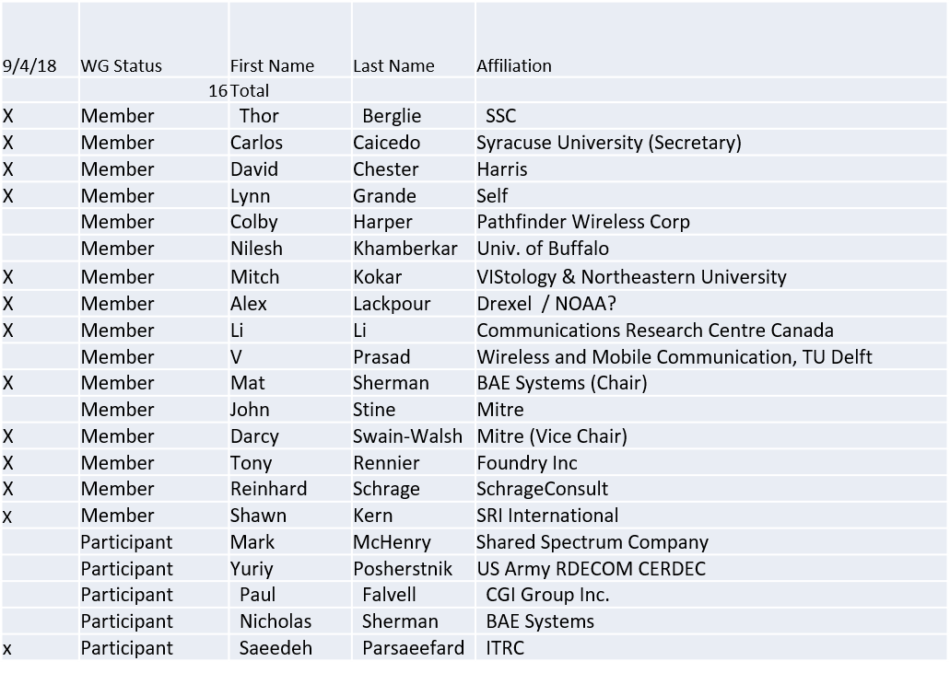

Quorum achieved

1.b. Approval of Agenda

Approval of Agenda contained in 5-18-0031-00
- Mover: Dave
- Second: Mitch

Vote: Approved by unanimous consent

1.c. Patent slides / Notes on status
Patent related slides were presented, no issues came forward

1.d. Approval of recent minutes

Motion to approve WG minutes contained in 5-18-0030-00

Mover: Carlos
Second: Lynn
Discussion – None

Motion approved by unanimous consent

2. Status on 1900.5.1

- Reinhard provided an update on 1900.5.1. He indicated that there are a few items that he is reviewing in preparation for having a draft for review.
- Chair deferred Ad Hoc till October when draft is expected to be complete. May conduct Ad Hocs during WG ballot process

3. Status of 1900.5.2a

- PAR Approved
- Editor for the standard: Carlos
- Contributions? See 5-18-0033-00
  - Initial document posted by Carlos to kick-off standard development process. Will follow next steps stated in the document and report back when they are completed for input from the group
- Call for Contributions? Not addressed.

4. Status on Architecture
- Proposed 1900.5 Revision PAR approved by WG
  - Should conduct some comment resolution
- Motion to adopt changes suggested by comments in the electronic ballot for the PAR - EB2018-01?
  - Otherwise, Chair will bring PAR forward to DySPAN for approval and submission
Motion: For the 1900.5 WG Chair to make any editorial changes as required and forward the draft PAR in document 5-18-0027-00 to the DySPAN-SC Sponsor for approval to submit the PAR for consideration by IEEE SASB.
Mover: Lynn Grande
Second: Darcy Swain Walsh
Vote: Approve: 11 Disapprove: 1 Abstain 1 DNV: 3
MOTION PASSES…

- The Chair will hold off submitting PAR until its description is updated. May have Ad Hoc to resolve this.

5. Review of other 1900 activities (1900.1, Leadership meeting etc)
- Leadership meetings
  - Last meeting in July (Skipped August meeting)
  - WG P&P and DySPAN-SC P&P updates pending
  - Working on Get DySPAN-SC program
  - Bringing back 1900.2 (our most popular standard!)
- Architecture / API Study Group
  - No Update presented
- Machine Learning Study Group
  - No Update presented

6. 1900.5 marketing inputs

- Free download of 1900.5.2 standard is available for WG Members (Note: standard is available to those that were WG members at time of 1900.5.2 approval only)
- Working on “Get DySPAN-SC” Program
- NSC – Status
  - Working towards release of project list
- Standards paper in process
  - Communications Magazine
    - 1900.5.1 tutorial in works
    - 1900.5.2 paper accepted (Publication moving along – December ?)
  - Paper on 1900.5.2 over VITA 49 Accepted (Publication date?)
- General set of DySPAN-SC papers for Pub
  - Issue in communications standards magazine
    - Spectrum related standards

7. 1900.5 meeting planning and review

- Next WG meeting 2:30 PM EDT (UTC-4) on Tuesday 02 October 2018
  - Should we change our time? A Doodle Poll will be sent to select a new time
- Face to Face for November? (1900.5 only)
  - A Doodle Poll will be sent to the workgroup to determine the date of the F2F November meeting. Current meeting place and date options for the meeting are
    - Bedford MA 6-8
    - Melbourne? 12-13 or 16-17
      - Harris (14-15 WinnComm)
- Face to Face in March for DySPAN-SC
  - FL , Cape Canaveral

8. AoB
None

Meeting ends at 3:35 P.M. EDT.

