an Working Group | IEEE DYSPAN-SC 1900.5
Title | Meeting minutes 0225 for the P1900.5 Meetings of – July 23 - 25, 2018
DCN | 5-18-0030-00-mins
Date Submitted | 9/2/2018
Source(s) | Carlos Caicedo (Syracuse University)  email: ccaicedo@syr.edu
Abstract | Minutes for the IEEE 1900.5 meetings held on July 23-25, 2018
Notice | This document has been prepared to assist the IEEE DYSPAN-SC. It is offered as a basis for discussion and is not binding on the contributing individual(s) or organization(s). The material in this document is subject to change in form and content after further study. The contributor(s) reserve(s) the right to add, amend or withdraw material contained herein.
Release | The contributor grants a free, irrevocable license to the IEEE to incorporate material contained in this contribution, and any modifications thereof, in the creation of an IEEE Standards publication; to copyright in the IEEE’s name any IEEE Standards publication even though it may include portions of this contribution; and at the IEEE’s sole discretion to permit others to reproduce in whole or in part the resulting IEEE Standards publication. The contributor also acknowledges and accepts that IEEE DYSPAN SC may make this contribution public.
Patent Policy | The contributor is familiar with IEEE patent policy, as outlined in Section 6.3 of the IEEE-SA Standards Board Operations Manual <http://standards.ieee.org/guides/opman/sect6.html#6.3> and in Understanding Patent Issues During IEEE Standards Development <http://standards.ieee.org/board/pat/guide.html>.
>.

1. Administrivia

1.a Roll Call

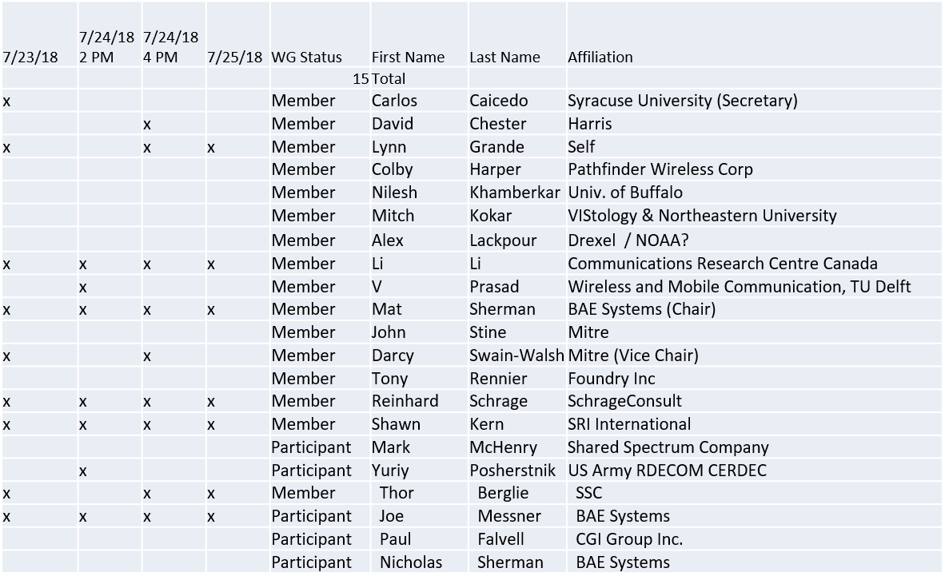

1.b. Approval of Agenda

1900.5 Architecture Ad Hoc (23 July @10 AM)
1900.5.1 Ad Hoc (24 July @ 8 AM)
1900.5 WG Meeting ( 24 July @ 10 AM)
1900.5.1 Ad Hoc (25 July @ 8 AM)

Approval of Agenda from 5-18-0024-00

Mover – Darcy
Second – Lynn
Discussion – None
Motion approved by unanimous consent

1.c. Patent slides / Notes on status
Patent related slides were presented, no issues came forward

1.d. Approval of recent minutes

Motion to approve WG minutes contained in 5-18-0026-00

Mover – Darcy
Second – Lynn
Discussion – None
Motion approved by unanimous consent

2. Status on 1900.5.1

- Reinhard provided an update on 1900.5.1. He indicated that there are a few items that he is reviewing in preparation for having a draft for review.
- Aimed at having a draft complete by September 4 WG meeting
- Mat indicated that he will plan on a WG vote to send the draft to ballot
  - Mat clarified that the vote to ballot does not necessarily mean that everyone agrees with the content, but that the group agrees that it’s ready to go to ballot
  - Mat indicated that there would be a 30 day ballot
3. Status of 1900.5.2a

- Planning to engage in the development of this standard starting in September
  - Carlos to lead effort

4. Status on Architecture
- Review posted draft PAR 5-18-0026-00
  - Recommendation to post the draft on Mentor for all to review
- ACTION ALL: review draft PAR posted on mentor

• Mat indicated that we will be entering a phase with quite a lot of activity, and recommended that everyone think about the time that they can spend on these activities and plan accordingly
- IEEE 1900.5.1 will be coming to balloting
- 1900.5.2a will be kicking off
- Architecture will be ramping up

5. Review of other 1900 activities (1900.1, Leadership meeting etc)

- Leadership meetings
  - WG P&P and DySPAN-SC P&P updates pending
  - 1900.2 revision PAR
- Architecture / API Study Group
  - Ad Hoc during Rome
- Machine Learning Study Group
  - No Ad Hoc
- Discussed the “GET 802” initiative, where the 802 WG uses meeting registration fees to pay IEEE so they can provide the standards for free
- 1900.2 standard is at the end of it’s life. It is currently the top seller of the DySPAN-SC standards (sold 32 copies in the past few months). The ANSI standard is cross-referncing it so it has been discussed a lot.

6. 1900.5 marketing inputs

- NSC – Status
  - Working towards release of project list

- Standards paper in process
  - Communications Magazine
    - 1900.5.1 tutorial in works
    - 1900.5.2 paper accepted (publication date September? )
  - Paper on 1900.5.2 over VITA 49 Accepted (Publication date?)

- Need to update website
  - Mat unable to do so. Lynn will give it a try

- General set of DySPAN papers for Publication
  - Issue on standards spectrum magazine
- No updates on John Chapin (needs copy of 1900.5 standard)

7. 1900.5 meeting planning and review

- No August meeting
- Next WG meeting on Tuesday 04 Sept 2018
  - Usual 2:30 PM ET
- Face to Face for November? (1900.5 only)
  - DC area or Bedford MA?
- Face to Face in March for DySPAN-SC
  - FL , Cape Canaveral

8. AoB
None

