an Working Group | IEEE DYSPAN-SC 1900.5
Title | Meeting minutes 0224 for P1900.5 Monthly Meetings – July 03, 2018
DCN | 5-18-0026-00-mins
Date Submitted | 7/23/2018
Source(s) | Carlos Caicedo (Syracuse University)  email: ccaicedo@syr.edu
Abstract | Minutes for IEEE 1900.5 meeting held on July 3, 2018
Notice | This document has been prepared to assist the IEEE DYSPAN-SC. It is offered as a basis for discussion and is not binding on the contributing individual(s) or organization(s). The material in this document is subject to change in form and content after further study. The contributor(s) reserve(s) the right to add, amend or withdraw material contained herein.
Release | The contributor grants a free, irrevocable license to the IEEE to incorporate material contained in this contribution, and any modifications thereof, in the creation of an IEEE Standards publication; to copyright in the IEEE’s name any IEEE Standards publication even though it may include portions of this contribution; and at the IEEE’s sole discretion to permit others to reproduce in whole or in part the resulting IEEE Standards publication. The contributor also acknowledges and accepts that IEEE DYSPAN SC may make this contribution public.
Patent Policy | The contributor is familiar with IEEE patent policy, as outlined in Section 6.3 of the IEEE-SA Standards Board Operations Manual <http://standards.ieee.org/guides/opman/sect6.html#6.3> and in Understanding Patent Issues During IEEE Standards Development <http://standards.ieee.org/board/pat/guide.html>.
>.

1. Administrivia

1.a Roll Call
Meeting starts at 2:35 p.m. EDT. The participants identified in table 1 were noted.

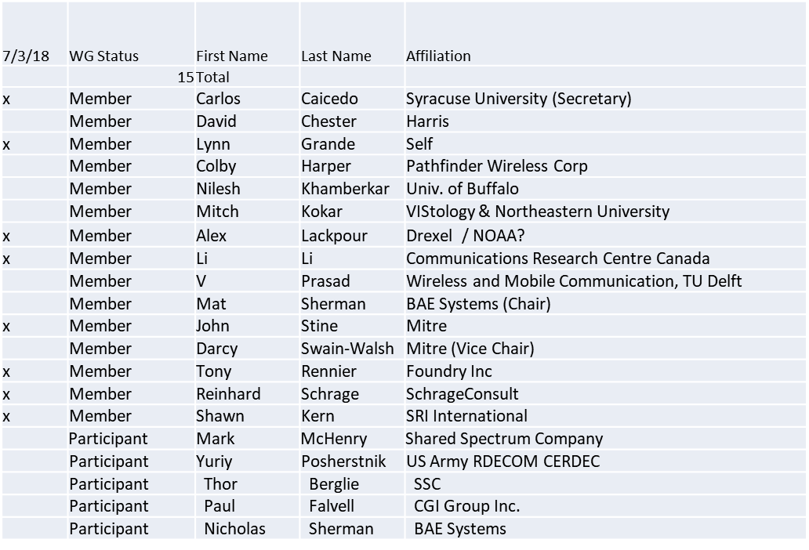

1.b. Approval of Agenda
Approval of Agenda from 5-18-0020-00

Approved by unanimous consent.

1.c. Patent slides / Notes on status
Patent related slides were presented, no issues came forward

1.d. Approval of recent minutes

Motion to approve WG minutes contained in 5-18-0017-00 and 5-18-0022-00

Approved by unanimous consent.

2. Status on 1900.5.1

Reinhard making changes. Discuss in ad-hoc at the end of regular meeting.

3. Status of 1900.5.2

- Base Standard complete and officially released
  - Issue date – 6/26/2018
- DRAFT 1900.5.2a PAR approved
  - Website needs to be updated to reflect the PAR
    - Chair to update website
  - Fully engage with activity in September to kickoff work on standard
    - Discussion on XML based schema to be led by Carlos
    - Also a JSON Schema is available with verification (Mitre)
  - Request interested parties to engage in September

4. Status on Architecture
- Focus on 1900.5.1
- Conducting additional architecture activities while not interfering with 1900.5.1/2
  - Goal is PAR to update base 1900.5 standard in next couple of months

5. Review of other 1900 activities (1900.1, Leadership meeting etc)

- Leadership meetings
  - No meeting for June (Will have full F2F at end of July)
  - WG P&P and DySPAN-SC P&P updates pending
- Architecture / API Study Group
  - Ad Hoc during Rome
- Machine Learning Study Group
  - Ad Hoc during Rome

6. 1900.5 marketing inputs

- NSC – Status
  - Working towards release of project list

- Standards paper in process
  - Communications Magazine
    - 1900.5.1 tutorial in works
    - 1900.5.2 paper accepted (publication expected in June/July )
  - Paper on 1900.5.2 over VITA 49 Accepted (Publication date?)

- Need to update website
  - Mat to complete this task during the month
- General set of DySPAN papers for Publication
  - Issue on standards spectrum magazine
- DARPA – Tony to check with John Chapin on 1900.5 opportunities

7. 1900.5 meeting planning and review

- Ad hocs for:
  - Review of 1900.5.1 or 1900.5 architecture
  - New 1900.5.2 ideas?
  - Will have ad hoc on .1 today

- Next WG meeting on Tuesday, July 24th
  - Tentatively 10:00 EDT (ET 16:00 CEST)
- F2F in Rome Italy, July 23-25
  - Lynn, Reinhard in-person
  - Matt remote…
  - Virtual Ad Hocs?
    - Architecture Ad Hoc
      - 7/23 @ 1600 CEST
    - 1900.5.1 Ad Hoc 7/24 14:00 7/25 14:00 CEST
- No August meeting
  - Next WG meeting 04 Sept. 2018 @ 2:30 PM ET

8. AoB
None

Meeting adjourns at 3:25 p.m.

