an Working Group | IEEE DYSPAN-SC 1900.5
Title | Meeting minutes 0222 for P1900.5 Monthly Meetings – May 08, 2018
DCN | 5-18-0017-00-mins
Date Submitted | 6/2/2018
Source(s) | Carlos Caicedo (Syracuse University)  email: ccaicedo@syr.edu
Abstract | Minutes for IEEE 1900.5 meeting held on May 8, 2018
Notice | This document has been prepared to assist the IEEE DYSPAN-SC. It is offered as a basis for discussion and is not binding on the contributing individual(s) or organization(s). The material in this document is subject to change in form and content after further study. The contributor(s) reserve(s) the right to add, amend or withdraw material contained herein.
Release | The contributor grants a free, irrevocable license to the IEEE to incorporate material contained in this contribution, and any modifications thereof, in the creation of an IEEE Standards publication; to copyright in the IEEE’s name any IEEE Standards publication even though it may include portions of this contribution; and at the IEEE’s sole discretion to permit others to reproduce in whole or in part the resulting IEEE Standards publication. The contributor also acknowledges and accepts that IEEE DYSPAN SC may make this contribution public.
Patent Policy | The contributor is familiar with IEEE patent policy, as outlined in Section 6.3 of the IEEE-SA Standards Board Operations Manual <http://standards.ieee.org/guides/opman/sect6.html#6.3> and in Understanding Patent Issues During IEEE Standards Development <http://standards.ieee.org/board/pat/guide.html>.
>.

1. Administrivia

1.a Roll Call
Meeting starts at 3:05 a.m. EDT. The participants identified in table 1 were noted.

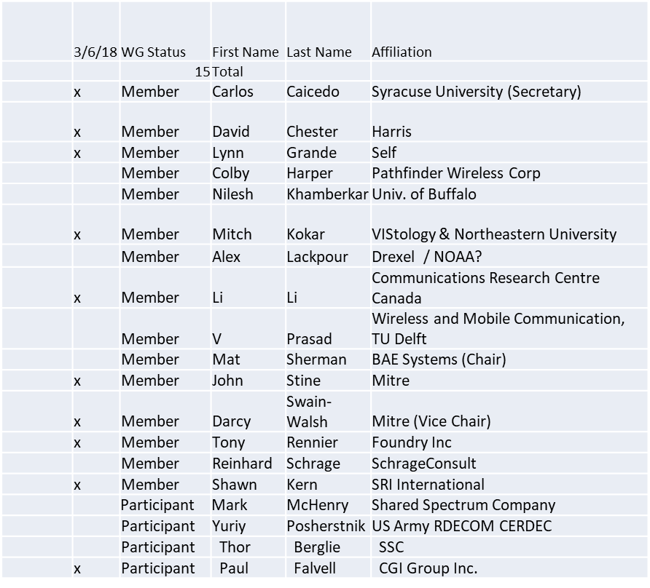

Note: quorum was achieved

1.b. Approval of Agenda
Motion to approve Agenda from 5-18-0014-01

Adopted by unanimous consent

1.c. Patent slides / Notes on status
Patent related slides were presented, no issues came forward

1.d. Approval of recent minutes

Motion to approve WG minutes contained in 5-18-0015-00

Approved by unanimous consent

2. Status on 1900.5.1

Reinhard making changes. Discuss in ad-hoc at the end of meeting

3. Status of 1900.5.2

- Base Standard complete and with IEEE staff for editing
  - Issue date – (not in IEEE standards store yet)
  - Draft standard available for purchase. Still waiting for definite standard
- DRAFT 1900.5.2a PAR posted
  - https://mentor.ieee.org/1900.5/dcn/18/5-18-0003-00-par0-draft-1900-5-2a-amendment-adding-spectrum-consumption-model-schema.pdf
  - Waiting for approval
- Submitted to IEEE-SA for consideration
  - Not clearly decided but some comments were received
  - Comments were addressed

4. Status on Architecture
- Focus on 1900.5.1 and 1900.5.2a PAR
- Conducting additional architecture activities while not interfering with 1900.5.1/2
  - Goal is PAR to update base 1900.5 standard in next couple of months

5. Review of other 1900 activities (1900.1, Leadership meeting etc)

- Leadership meetings: Meeting of April was postponed

- Architecture Study Group
Lynn to lead group

- Machine Learning study group
Alex to lead group

6. 1900.5 marketing inputs

- NSC – Status
  - Working towards release of project list

- Standards paper in process
  - Communications Magazine
    - 1900.5.1 tutorial in works
    - 1900.5.2 paper accepted (publication expected in June/July )
  - Paper on 1900.5.2 over VITA 49 Accepted (Publication date?)

- Need to update website
  - Mat Sherman action but on back burner
- General set of DySPAN papers for Publication
  - Issue on standards spectrum magazine

7. 1900.5 meeting planning and review

- 05 June 2018 will be next electronic Meeting
- F2F in Rome Italy, July?
  - Lynn, Mat, Reinhard could attend?

8. AoB
None

Meeting adjourns at 3:29 p.m. and transitions to ad-hoc on 1900.5.1

