an Working Group | IEEE DYSPAN-SC 1900.5
Title | Meeting minutes 0219 for P1900.5 Monthly Meetings – February 6, 2018
DCN | 5-18-0008-00-mins
Date Submitted | 3/3/2018
Source(s) | Carlos Caicedo (Syracuse University)  email: ccaicedo@syr.edu
Abstract | Minutes for IEEE 1900.5 meeting held on February 6, 2018
Notice | This document has been prepared to assist the IEEE DYSPAN-SC. It is offered as a basis for discussion and is not binding on the contributing individual(s) or organization(s). The material in this document is subject to change in form and content after further study. The contributor(s) reserve(s) the right to add, amend or withdraw material contained herein.
Release | The contributor grants a free, irrevocable license to the IEEE to incorporate material contained in this contribution, and any modifications thereof, in the creation of an IEEE Standards publication; to copyright in the IEEE’s name any IEEE Standards publication even though it may include portions of this contribution; and at the IEEE’s sole discretion to permit others to reproduce in whole or in part the resulting IEEE Standards publication. The contributor also acknowledges and accepts that IEEE DYSPAN SC may make this contribution public.
Patent Policy | The contributor is familiar with IEEE patent policy, as outlined in Section 6.3 of the IEEE-SA Standards Board Operations Manual <http://standards.ieee.org/guides/opman/sect6.html#6.3> and in Understanding Patent Issues During IEEE Standards Development <http://standards.ieee.org/board/pat/guide.html>.
>.

1. Administrivia

1.a Roll Call
Meeting starts at 2:35 p.m. EDT. The participants identified in table 1 were noted.

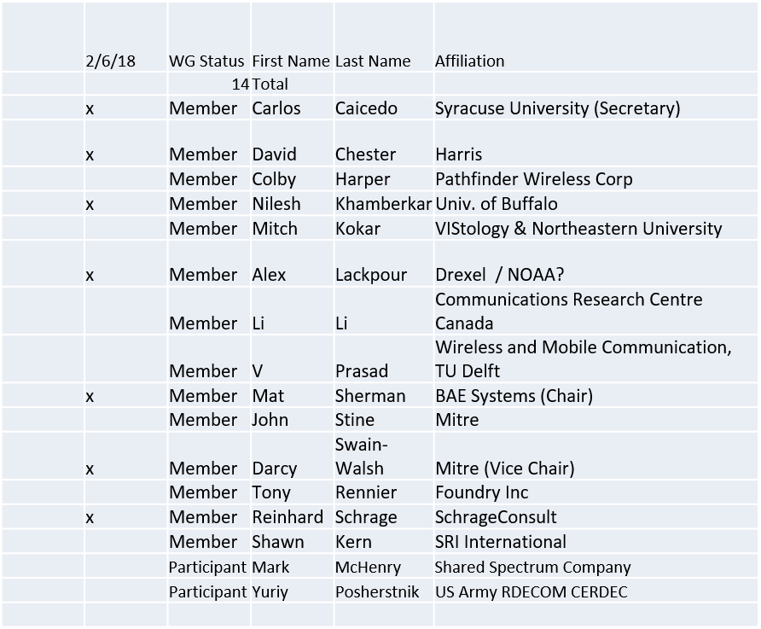

Quorum was not achieved

1.b. Approval of Agenda
Motion to approve Agenda from 5-18-0004-00

No quorum to approve – postponed for next meeting

1.c. Patent slides / Notes on status
Patent related slides were presented, no issues came forward

1.d. Approval of recent minutes
Motion to approve WG minutes contained in 5-18-0005-00
No quorum to approve

2. Status on 1900.5.1

Reinhard making changes. Discuss in ad-hoc at the end of meeting.

3. Status of 1900.5.2

- Base Standard complete and with IEEE staff for editing
  - Issue date – 3/18 possibly
- DRAFT 1900.5.2a PAR posted
  - https://mentor.ieee.org/1900.5/dcn/18/5-18-0003-00-par0-draft-1900-5-2a-amendment-adding-spectrum-consumption-model-schema.pdf
  - Submitted to DySPAN-SC for consideration

4. Status on architecture
- Conducted Ad Hoc in January
  - Collected feedback
- Focus on 1900.5.1 and 1900.5.2a PAR
- Conducting additional architecture activities while not interfering with 1900.5.1/2
  - Goal is PAR to update based station in next couple of months

5. Review of other 1900 activities (1900.1, Leadership meeting etc)

- Leadership meetings
  - Elections for Chair held and new Chair appointed
    - Dr. Oliver Holland is now Chair of DySPAN-SC
  - Officers appointed
    - Mat Sherman as Vice-Chair
    - Alex Lackpour as Secretary
    - Lynn Grande as Treasurer
- “Virtual” F2F planned 3/26-29/18
  - Hosted by Mat Sherman
  - Need to plan meetings
- Delay in appointing chair has impacted progress of 1900.5.2a PAR
  - Can now proceed ahead

6. 1900.5 marketing inputs

- NSC - Status
- Standards paper in process
  - Communications Magazine
    - 2 papers – 1900.5.1 and 1900.5.2
  - Paper on 1900.5.2 over VITA 49 Accepted
    - More details to be provided (Sherman / Cooklev)
- Need to update website
Mat Sherman action but on back burner

6. 1900.5 meeting planning and review
- 06 March 2018 is next scheduled monthly electronic meeting
- Will likely skip April meeting and have end of March meetings
  - Aligns with DySPAN-SC meetings
  - Poll on who will attend
    - Alternate is DC April 4-5
- Ad Hocs?
- Another F2F? Take Poll
- Meeting Platform
Will be GoTo meeting just for end of March meetings

Meeting ends at 2:58 P.M. EDT and transitions to ad-hoc on 1900.5.1

