an Working Group | IEEE DYSPAN-SC 1900.5
Title | Meeting minutes 0218 for P1900.5 Monthly Meetings – January 9 to 10, 2018
DCN | 5-18-0005-00-mins
Date Submitted | 2/5/2018
Source(s) | Carlos Caicedo (Syracuse University)  email: ccaicedo@syr.edu
Abstract | Minutes for IEEE 1900.5 meetings held on Jan 9 to 10, 2018 in Melbourne, FL
Notice | This document has been prepared to assist the IEEE DYSPAN-SC. It is offered as a basis for discussion and is not binding on the contributing individual(s) or organization(s). The material in this document is subject to change in form and content after further study. The contributor(s) reserve(s) the right to add, amend or withdraw material contained herein.
Release | The contributor grants a free, irrevocable license to the IEEE to incorporate material contained in this contribution, and any modifications thereof, in the creation of an IEEE Standards publication; to copyright in the IEEE’s name any IEEE Standards publication even though it may include portions of this contribution; and at the IEEE’s sole discretion to permit others to reproduce in whole or in part the resulting IEEE Standards publication. The contributor also acknowledges and accepts that IEEE DYSPAN SC may make this contribution public.
Patent Policy | The contributor is familiar with IEEE patent policy, as outlined in Section 6.3 of the IEEE-SA Standards Board Operations Manual <http://standards.ieee.org/guides/opman/sect6.html#6.3> and in Understanding Patent Issues During IEEE Standards Development <http://standards.ieee.org/board/pat/guide.html>.
>.

January 9/2018 - Minutes

1. Administrivia

1.a Roll Call
Meeting starts at 2:35 p.m. EDT. The participants identified in table 1 were noted.

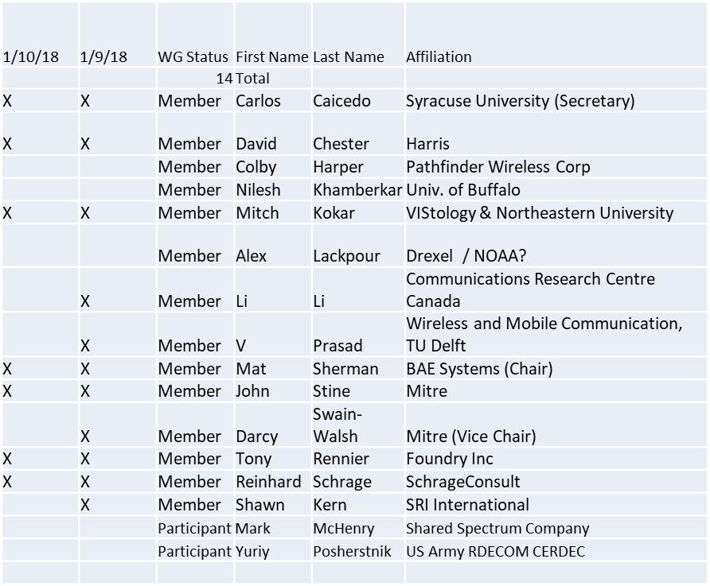

1.b. Approval of Agenda
Motion to approve Agenda from 5-18-0001-00

Adopted by unanimous consent

1.c. Patent slides / Notes on status
Patent related slides were presented, no issues came forward

1.d. Approval of recent minutes

Motion to approve WG minutes contained in 5-18-0002-00

Mover: Carlos
Second: John

Approved by unanimous consent

2. Status on 1900.5.1

Document moving forward. Working on “negation” support
Working schedule updated – Aiming for WG Ballot in February /18, end date for submission to REVCOM will be March/19

3. Status of 1900.5.2

1900.5.2 base standard has been approved in December by Revcom

PAR to add schema to 1900.5.2
- Vote for WG approval on this new PAR was presented as:
  - Motion to empower 1900.5 Chair to complete all processes required to start a new 1900.5.2a project based on the material on slides 17-20 of this presentation ?
- Moved: John
- 2nd: Tony
- Vote results: Approve: 10 Against: 0 Abstain 0

4. Review of other 1900 activities (1900.1, Leadership meeting etc)

Leadership meetings
- Had leadership meetings in December
- GoTo Meeting issues being worked

Is it time to revisit the 1900.5 Architecture?
- Ad Hoc discussions? Discuss Ad Hoc at end of meeting – Mat has action to organize architecture ad hoc
  - Previous ad-hoc was conducted on Dec 19/2017
- Matt is working on PAR to revise 1900.5

5. 1900.5 marketing inputs

- NSC – Status
  - 1900.5.2 will potentially be used or referred to by a few projects
- 1900.5 papers in process
  - A paper from Mitch has been published
  - Carlos & group 1900.5.2 paper has been approved for publication in IEEE Standards Communication Magazine
- FCC activities
  - More than 250 sets of comments have been sent to the NOI to which 1900.5 had also sent comments
  - Waiting for FCC reply to see if response necessary

6. 1900.5 meeting planning and review
- Social gathering for 1/9/18
  - Reservation for 10 at 6 PM at Bonefish Willy’s
- 06 February 2018 WG Electronic Meeting
  - 1900.5.1 Ad Hoc to immediately follow the meeting
- Meeting Platform
  - WebEx for now
- Architecture Ad Hoc at end Feb 6 meeting
- DySPAN Plenary last week of March
  - All virtual
  - Mat Sherman hosting – GoToMeeting rather than WebEx

Meeting ends at 3:27 P.M. EDT. A demo on an updated version of the Spectrum Consumption Model Builder and Analysis Tool (SCMBAT), presented by Carlos follows along with an Ad-hoc meeting for discussion the 1900.5 Architecture.

January 9 – Minutes – 1900.5. Architecture Ad-hoc meeting

- Check definitions in 1900.5 for consistence with 1900.1
- Should be updated to address cognitive radio “network”?
- Support for hierarchical policy architecture
- SCM should be a primitive of the 1900.5 policy language – requirement?
- Support for adaptive (state machine) systems rather than reasoner
- Page 18 of 1900.5- req 6.1.1.2. Clarify this is just for human readable comments, and not the current formal definition of annotations in OWL
- 1900.5-2011 6.1.1.6 Clarify not doing “temporal semantics” but rather have the ability to describe temporal system behavior
- 6.1.1.8 Clarify that “functions” means binary relations. Also “temporal” here overlaps with 6.1.1.6
- 6.1.1.14 is this the same as 6.1.1.12?
- 6.1.2.2 table 1 – Change route to trajectory or similar to avoid confusion with ‘network’ route.

- Should we address system performance as well as spectrum with 1900.5 policy?
  - No Consensus
  - Summarize for and against arguments next ad hoc
- Expansion to support 1900.5.2?

January 10 – Minutes – 1900.5.1 Ad-hoc meeting

- Reviewed draft
- Discussions on definition of policy, rules etc
  - No clear consensus, left everything as is
- Reviewed requirements in 1900.5-2011
  - Decided 6.1.1.10i should be deferred to later version of 1900.5.1
  - Decided 6.1.1.10k should be deferred to later version of 1900.5.1
  - Policies that require or prohibit spectrum uses that are within the bounds or constraints of an SCM should be included in current 1900.5.1
  - 6.1.2 full compliance deferred to future version in light of 6.1.1.10 exceptions

