an Working Group | IEEE DYSPAN-SC 1900.5
Title | Meeting minutes 0217 for P1900.5 Monthly Meeting – December 5, 2017
DCN | 5-18-0002-00-mins
Date Submitted | 1/6/2017
Source(s) | Carlos Caicedo (Syracuse University)  email: ccaicedo@syr.edu
Abstract | Minutes for IEEE 1900.5 meeting (electronic) held on December 5 / 2017
Notice | This document has been prepared to assist the IEEE DYSPAN-SC. It is offered as a basis for discussion and is not binding on the contributing individual(s) or organization(s). The material in this document is subject to change in form and content after further study. The contributor(s) reserve(s) the right to add, amend or withdraw material contained herein.
Release | The contributor grants a free, irrevocable license to the IEEE to incorporate material contained in this contribution, and any modifications thereof, in the creation of an IEEE Standards publication; to copyright in the IEEE’s name any IEEE Standards publication even though it may include portions of this contribution; and at the IEEE’s sole discretion to permit others to reproduce in whole or in part the resulting IEEE Standards publication. The contributor also acknowledges and accepts that IEEE DYSPAN SC may make this contribution public.
Patent Policy | The contributor is familiar with IEEE patent policy, as outlined in Section 6.3 of the IEEE-SA Standards Board Operations Manual <http://standards.ieee.org/guides/opman/sect6.html#6.3> and in Understanding Patent Issues During IEEE Standards Development <http://standards.ieee.org/board/pat/guide.html>.
>.

1. Administrivia

1.a Roll Call
Meeting starts at 2:35 p.m. EDT. The participants identified in table 1 were noted.
Quorum was achieved.

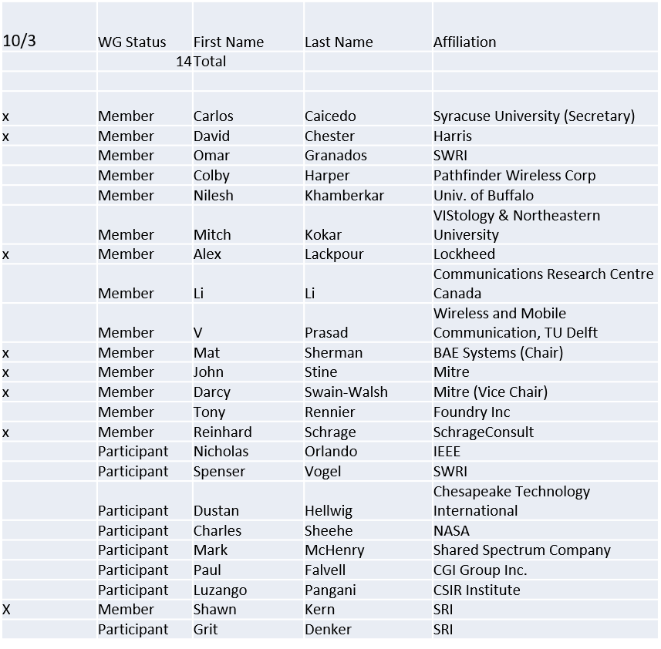

Table 1

1.b. Approval of Agenda
Motion to approve Agenda from 5-17-0028-01

Mover: Carlos
Second: Darcy

Adopted by unanimous consent

1.c. Patent slides / Notes on status
Patents related slides were presented, no issues came forward

1.d. Approval of recent minutes
Motion to approve WG minutes contained in 17-0027-00, 5-17-0029-00.

Mover: Carlos
Second: Darcy

Vote: Approved by unanimous consent

1.e. 1900.5 officer elections
- Status
  - Dave Chester has been appointed Elections officer
  - The following nominations have been received and accepted
    - Chair:
    - Vice Chair:
    - Secretary:
- Will poll for candidates and then conduct election

2. Status on 1900.5.1

Face to face sessions of January should cover the whole draft in one go to address any pending issues with the text.

3. Status of 1900.5.2

On Revcom agenda for Dec 5
- Approved by RevCom
- On agenda for standards board approval
PAR to add Schema ready after Revcom approval of 1900.5.2

4. Review of other 1900 activities (1900.1, Leadership meeting etc)

No leadership meetings. Next one in two weeks.
GoTo Meeting issues being worked out

Is it time to revisit the 1900.5 architecture?
- Ad Hoc discussions?
  - Planned for the week of December 19

Other activities? 1900.5.2 amendment for Schema

5. 1900.5 marketing inputs

- Standards paper in process
  - Communications Magazine
    - 2 papers – 1900.5.1 and 1900.5.2
- FCC Call for comments
  - Deadline for some companies to submit comments was extended (mostly carriers)

6. 1900.5 meeting planning and review

- Deferred monthly electronic meeting to January 9th

- DySPAN-SC meetings 12/19-22/17
  - Would like short WG meeting + Ad Hocs that week
  - 1900.5.1 - have ad hoc at 2:30 PM EST on 12/19
  - Architecture? Have ad hoc at 9 AM EST on 12/21

- Face to Face in January 9-10 (Won’t meet on 11th)
  - Move monthly meeting to 9th.
  - Host: Harris Corp
  - Melbourne FL
  - Please register with Harris if you plan to attend

- Meeting Platform
  - WebEx for now

7. AoB
Ad-hoc
- Review of 1900.5.1 architecture

8. Adjourn
Meeting ends at 3:25 p.m. EDT

