an Working Group | IEEE DYSPAN-SC 1900.5
Title | Meeting minutes 0216 for P1900.5 Monthly Meeting – November 7, 2017
DCN | 5-17-0029-00-mins
Date Submitted | 12/4/2017
Source(s) | Carlos Caicedo (Syracuse University)  email: ccaicedo@syr.edu
Abstract | Minutes for IEEE 1900.5 meeting (electronic) held on November 7 / 2017
Notice | This document has been prepared to assist the IEEE DYSPAN-SC. It is offered as a basis for discussion and is not binding on the contributing individual(s) or organization(s). The material in this document is subject to change in form and content after further study. The contributor(s) reserve(s) the right to add, amend or withdraw material contained herein.
Release | The contributor grants a free, irrevocable license to the IEEE to incorporate material contained in this contribution, and any modifications thereof, in the creation of an IEEE Standards publication; to copyright in the IEEE’s name any IEEE Standards publication even though it may include portions of this contribution; and at the IEEE’s sole discretion to permit others to reproduce in whole or in part the resulting IEEE Standards publication. The contributor also acknowledges and accepts that IEEE DYSPAN SC may make this contribution public.
Patent Policy | The contributor is familiar with IEEE patent policy, as outlined in Section 6.3 of the IEEE-SA Standards Board Operations Manual <http://standards.ieee.org/guides/opman/sect6.html#6.3> and in Understanding Patent Issues During IEEE Standards Development <http://standards.ieee.org/board/pat/guide.html>.
>.

1. Administrivia

1.a Roll Call
Meeting starts at 2:37 p.m. EDT. The participants identified in table 1 were noted.
Quorum was not achieved.
Meeting proceeds in ad-hoc mode

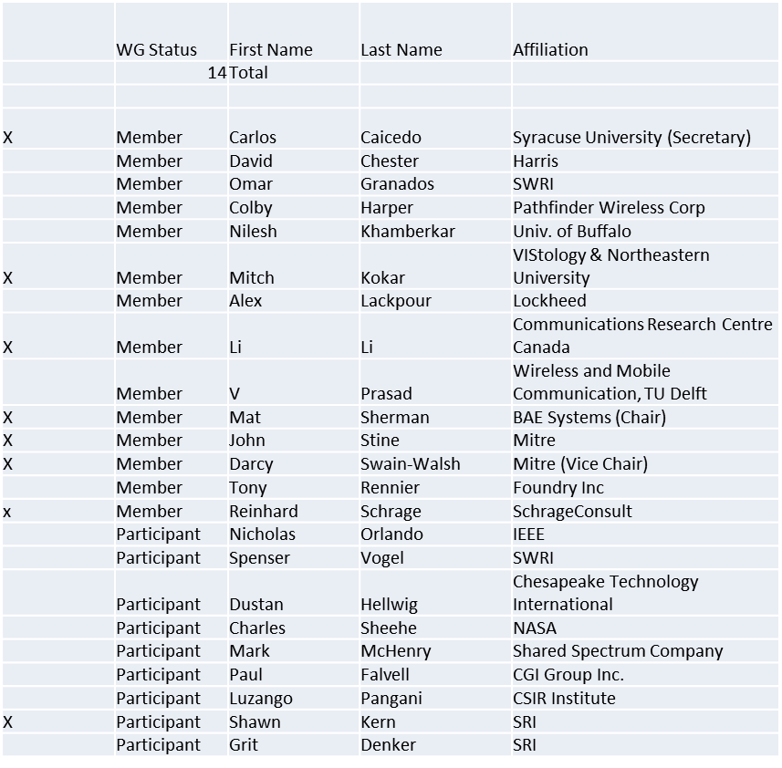

Table 1

1.b. Approval of Agenda
Motion to approve Agenda from 5-17-0026-00

Adopted by unanimous consent

1.c. Patent slides / Notes on status
Patents related slides were presented, no issues came forward

1.d. Approval of recent minutes
Postponed to next meeting

2. Status on 1900.5.1

Face to face sessions of January should cover the whole draft in one go to address any pending issues with the text.

3. Status of 1900.5.2

On Revcom agenda for Dec 5
One request to formally reject comment and explain why
- Reuest Completed based on existing WG approved resolution
PAR to add Schema ready to roll but waiting for Revcom approval of 1900.5.2 first

4. Review of other 1900 activities (1900.1, Leadership meeting etc)

No leadership meetings
GoTo Meeting issues being worked out

Is it time to revisit the 1900.5 architecture?
- Ad Hoc discussions? Discussion ad-hoc at the end of this meeting
Mat has action to organize architecture ad hoc

Other activities? 1900.5.2 amendment for Schema

5. 1900.5 marketing inputs

- Standards paper in process
  - Communications Magazine
    - 2 papers – 1900.5.1 and 1900.5.2
- DARPA Spectrum Challenge?
  - PM(Paul Tilghman) pitch WInnForum
    - Interest in Commercial overlap
    - Opportunistic use of commercial spectrum / networks

6. 1900.5 meeting planning and review

- 05 December 2017 is next scheduled monthly electronic meeting
  - May push to week of 11th to synchronize with “Plenary” meeting in “Tokyo” (will be electronic)
- Syncing with Tokyo meetings of the week of December 11
  - On Monday 7 PM have 1900.5 Ad hoc to sync
  - On Tues 2:30 PM normal WG meeting
  - Ad hoc: 1900.5.1 @ 8 AM Wednesday
  - Ad hoc: Architecture: 7 PM Wednesday

- Plan Face to Face in January 9-10?
  - Host: Harris Corp in Melbourne, FL
  - Move monthly meeting to Jan 9th.

- Meeting platform
  - Continue with WebEx for now

7. AoB
Ad-hoc
- Review of 1900.5.1 architecture

8. Adjourn
Meeting ends at 3:35 p.m. EDT and transitions to an ad-hoc to discuss revisions to the 1900.5 architecture

