an Working Group | IEEE DYSPAN-SC 1900.5
Title | Meeting minutes 0213 for P1900.5 Monthly Meeting – August 1, 2017
DCN | 5-17-0022-00-mins
Date Submitted | 8/1/2017
Source(s) | Carlos Caicedo (Syracuse University)  email: ccaicedo@syr.edu
Abstract | Minutes for IEEE 1900.5 meeting (electronic) held on August 1 / 2017
Notice | This document has been prepared to assist the IEEE DYSPAN-SC. It is offered as a basis for discussion and is not binding on the contributing individual(s) or organization(s). The material in this document is subject to change in form and content after further study. The contributor(s) reserve(s) the right to add, amend or withdraw material contained herein.
Release | The contributor grants a free, irrevocable license to the IEEE to incorporate material contained in this contribution, and any modifications thereof, in the creation of an IEEE Standards publication; to copyright in the IEEE’s name any IEEE Standards publication even though it may include portions of this contribution; and at the IEEE’s sole discretion to permit others to reproduce in whole or in part the resulting IEEE Standards publication. The contributor also acknowledges and accepts that IEEE DYSPAN SC may make this contribution public.
Patent Policy | The contributor is familiar with IEEE patent policy, as outlined in Section 6.3 of the IEEE-SA Standards Board Operations Manual <http://standards.ieee.org/guides/opman/sect6.html#6.3> and in Understanding Patent Issues During IEEE Standards Development <http://standards.ieee.org/board/pat/guide.html>.
>.

1. Administrivia

1.a Roll Call
Meeting starts at 2:35 p.m. EDT. The participants identified in table 1 were noted.
Quorum was achieved.

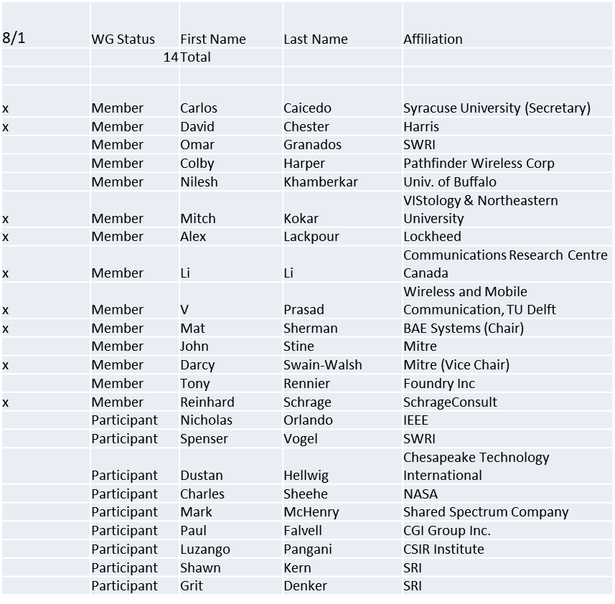
Table 1

1.b. Approval of Agenda
Motion to approve Agenda from 5-17-0019-00

Mover: Li
Second: Alex
Adopted by unanimous consent

1.c. Patent slides / Notes on status
Patents related slides were presented, no issues came forward

1.d. Approval of recent minutes
Motion to approve WG minutes contained in 5-17-0020-00

Mover: Carlos
Second: Dave
Vote: Adopted by UC

2. Status on 1900.5.1

PAR Extension request submitted for 2 years
No comments received so far on the extension
Scheduled for discussion by NesCom in September 12/ 2017

3. Status of 1900.5.2

- All Balloting complete
- Working on submittal paperwork
  - Submittal is to “review committee” (RevCom)
- PAR to add Schema ready to roll but waiting for Revcom approval of 1900.5.2 first

4. Review of other 1900 activities (1900.1, Leadership meeting etc)

No leadership meetings

Is it time to revisit the 1900.5 architecture?
- Ad Hoc discussions? Discuss Ad Hoc at end of meeting – mat has action to organize architecture ad hoc
- Can Chair distribute standard to members for review?
Other activities? 1900.5.2 amendment for Schema

5. 1900.5 marketing inputs

- NSC
  - Several projects appear to be leveraging 1900.5

- Standards paper in process
  - Communications Magazine
    - 2 papers – 1900.5.1 and 1900.5.2
    - Aiming for Standards supplement of the magazine
- DARPA Spectrum Challenge?
  - PM(Paul Tilghman) pitch WInnForum
    - Interest in Commercial overlap
    - Opportunistic use of commercial spectrum / networks

6. 1900.5 meeting planning and review

- September 5 / 2017 @ 2:30 p.m. EDT

- Ad Hocs to discuss 1900.5 Architecture
  - Schedule for August meeting if possible

- Plan Face to Face in November week of 27?
  - January 8th?
  - Florida or DC
- Select new meeting Platform, choices:
  - GoToMeeting
  - JoinMe
  - WebEx
  - Loopup

7. AoB
Ad-hoc
Will continue 1900.5.1 review at September meeting
- So question as to whether ensuring an ontology / rules set is decidable is in scope or should be decided by another group
- Chair believes it is in scope for our group
8. Adjourn
Meeting ends at 3:30 p.m. EDT and transitions to an ad-hoc for 1900.5.1 topics which will be continued at the next monthly meeting in September

